LESSONS FROM THE HISTORY
OF THE TWELVE TRIBES OF ISRAEL
Dr. Jerry A. Collins

The Origin of the Twelve Tribes of Israel
The story of the 12 tribes of Israel begins in the book of Genesis with the calling of Abram. There are three important passages that explain the origin of Israel’s tribes in relation to that calling. Each of these passages add significant components of Abram’s calling to faith and that calling’s contribution to the origin of the 12 tribes of Israel.
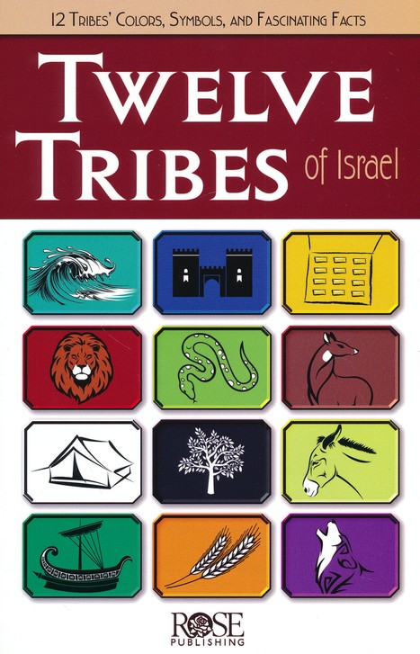

Genesis 12 — The Promise to Abraham
This chapter supplies the foundation of the Abrahamic promises. It formulates the beginning of the nation of Israel and its 12 tribes as a worshiping community. Abram’s calling to leave his homeland and found a new nation would become the means of blessing to the world. The 12 tribes would subsequently learn that their very existence as a nation was by God’s election of one man who responded by faith. It would affirm to the 12 tribes that their beginnings were rooted in the will of God.
PT—The 12 tribes have a supernatural beginning just as the church does. God is at work to accomplish His plan and purpose, first, through a nation of people called Israel, and then, through a global network of people called the church.

God Calls Abraham
Now the Lord said to Abram, “Go forth from your country, and from your relatives and from your father’s house, To the land which I will show you; And I will make you a great nation, And I will bless you, and make your name great; And so you shall be a blessing; And I will bless those who bless you, and the one who curses you I will curse. And in you all the families of the earth will be blessed.” So Abram went forth as the Lord had spoken to him (Genesis 12:1-4).

Verse 1—Now the Lord said to Abram—The starting point of the narrative is the divine word to Abram, calling him to leave his homeland and found a new nation that would eventually be comprised of the 12 tribes of Israel. The Lord called Abram while he was in Ur. Terah took Abram his son, and Lot the son of Haran, his grandson, and Sarai his daughter-in-law, his son Abram’s wife; and they went out together from Ur of the Chaldeans in order to enter the land of Canaan (11:31). The record of the Word of the Lord to Abram was placed at the start of the Abraham stories because it is the formal beginning of the account of Abram.
- “Go forth from your country, and from your relatives and from your father’s house”—The divine imperative simply instructed Abram to leave. The instruction to leave was very specific—his land, his relatives, and his father’s household.
PT—God’s discipleship of Abram meant moving into his personal space and calling him to go forth from country (geographic cultural move) …from relatives (a change of close relations) …from father’s house (leaving personal security). God created necessity for Abram. God asked him to leave everything that was familiar to establish his own independence. Necessity is what forces us out of the familiar, which can be frightening and difficult to do, as an essential step to move us toward the unfamiliar where our faith is tested and personal and spiritual growth is possible. Joseph was forced from Potiphar’s house due to the intrigue of Potiphar’s wife. Moses was forced from Pharaoh’s household due to killing the Egyptian. Ruth was forced to follow Naomi due to her husband’s death. Esther was forced into the king’s palace. David was forced into the wilderness due to Saul’s scheming to kill him. Paul was forced into itinerate missionary work due to his vision of Jesus and his conversion. In each case, the necessity created the possibility of growth through newness. Without newness, maturity is not possible. God is a God of newness because His commitment is to our spiritual maturity.
- To the land which I will show you—The Lord’s word is very specific about what Abram is to leave (the three prepositional phrases narrow to his father’s household), but is not specific at all about where he is to go. He was to go forth to an unknown land, which God would show him. So walking by faith includes leaving and going. God required faith, a point that Hebrews 11:8 notes: by faith Abraham, when he was called, obeyed by going out to a place which he was to receive for an inheritance; and he went out, not knowing where he was going.
PT—Abram was being discipled by God, which involved moving from the familiar into the unfamiliar that forever changed the course of his life. Now Abram would need to negotiate the newness God introduced into his life. He would need ingenuity, to develop strategy, and apply creativity as he followed the revealed will of God into the unfamiliar. All the while, Abram’s faith was being shaped and developed by his new understanding.

An Application—Familiarity may be good for us spiritually when it is connected to what we have learned from God’s Word. It is not good when what we understood was true may need to be changed, due to a clearer understanding of the truth. Familiarity is never good just because it’s familiar. It must be true.
- When what has been familiar to us is no longer sufficient, we must decisively decide to move away from it toward the new unfamiliar we have learned from God’s Word, or a new application from a familiar understanding. For instance, when I became a husband, my thinking about that was insufficient, due to my lack of understanding the truth of husbanding. As my understanding of the Word of God increased about husbanding, so did my knowledge of the truth about husbanding. That then changed my husbanding—or, at least, I hope so.
- The unfamiliar, in Abram’s case it was the unknown land he was to traverse, that which was previously unknown and not understood, must now be ventured into in order to grow and mature. The unfamiliar, the new, is where God is calling us so that we can move on to spiritual maturity.
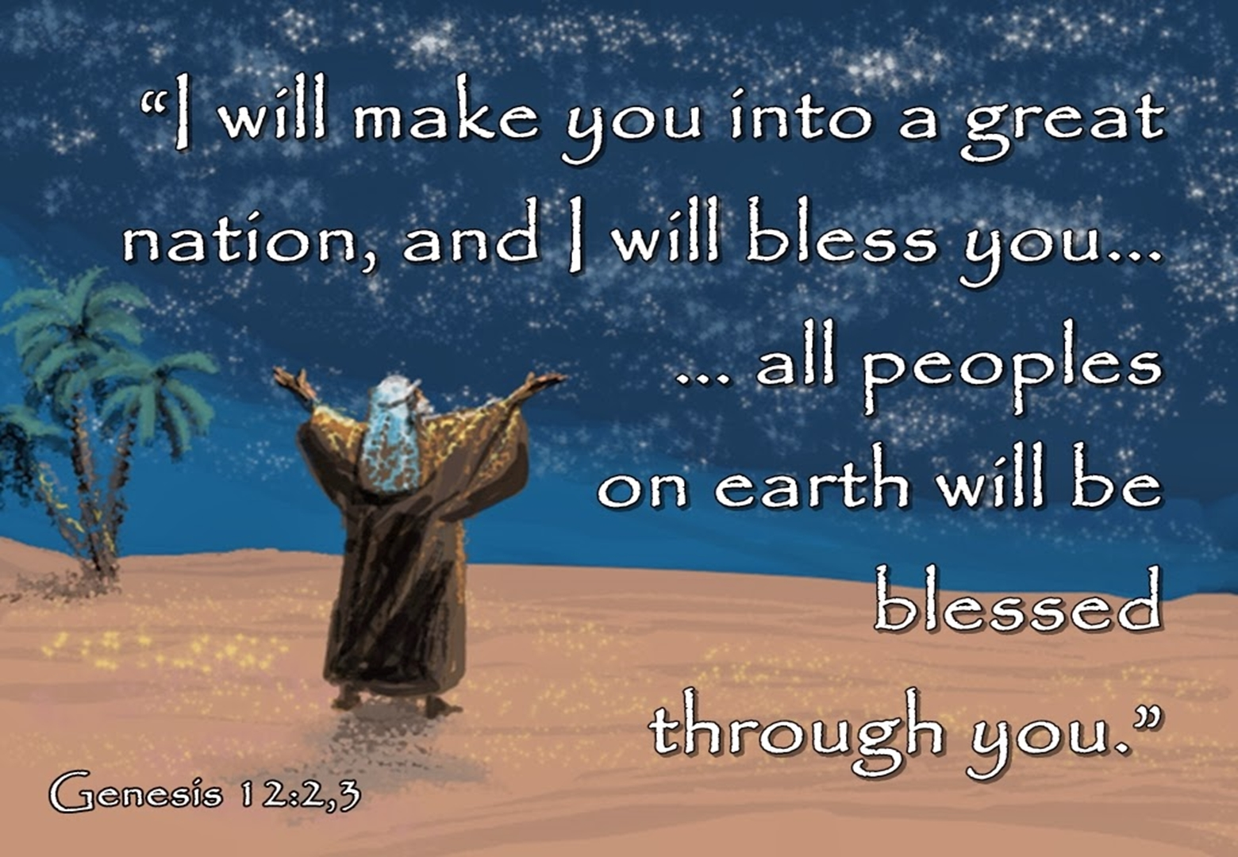

Verse 2—And I will make you a great nation—God’s call included not only a new land or territory but also to become a great nation there. Here is the beginning of a general description of descendants that will eventually coalesce into a nation. This is a nascent reference to the origin and ultimate existence of the 12 tribes of Israel.
- And I will bless you—In addition to a national promise, God also gave Abram a personal promise. Essentially, God promised to convey spiritual and physical enrichment to Abram. God would give Abram fame and fertility.
- And make your name great—Abram’s influence would be such that Abram would become famous. Consider the testimony of the Apostle Paul some 2000 years later, without becoming weak in faith he contemplated his own body, now as good as dead since he was about a hundred years old, and the deadness of Sarah’s womb; yet, with respect to the promise of God, he did not waver in unbelief [about the deadness of his body and Sarah’s womb hindering God from acting] but grew strong in faith [in spite of the deadness that would make it impossible to conceive], giving glory to God, and being fully assured that what God had promised, He was able also to perform [that the womb could not conceive without God’s intervention]. Therefore, it was also credited to him as righteousness (Romans 4:19-22).
- PT—Faith is understanding God’s Word to be true. Abram understood God’s promise of a child from a dead womb to be truth. That understanding was his faith that God honored as righteousness.

And so you shall be a blessing—Abram would become such a blessing that nations would hold Abram up as a paradigm of divine blessing in their own blessings to one another. Abram would be responsible for opening the blessing of the Lord, enrichment in life, to the families of the earth. Abram would share the knowledge of God and so others would know from where the blessing came.

Verse 3—And I will bless those who bless you—The Lord would send blessing (fame and fertility) in order that Abram himself might be a blessing. God bound himself to Abram so that those who enrich Abram share in his blessing. That is, those supporting and endorsing Abram in his faith in God would find enrichment, too.
- And the one who curses you I will curse—Since God is binding himself to Abram, the statement would read like this: “but the one who treats you with contempt, I must curse.” Whoever treated Abram and his faith with disrespect, took his faith lightly or the covenant with contempt as worthless, God would banish from the blessing.
- And in you all the families of the earth will be blessed—God’s blessing of Abram extends beyond the personal and national to the universal. The middle voice nuance may be expressed as “they may consider themselves blessed through you,” or “all the families of the earth will bless themselves” (depending upon how they treat Abram, his faith, and seed). The logical outcome is that those who bless Abraham receive blessing and thus will be blessed and that anyone on the earth may be part of that category. No one would find divine blessing apart from the blessings given through Abram and his seed.
PT—The difference in Abram’s blessing and Christ’s blessing is the content of that blessing. In the OT, it was fame, fertility, and favor in the land, and material in nature. In Christ, it is spiritual blessings. (Look at RCI brochure.)

An Application—All of God’s activity in relation to the promise given to Abram is not limited to just Abram or his posterity, but extends to and reaches its climax when it includes all of the families of the earth. Of course, this includes the global blessing of salvation that would go to the world through Abram’s seed, Jesus Christ. But universal blessing is still destined to come for the nations when Jesus Christ returns to reign. Then the seventh angel sounded; and there were loud voices in heaven, saying, “The kingdom of the world has become the kingdom of our Lord and of His Christ; and He will reign forever and ever” (Revelation 11:15).

Verse 4—So Abram went forth as the Lord had spoken to him—When Abram heard the call and the promises, he obeyed. The point is that Abram went as an act of obedience to the Word of the Lord, and not as a natural migration. This simple act of faith set in motion a destiny with ramifications yet into the future for the nation and the tribes.

An Application—All believers are called of God. The call of God is our salvation in Christ. The Apostle Paul wrote, ...whom He predestined, these He also called; and whom He called, these He also justified; and whom He justified, these He also glorified (Romans 8:29-30). So the call of God is the predetermination of our salvation. The call of God deals with our salvation, not our service.

Implications for the 12 Tribes
- The promises the 12 tribes would live for were truly from God—the promises of a great nation, a land, God’s protection, and future blessings of enrichment and fertility.
- The Lord’s appearance and confirmation proved to the tribes that the land of Canaan specifically was their land of promised destiny.
- Abram’s pilgrimage would also become theirs. Abram came to Shechem, Bethel, Ai, and the Negev, and so the tribes would come into the land from the Negev, to Bethel, Ai and Shechem where they would then enact the covenant. The people said to Joshua, “No, but we will serve the Lord.” Joshua said to the people, “You are witnesses against yourselves that you have chosen for yourselves the Lord, to serve Him.” And they said, “We are witnesses” (Joshua 24:21-22).
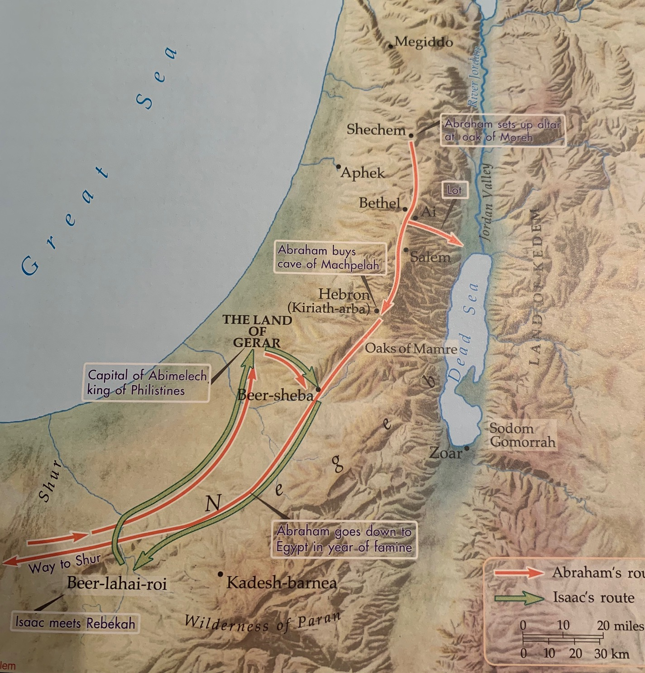
- The tribes would understand (even though they rebelled) that God required faith for successive generations of Israelite tribes to share in those promised blessings.
- The tribes shared in the same call as that of their founding ancestor—to go on a pilgrimage by faith to the Land of Promise to worship, proclaim, and serve the Lord. Belief in the promises would be required in order to go and serve as evidence of their faith.

Genesis 15 — God Confirms the Promise
With this chapter there is a transition from a focus upon the Land to attention directed to the seed inheriting the Land. There are essentially two things going on in this passage. First, can Abram trust the Lord to deliver an heir to him and his household as promised? Second, can God be trusted to perform His promise of an heir to Abram? The remainder of the Abrahamic narrative explores and addresses his faith to trust God with the promises God had made to him. These questions have direct implication to the origin of the 12 tribes of Israel. God will both confirm and verify, to Abram and by extension to the 12 tribes, that He indeed can be trusted. In other words, that Abram understand that God’s Word of promise to him was true.

Abraham Believed the Lord
Abram said, “O Lord God, what will You give me, since I am childless, and the heir of my house
is Eliezer of Damascus?” And Abram said, “Since You have given no offspring to me, one born in my house is my heir.” Then behold, the word of the Lord came to him, saying, “This man will not be your heir; but one who will come forth from your own body, he shall be your heir.” And He took him outside and said, “Now look toward the heavens, and count the stars, if you are able to count them.” And He said to him, “So shall your descendants be.” Then he believed in the Lord; and He reckoned it to him as righteousness. And He said to him, “I am the Lord who brought you out of Ur of the Chaldeans, to give you this land to possess it.” He said, “O Lord God, how may I know that I will possess it?” So He said to him, “Bring Me a three year old heifer, and a three year old female goat, and a three year old ram, and a turtledove, and a young pigeon.” Then he brought all these to Him and cut them in two, and laid each half opposite the other; but he did not cut the birds. The birds of prey came down upon the carcasses, and Abram drove them away.
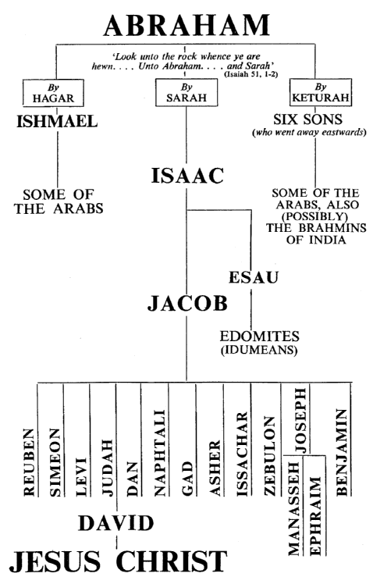

Now when the sun was going down, a deep sleep fell upon Abram; and behold, terror and great darkness fell upon him. God said to Abram, “Know for certain that your descendants will be strangers in a land that is not theirs, where they will be enslaved and oppressed four hundred years. But I will also judge the nation whom they will serve, and afterward they will come out with many possessions” (Genesis 15:2-14).
Verses 2-3—Abram said, “O Lord God, what will You give me, since I am childless, and the heir of my house is Eliezer of Damascus?”—The absence of a child complicated the matter of inheritance. If Abram died childless, that would mean his household servant would become his heir.
- Since You have given no offspring to me, one born in my house is my heir.”—Apparently, the concern was because then the heir would be Eliezer of Damascus, highlighting the incongruity that Abram’s heir would be an alien (cf. Jeremiah 49:1).

Verses 4-5—Then behold, the word of the Lord came to him, saying—God decisively overrules Abram’s fears directly from the word of Lord.
- “This man will not be your heir; but one who will come forth from your own body, he shall be your heir.”—That word made no specific reference to the servant’s name this man will not be your heir. In essence, God guaranteed that the heir would be through a ‘natural-born’ son.
- And He took him outside and said, “Now look toward the heavens, and count the stars, if you are able to count them.” And He said to him, “So shall your descendants be.”—God’s requirement that Abram gaze into the heavens indicated the incredible achievement that his seed would be as innumerable as the stars in the heavens so shall your descendants be. A feat that conveyed from childless Abram the need for greater faith.

Verse 6—Then [Now] he believed in the Lord—This does not necessarily mean Abram came to faith as a result of the preceding section. Hebrews 11:8 asserts that he left Ur by faith. This verse simply reports that Abram believed and so God credited him with righteousness. This could be a parenthetical statement or a summary or transitional note. What Abram believed was that God’s word about an heir was reliable.
- and He reckoned it to him as righteousness—Since Abram accepted the Word of the Lord as true the Lord attributed Abram as righteous and acceptable. Thus, Abram’s righteousness would now bind God to this believer by covenant. God made this covenant with a man who believed him.

An Application—Righteousness is conformity to the standard of what is right in God’s eyes. Righteousness is the correct action and attitude before God. To act in concert with God’s point of view is to be a righteous person. The question we must always ask ourselves in any given situation is ‘how righteous do I want to be?’

Verses 7-8—And He said to him, “I am the Lord who brought you out of Ur of the Chaldeans, to give you this land to possess it.”— The Lord is about to initiate a covenant-making ceremony with a declaration of who He is and what He has done for Abram. “I am the Lord who brought you out.” God revealed Himself to be the great Deliverer and Benefactor of His people due to the specific promise to give you [Abram and his posterity] this land to possess it.
- He said, “O Lord God, how may I know that I will possess it?”—The mention of this land raised doubts in Abram’s mind. Abram wanted assurance that I will possess it. What’s amazing about this is that God had just declared Abram ‘righteous’ (v. 6), and had repeated the land promise (v. 7). However, those doubts did not stop Abram from obeying God. The faith that Abraham exhibited at critical junctures was always accompanied by his obedience to God’s commandments. Indeed, at the end of his life, God would commend him, saying Abraham obeyed my voice and guarded my charge: my commandments, my statutes, and my laws (Genesis 26:5).

An Application—We may stagger at the promises of God when they seem so impossible and doubt God’s faithfulness. But a devout follower will screen the doubt by taking it back to the Word of God for confirmation of God’s promises. Then, assured of God’s faithfulness will continue in obedience as appropriate to the life situation.

Verses 9-11—So He said to him, “Bring Me a three year old heifer, and a three year old female goat, and a three year old ram, and a turtledove, and a young pigeon.”—Abram’s question prompted the enacting of the covenant for the guarantee of the Word of the Lord. God had sworn an unconditional oath in Genesis 12. Now, in response to Abram’s doubts, God cuts a covenant with him. The passage describes how meticulously the Lord prepared to assure Abram and how Abram participated in the preparation. These animals were standard type of sacrificial animals later represented in the nation.
- Then he brought all these to Him and cut them in two, and laid each half opposite the other; but he did not cut the birds —A party to cutting a covenant was, in essence, swearing that should he fail to keep its terms, he was to die like these animals cut into pieces. Adopting such a death position assured the other party one was going to keep the covenant at all costs.
- The birds of prey came down upon the carcasses, and Abram drove them away—These birds of prey were unclean and were attacking the sacrifice for God. This incident interjects the ominous thought of these unclean birds approaching and devouring this offering to Abram’s God. Thus, Abram drove them away.

Verses 12-14—Now when the sun was going down, a deep sleep fell upon Abram; and behold, terror and great darkness fell upon him—The darkness that overcame Abram may have been the objectifying of his trepidation at the prospect of dying without an heir. In this state, Abram himself could not walk through the pieces. The terror and great darkness he experienced may have been God’s way of preventing Abram’s participation in the covenant ritual so that God alone would be the guarantor of the promise to Abram, and his posterity would possess the Land.
- God said to Abram, “Know for certain that your descendants will be strangers in a land that is not theirs”—During the ceremony God declared that Abram’s descendants, eventually including the 12 tribes, will stay in a land as resident foreigners without rights of citizenship.
- Where they will be enslaved and oppressed four hundred years—The announcement of enslavement clarified the meaning of the symbols in the sacrifice. The family would be enslaved and oppressed by a foreign nation for four hundred years. The word oppressed is the same word used in Exodus 1:11 to describe the oppression of Egypt. Abram had asked how may I know that I will possess it (v. 8). God said that Abram would know for certain that before the fulfillment there would be suffering for four centuries. Israel during the time of Moses could note the years and see that the time of deliverance was at hand. This period of time was tied in part to the divine longsuffering for the Amorites, whose sin was not yet full (v. 16).
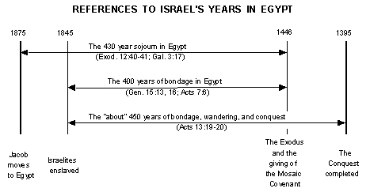
- But I will also judge the nation whom they will serve, and afterward they will come out with many possessions—The fulfillment of the promises to Abram required retributive judgment on Egypt and the inhabitants of the land of Canaan. Abram’s seed would indeed get the Land but not one hour before absolute justice allowed it. God also revealed that Abram’s posterity would be fully provisioned to journey to and settle in the Land of promise and afterward they will come out with many possessions. The promises were ratified by God Himself (vv. 16-21).

Implications for the 12 Tribes
- The oppression and enslavement in Egypt would not be a threat to the fulfilment of the promises—God assured it.
- The Egyptian slavery would be part of the divine plan to discipline the nation to make it fit for the promises.
- That in spite of the prospects of death and suffering the 12 tribes could be encouraged by this guarantee at the exodus as well as subsequent times of distress and captivity.
- The prophets of Israel would use God’s ratification of the Abrahamic covenant to call the nation to be faithful to God.

Genesis 22 — Abraham’s Faith Is Tested
In this chapter is the single greatest test in the life of Abraham which came after he had finally received the promise. He was to give his son back to God through sacrifice. This test was designed to see to what extent Abraham would obey God. In the final analysis, Isaac would be brought twice from the dead, once from Sarah’s dead womb and once again from the high altar. Afterward, God reiterated the promised blessings adding a solemn oath. The 12 tribes would note that God would also test their willingness to obey God. The wilderness wanderings, the entry into and conquering the Land of promise, and the extent of their obedience as they settled there, would test their faith as God had their founding father, Abraham. The significant question for Abraham’s posterity was would they, too, pass the test?

Abraham Prepares to Sacrifice His Son of Promise
Abraham stretched out his hand and took the knife to slay his son. But the angel of the Lord called to him from heaven and said, “Abraham, Abraham!” And he said, “Here I am.” He said, “Do not stretch out your hand against the lad, and do nothing to him; for now I know that you fear God, since you have not withheld your son, your only son, from Me.” Then Abraham raised his eyes and looked, and behold, behind him a ram caught in the thicket by his horns; and Abraham went and took the ram and offered him up for a burnt offering in the place of his son. Abraham called the name of that place The Lord Will Provide, as it is said to this day, “In the mount of the Lord it will be provided.” Then the angel of the Lord called to Abraham a second time from heaven, and said, “By Myself I have sworn, declares the Lord, because you have done this thing and have not withheld your son, your only son, indeed I will greatly bless you, and I will greatly multiply your seed as the stars of the heavens and as the sand which is on the seashore; and your seed shall possess the gate of their enemies. In your seed all the nations of the earth shall be blessed, because you have obeyed My voice” (Genesis 22:10-18).

Verse 10—Abraham stretched out his hand and took the knife to slay [slaughter] his son—At the moment of truth, Abraham did not look around for an animal or wait hesitatingly for God to intervene. He raised his hand to slay his son, the heir to the promise. The divine intervention came when the sacrifice was made—in the mind of Abraham, if not in fact. Hebrews 11:19 suggests that Abraham concluded that God was able to raise Isaac from the dead. He [Abraham] considered that God is able to raise people even from the dead. Abraham’s explanation to Isaac that “God will provide for Himself the lamb for the burnt offering, my son” (v. 8) was ambiguous enough to allow for this act. Whether Abraham had actually worked out the details of a bodily resurrection is difficult to conclude. But Abraham had deferred the answer to his son’s question to God and so gave God a way of resolution.
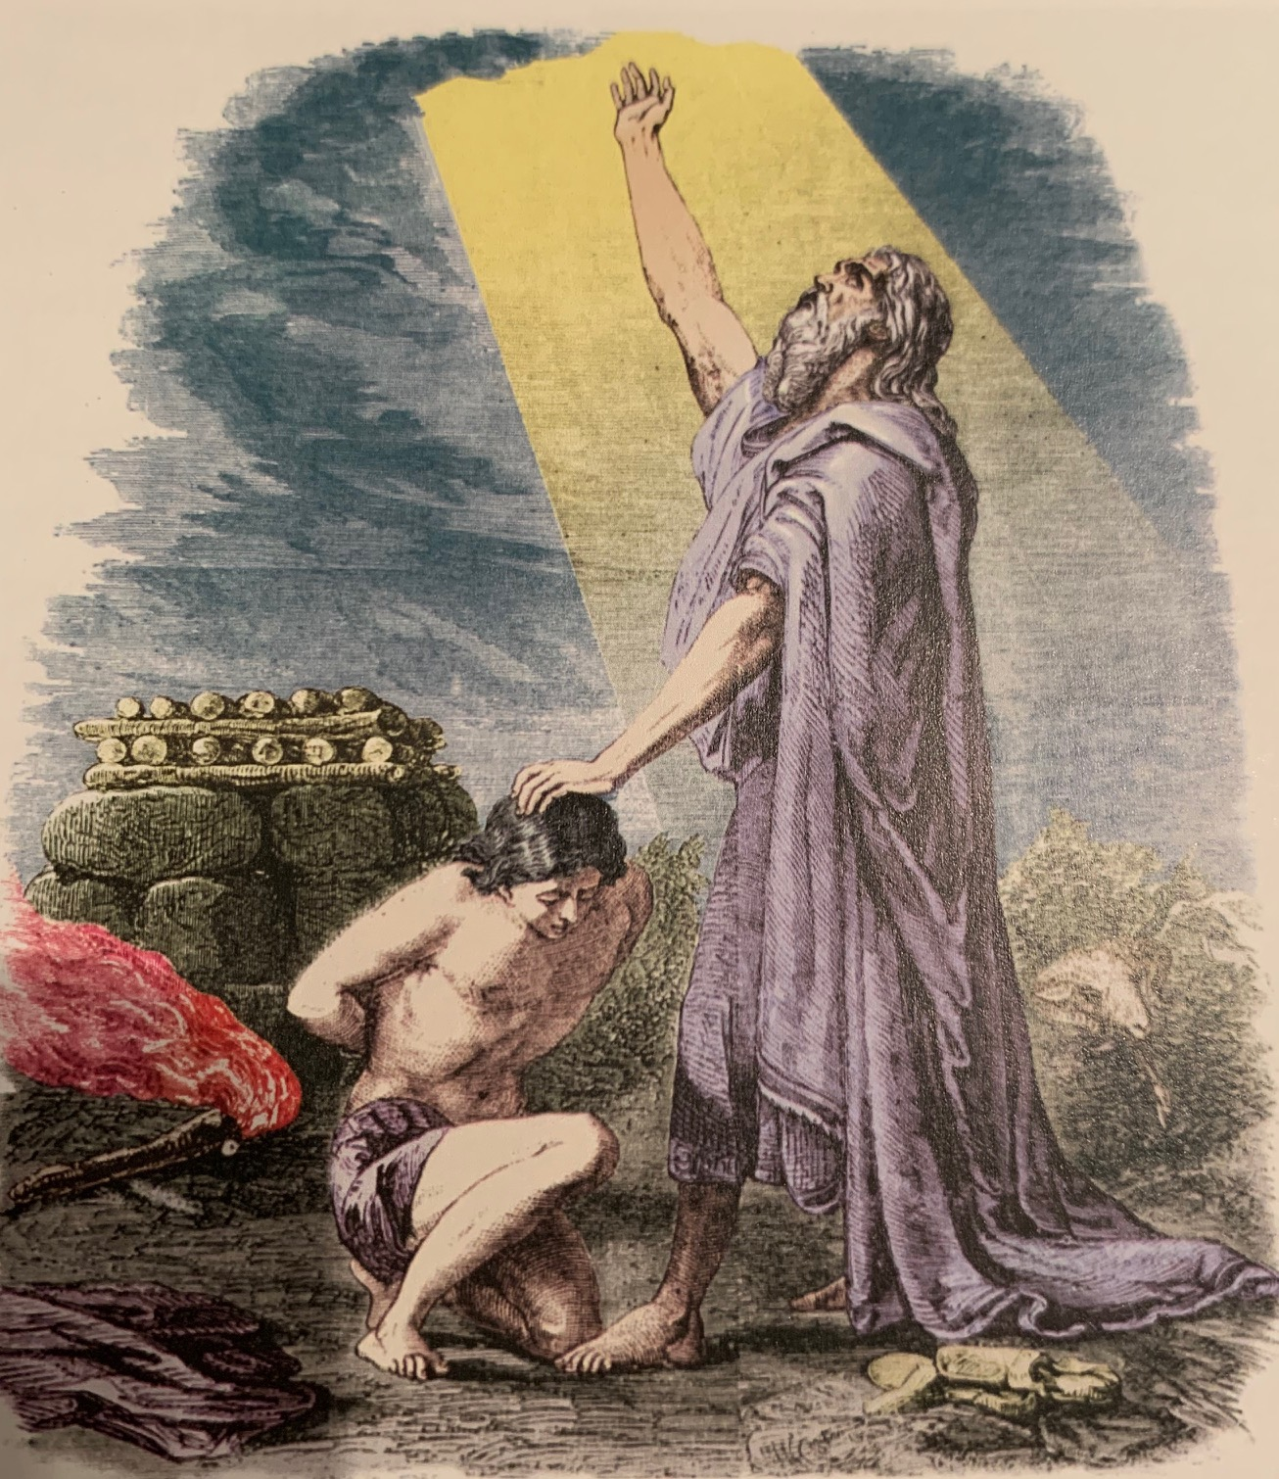

Verse 11—But the angel of the Lord called to him from heaven and said, “Abraham, Abraham!” And he said, “Here I am.”—This call from heaven reflects the initial call of verse 1. God tested Abraham, and said to him, “Abraham!” And he said, “Here I am.” Unlike verse 1, there is a tone of intensity through the repetition of the name. Abraham was to do no harm to the lad. Abraham did not know this entire episode was a test. It surely was unimaginable and its unpredictability made it a staggering test for Abraham. The long awaited son would not become a victim of sacrifice. God’s sudden intervention would make it clear that this was a test after all.
- And he said, “Here I am”—When Abraham said here I am, in Genesis 22:1, his life was full of God’s blessings. His dreams and promises had been received. It was a time when he was enjoying the blessings of the Lord. But when he said, “here I am” in Genesis 22:11, he had offered his son, his only son, his love. His only son represented his only hope and influence over his future, and his love represented all his soul and mind. But Abraham was still responsive to whatever the Lord had to say to him.

An Application—There is something you should know about God. He tests people. He tests His own people. He tests the faithful, the saints, those who are following Him closely, those who are in the center of His will. Why does He test His own faithful people? James says it’s to demonstrate their faith (James 1:2-4; 2:21-24). Jesus said to Simon Peter, “Simon, Simon, behold, Satan has demanded permission to sift you like wheat; but I have prayed for you, that your faith may not fail; and you, when once you have turned again, strengthen your brothers” (Luke 22:31-32). How does God test people? By bringing them to the edge, then seemingly over the edge, where there is no return, no rescue, no reasonable hope, seemingly no hope at all. Then in the midst of what would appear to be a situation of despair, at the last minute, God delivers.

Verse 12—He said, “Do not stretch out your hand against the lad, and do nothing to him”—Now the divine instructions prevented Abraham from doing any harm to the child. In essence, God was saying “do not extend your hand toward the boy.”
- “for now I know that you fear God, since you have not withheld your son, your only son, from Me”—The joyful knowledge God gained through this test was that Abraham feared God. He did not withhold his son, your only son, from Me. Truly fearing the Lord was demonstrated by Abraham’s compliance with the Word of God, no matter the cost. He was not commended for obeying but for fearing. Apparently, obeying God is a component of fearing God.

An Application—The primary reason we should fear God is because we are commanded to. Yet there is a logical reason why God wants us to fear Him. Fear inspires obedience. And by the fear of the LORD one keeps away from evil (Proverbs 16:6, see also Exodus 20:20). It is when we do not live in the fear of the Lord that our hearts envy sinners (Proverbs 23:17), which is why Solomon says, after extensively evaluating life, the conclusion, when all has been heard, is: fear God and keep His commandments, because this applies to every person (Ecclesiastes 12:13-14).
Verse 13—Then Abraham raised his eyes and looked, and behold, behind him a ram caught in the thicket by his horns—God had provided an alternative sacrifice in place of Abraham’s son, Isaac. Abraham noticed a ram caught in the thicket by his horns.
- And Abraham went and took the ram and offered him up for a burnt offering in the place of his son—Abraham eventually offered a sacrifice, an act of devotion, in the form of a burnt offering in the place of his son. Abraham was cognizant of the fact that it was his son who was to have been sacrificed.

Verse 14—Abraham called the name of that place ‘The Lord Will Provide’—The commemorative naming of the place by Abraham indicated that the discovery of the sacrificial ram was not interpreted by the patriarch as mere chance, but that the Lord provided the animal for sacrifice. The motivation for the name came from verse 8, God will provide. By so naming the place Abraham preserved in the memory of God’s people the amazing event that took place there.
- As it is said to this day, “In the mount of the Lord it will be provided”—The saying connected with these events has some ambiguity, which was probably intended. If the mount refers to the Temple Mount later in the nation’s history, then the point of the epitaph would be “the Lord provides” just as he did for Abraham with the sacrificial ram. The acts of worship in Jerusalem at the holy mount would be perpetual experiences of the Lord’s provision for His people. The Lord would see their needs, answer their prayers, and provide their needs. In turn, the people would bring sacrifice praise, and worship in response to Gods faithful provision.

Verses 15-18—Then the angel of the Lord called to Abraham a second time from heaven—After the event was finished the angel of the Lord called out from heaven to Abraham. This could possibly be a Christophony where the Lord himself appeared to Abraham with this instruction.
- And said, “By Myself I have sworn, declares the Lord, because you have done this thing and have not withheld your son, your only son”—The angel of the Lord reiterated the promised blessings, but now added a solemn oath, by Myself I have sworn. The reassurance of the promises was given, but only after the sacrifice of the substitute. The fullness of provision was based upon Abraham’s obedience, because you have done this. Again, notice the repeated acknowledgement of the test of obedience. Abraham offered and have not withheld your son, your only son! God took notice of such a great sacrifice.
- Indeed, I will greatly bless you and I will greatly multiply your seed as the stars of the heavens and as the sand which is on the seashore—The blessing of the Lord is reiterated. Abraham can expect bounty and fertility. The Lord promises that Abraham’s descendants will be as numerous as the stars and the sand. Whether he gazes into the night sky or reflects on the Mediterranean shore, he will be reminded of the promise.
- and your seed shall possess the gate of their enemies. In your seed all the nations of the earth shall be blessed—Here is prophecy related to Abraham’s descendants, the 12 tribes of Israel. Not only would they be numerous, they would possess the gate of their enemies. To break through the gate complex would be to conquer the city, for the gate complex was the main area of defense. In practical terms for the nation, Abraham’s seed would dispossess the Canaanites, just as the way of faith in fearing God would be victorious over the Canaanitish way.
- because you have obeyed My voice— Abraham’s obedience brought God’s ratification of the earlier conditional promise that became unconditional by his obedience to depart his homeland and enter the unfamiliar land of Canaan. Again, we can note the relationship between Abraham’s faith and his obedience.

An Application—What you do is what you believe. No one can say ‘just do what I say, not what I do’ as if that settles what it is one believes. That is an oxymoron—it is self-contradictory. Your belief is expressed by your actions. James says, even so faith, if it has no works, is dead, being by itself (James 2:17). Abraham proved his faith by his obedience.

Implications for the 12 tribes
- When the sons of Israel, the 12 tribes, reached Mt. Sinai, in the third month after they had gone out of the land of Egypt, God said to Moses, “Assemble the people to me that I may let them hear My words so they may learn to fear me all the days they live on the earth and that they may teach their children” (Deuteronomy 4:10). If our goal is to learn to fear God, the first step is to hear His words, which, for us, means studying the Bible, since these are the only words from God which we have today. Solomon says in Proverbs 2:1-5, IF you: (1) will receive my sayings, And (2) treasure my commandments within you,(3) Make your ear attentive to wisdom, (4) Incline your heart to understanding; For if you (5) cry for discernment, (6) Lift your voice for understanding; If you (7) seek her as silver, And (8) search for her as for hidden treasures; THEN you will discern the fear of the LORD, and discover the knowledge of God.
- Naming specific sacred places would preserve in the memory of the 12 tribes the incident that had occurred there, and establish it as a shrine to the faith and the faithfulness of God.
- The 12 tribes could expect to be tested by God to prove their faith. The expectation would be that they, too, would recognize that God was the Lord of the promise.
- The 12 tribes would learn that God would not ask true worshipers to give Him that which they do not treasure or that which they no longer care for or need. Rather, God would require they offer Him the best they have, even their firstborn in sacrifice.

The History of the Twelve Tribes of Israel

The 12 tribes of Israel were the family groups descended from the biblical patriarch Jacob. The tribes are important because God worked through the tribes to fulfill His promises—especially the promise of bringing from the tribe of Judah, Jesus the Savior, the Lion of Judah. Behold, the Lion that is from the tribe of Judah, the Root of David (Revelation 5:5). The 12 sons of Jacob were offspring of two of his wives and two concubines. The promises to Abraham of a land, people, and blessing would be passed onto these family groups. The future nation of Israel would be identified by these 12 sons of Jacob.
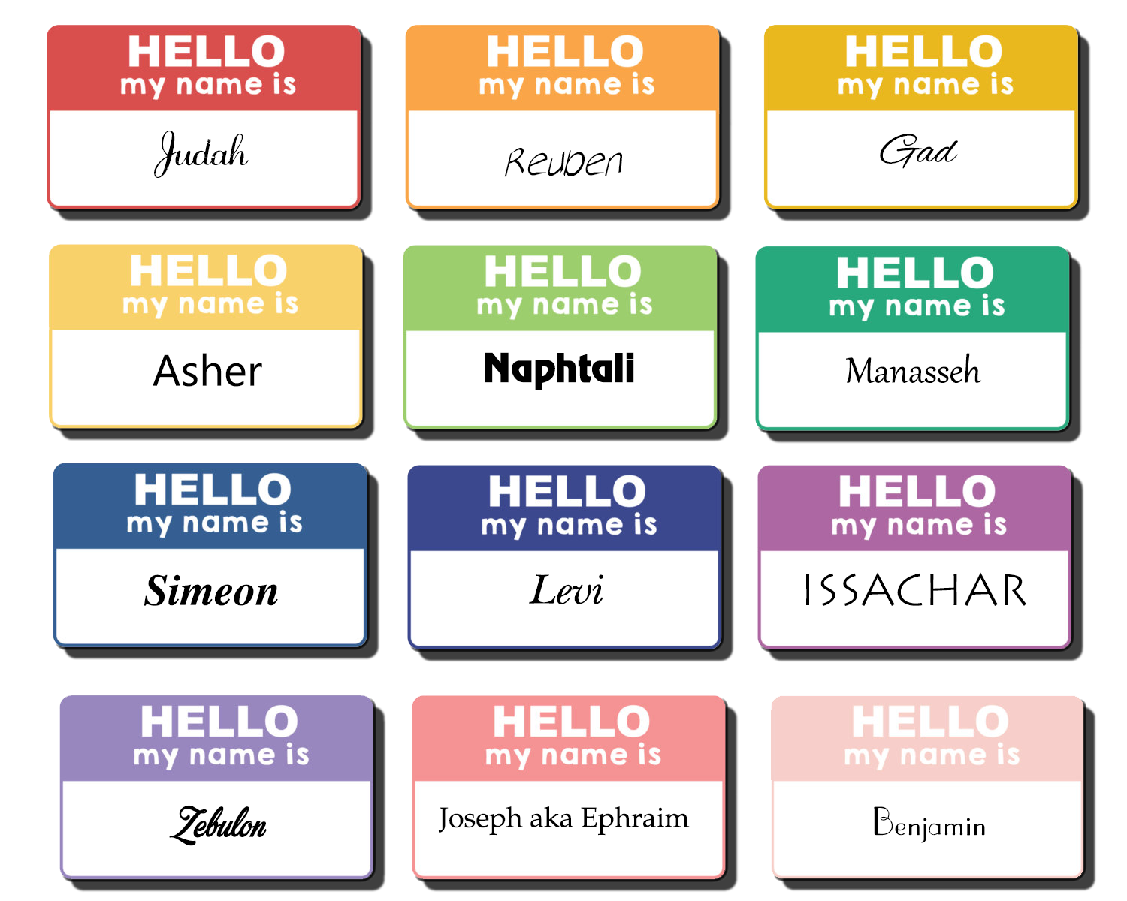

Genesis 37 — Joseph’s Leadership Over the Family
This chapter provides the introduction to the Joseph story in that it lays the foundation for the crisis between Joseph and his brothers. It foreshadows, through Joseph’s dreams, the final resolution to the family crisis. The story develops further the history of the patriarchal family with its old animosities and its propensity to deceptive practices. The Joseph story, like the Jacob story, is constructed around a journey out of the land, which was caused by deception within the family.

Unlike Jacob, Joseph’s return to the Land is not reported in the story but rather the story ends with preparation for the exodus of the family out of Canaan into Egypt. Joseph, like Jacob, endured a twenty-year period of separation from the family and ended it with a reconciliation with his brothers. However, they came to Egypt. Joseph did not return home. Like Esau, the brothers exhibited a profound change from their earlier hatred of Joseph.

The story of Joseph serves as a paradigm for the for the future 12 tribes’ own experience as a nation. Just as Joseph lived in bondage in Egypt before his deliverance and supremacy over Egypt, so would the nation. Just as suffering and the bondage formed tests for Joseph to see if he would keep faith and was worthy of the promise, so, too, the bondage of the nation was a means of discipline and preparation for the nation’s future responsibilities. In the end, Joseph and the 12 tribes served a God who was infinitely superior to Egypt—one who controlled Egypt’s economy and whose wisdom outstripped the wisdom of Egypt. This reality would be evidenced in the nation once they settled in the Land of Promise.

In Genesis 37 is the report of Joseph’s dreams, which reveal God’s call and choice of Joseph to lead the nation. The immediate effect of this choice was the jealousy and hatred of his brothers. This jealousy eventually turned into murderous hatred. Joseph is portrayed as simply faithfully serving his father’s interests. When God chooses someone to lead, there may be envy and jealousy of the choice, and even bitter hatred, by those who may feel more qualified to have the position of leadership. The one chosen must be careful not to give occasion to find fault.
Joseph Is Destined to Lead
Joseph, when seventeen years of age, was pasturing the flock with his brothers while he was still a youth, along with the sons of Bilhah and the sons of Zilpah, his father’s wives. And Joseph brought back a bad report about them to their father. Now Israel loved Joseph more than all his sons, because he was the son of his old age; and he made him a varicolored tunic. His brothers saw that their father loved him more than all his brothers; and so they hated him and could not speak to him on friendly terms. Then Joseph had a dream, and when he told it to his brothers, they hated him even more. He said to them, “Please listen to this dream which I have had; for behold, we were binding sheaves in the field, and lo, my sheaf rose up and also stood erect; and behold, your sheaves gathered around and bowed down to my sheaf.” Then his brothers said to him, “Are you actually going to reign over us? Or are you really going to rule over us?” So they hated him even more for his dreams and for his words. Now he had still another dream, and related it to his brothers, and said, “Lo, I have had still another dream; and behold, the sun and the moon and eleven stars were bowing down to me.” He related it to his father and to his brothers; and his father rebuked him and said to him, “What is this dream that you have had? Shall I and your mother and your brothers actually come to bow ourselves down before you to the ground?” His brothers were jealous of him, but his father kept the saying in mind (Genesis 37:2-11).

Verse 2—Joseph, when seventeen years of age, was pasturing the flock with his brothers while he was still a youth, along with the sons of Bilhah and the sons of Zilpah, his father’s wives—The beginning of the story portrays Joseph as a faithful young son. The occasion for this portrayal is Joseph keeping his father’s flocks along with some of his brothers: Dan and Naphtali, Gad, and Asher.
- And Joseph brought back a bad report about them to their father—Joseph delivered a report of their evil deeds to Jacob. This is the first glimpse of the evil activity of Joseph’s brothers. This ‘bad report’ implies the brothers, particularly Dan, Naphtali, Gad, and Asher in this instance, were participating in some serious wicked behavior.
PT—Such a report would not be popular and before the story gets very far, the brother’s evil will be turned upon Joseph. On the one hand, Joseph is being faithful to his father. On the other hand, he will suffer at the hand of his brothers for being a sort of tattletale because they take the evil lightly.

An Application—Joseph was faithful to his father in little things, even though unpopular—and so he will eventually be given authority over greater things. Those who would be leaders must prove faithful in the smaller responsibilities.

Verse 3—Now Israel loved Joseph more than all his sons—This information explains in part the brother’s animosity toward Joseph. The statement brings forward a motif that played an important role in the family of Isaac—parental favoritism. Jacob surely knew what that had done to him and his brother Esau, and to his own family. But now he showers affection on Rachel’s son Joseph. Favoritism had a long history in Jacob’s family (Isaac’s preference for Esau, Rebekah’s for Jacob, and Jacob’s preference for Rachel). In every case, it created major problems. Leah was hated, and her sons hated (cf. 29:31, 33)
- because he was the son of his old age—Son of his old age means wise son or son of wisdom. Joseph was old for his years. He had the wisdom of age in his youth. Joseph was born when Jacob was 91 years old, but he was not Jacob’s youngest son. Benjamin, one of Joseph’s brothers, was younger than he.
- and he made him a varicolored tunic—Jacob’s love was expressed in giving Joseph a distinctive tunic. Rather than the traditional understanding of a ‘coat of many colors’ it most likely described a sleeved coat that reached to the wrists and ankles. In any case, this tunic set Joseph apart from the rest of the clan as the favored one.
PT—One would think that Jacob would have remembered his own childhood and early days of marriage and what a display of favoritism would do to his family. It had separated him from his mother, and now it would separate him from Joseph. His decision doomed his family to the same strife he had experience in his father’s household.

Verse 4—His brothers saw that their father loved him more than all his brothers—Joseph’s brothers observed exactly what was going on between Jacob and Joseph. What they knew was that Joseph was their father’s personal favorite.
- and so they hated him and could not speak to him on friendly terms—What is interesting is that they hated Joseph, but not Jacob. This was not unlike Cain and Abel, when Cain attacked Abel, not God. The envious usually turn their animosity toward the one who is favored. The hatred was so palpable that the brothers could not even speak to Joseph on friendly terms.
PT—The outcome of this incident reveals that Jacob acted unwisely. If the tunic anticipates Jacob’s bestowing the birthright upon Joseph, it was a premature and insensitive way to demonstrate it. The birthright would belong to Joseph, the eldest son of Rachel, due to Reuben his eldest son, forfeiting it. But Jacob had exposed Joseph to the envy of his brothers, and years of personal affliction for both himself and his son, due to distinguishing Joseph in this way.

Verse 5—Then Joseph had a dream—These dreams were revelations from God. God used dreams to predict the rule of Joseph over his family. God confirmed Jacob’s choice of his faithful son to be the leader. Joseph had two dreams—one introduced his role as leader and the other reiterated that role.
- and when he told it to his brothers, they hated him even more—Joseph regarded the dreams as important and so reported them to his family. The unfortunate outcome is that they hated him even more.

Verses 6-7—He said to them, “Please listen to this dream which I have had; for behold, we were binding sheaves in the field”—The first dream had agricultural symbolism, possibly anticipating the manner by which Joseph would come to power in Egypt.
- “and lo, my sheaf rose up and also stood erect; and behold, your sheaves gathered around and bowed down to my sheaf”—The key idea of the dream is that the symbols of the brothers in the dream bowed down to Joseph, showing an act of submission. The report is vivid: stood erect…and bowed down, making the report both striking and animated.

Verse 8—Then his brothers said to him, “Are you actually going to reign over us? Or are you really going to rule over us?”—They questioned the audacity of Joseph to actually suggest such a thing. Their interpretation of the dream was correct, and so they forcefully scoffed at such an idea. It is as if Joseph’s brothers said, ‘You don’t really think you will rule over us, do you? You don’t really think you will have dominion over us, do you?’
- So they hated him even more for his dreams and for his words—In response to this dream report, the brothers hated Joseph all the more. The dream bothered them, as well as his telling them. One would think that Joseph would ‘get it’ by now and now incite his brothers all the more. However, it is God who is moving the narrative along and forcing the brothers to have to come to terms with God’s choice in the matter.

Verse 9—Now he had still another dream, and related it to his brothers—God continues His revelation of Joseph’s status within the family, and thus, among the 12 tribes. The dream would indicate this was more than just Joseph’s opinion—it was God speaking. Since it is a second dream, God, with the repetition, is underlining His choice of Joseph.
- “Lo, I have had still another dream; and behold, the sun and the moon and eleven stars were bowing down to me”—This dream, using celestial images, is just a vivid as the first. The sun, moon, and stars are easily recognized for the significance for rulership. This dream, with the symbols bowing down in acts of submission, also symbolized the exaltation of Joseph over his whole family. Incidentally, the brothers would also have positions of authority and leadership, as the symbol of the stars represented, but that point was missed when all they saw was the supremacy of Joseph.

Verse 10—He related it to his father and to his brothers; and his father rebuked him and said to him—Jacob took note of these revelations but resented the possibility that his son might be in a position of authority over him. At first he reacted strongly, rebuking his son. The question of who should rule can be offensive to others, even to those closest to you.
- “What is this dream that you have had?”—The question: What is this dream that you have had? expressed Jacob’s dismay at what he perceived to be Joseph’s audacity.
- “Shall I and your mother and your brothers actually come to bow ourselves down before you to the ground?”—It is as if Jacob said, ‘You don’t really think we will come…to bow down…do you?’ Both the brothers and the father react similarly. The brothers were incredulous at the prospect of their brother ruling over them. Jacob was skeptical of the family bowing down in submission to Joseph’s leadership.
PT—God chooses faithful, righteous individuals for positions of leadership, but those chosen may experience the jealous hatred from their brethren. Many people today also are offended by God’s election of some to special prominence and usefulness. The choice of Joseph marked a change from the normal societal order but did not differ from previous narratives in which the younger son was made lord over his older brother.

Verse 11—His brothers were jealous of him—Joseph’s brothers were already jealous of him, but this made it even worse. Such jealousy easily leads to action, as the next episode in the story shows. Yet dreams were considered a form of revelation, and their jealousy was not only of the favoritism of their father, but of the dreams.
- but his father kept the saying in mind—After his initial reaction, Jacob then observed the saying. Apparently, Jacob kept the matter in mind due to the possibility that the dreams were actually revelation from God. He would have observed the repetition of his own beginnings in the beginnings of Joseph’s career. He would personally have known that God would select the younger over the older, declaring His choice in advance by oracle or dream.
PT—His brothers hated Joseph before he ever had a vision (37:4). When he had the dreams, he simply made them known. Should we not make known the Word of God as we learn it? We know little about Joseph’s maturity or motives at this time, so there is no point in guessing. What we do know is he was (1) truthful, (2) honest, (3) obedient to his father (verse 13), and (4) he made known the Word of God, and he did that even when it caused him to be rebuked by his father and hated even more by his brothers. We should not go about preaching to everybody. But there are many significant occasions where we should make known the Word of God to those close to us, even if it affects our social standings with those people.
An Application—God will choose a faithful, righteous person for a position of leadership and influence in spite of the jealousy of others around him. Chosen leaders must discharge their duties faithfully. Those who must submit, even if they feel more qualified, must not become jealous nor let jealousy turn into cruel hatred.

Implications for the 12 Tribes
- The 12 tribes would learn that God had chosen Joseph to be elevated so as to rule over his brothers.
- Like the original brothers, their posterity would create conflict due to envy and hatred, based upon the tension created by the positioning of the tribes in the Land.
- God would continue to sovereignly select faithful righteous leaders among the tribes who would lead honorably in accord with God’s commands. The people must not set themselves against them—whether judges, priests, kings, or prophets.
- There would be no place in leadership for such uncontrollable hatred and envy as noted amongst the tribal family of Jacob. However, leaders will unfortunately often face such opposition.

Joseph Is Sold into Bondage at the Hands of His Brothers
When they saw him from a distance and before he came close to them, they plotted against him to put him to death. They said to one another, “Here comes this dreamer! Now then, come and let us kill him and throw him into one of the pits; and we will say, ‘A wild beast devoured him.’ Then let us see what will become of his dreams!” But Reuben heard this and rescued him out of their hands and said, “Let us not take his life.” Reuben further said to them, “Shed no blood. Throw him into this pit that is in the wilderness, but do not lay hands on him”–that he might rescue him out of their hands, to restore him to his father. So it came about, when Joseph reached his brothers, that they stripped Joseph of his tunic, the varicolored tunic that was on him; and they took him and threw him into the pit. Now the pit was empty, without any water in it. Then they sat down to eat a meal. And as they raised their eyes and looked, behold, a caravan of Ishmaelites was coming from Gilead, with their camels bearing aromatic gum and balm and myrrh, on their way to bring them down to Egypt. Judah said to his brothers, “What profit is it for us to kill our brother and cover up his blood? Come and let us sell him to the Ishmaelites and not lay our hands on him, for he is our brother, our own flesh.” And his brothers listened to him. Then some Midianite traders passed by, so they pulled him up and lifted Joseph out of the pit, and sold him to the Ishmaelites for twenty shekels of silver. Thus they brought Joseph into Egypt (Genesis 37:18-28).

Verse 18—When they saw him from a distance and before he came close to them, they plotted against him to put him to death—In contrast to Joseph’s faithful obedience (vv. 12-17) is the plotting of his brothers. The plotting was instigated by Joseph’s impending arrival. On his way, while approaching his brothers from a distance, they deliberately planned to put him to death.
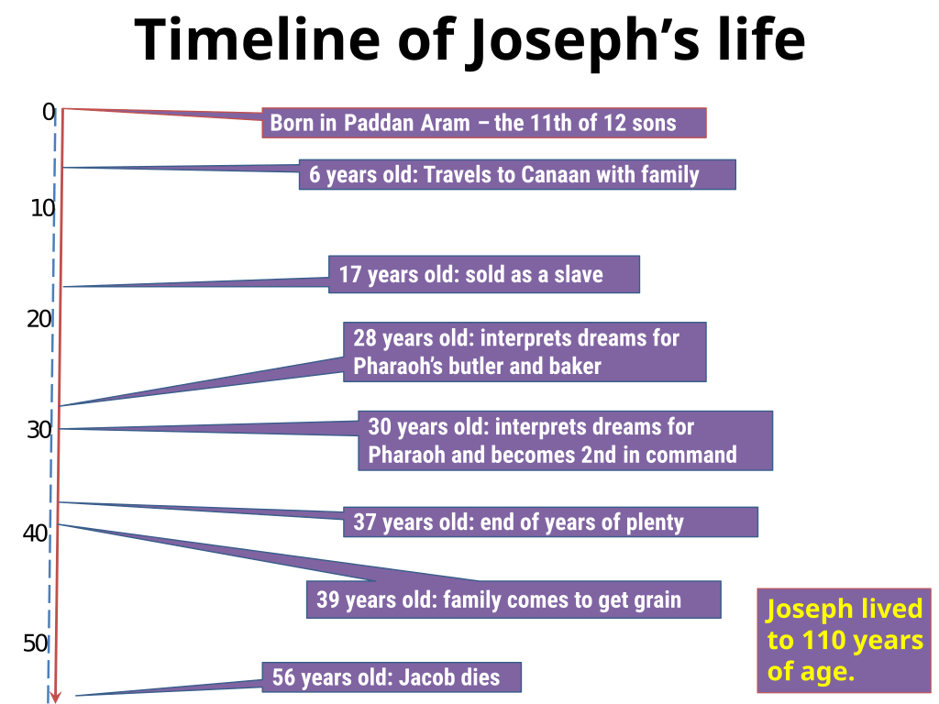

Verse 19—They said to one another, “Here comes this dreamer!” They conspired to kill him, to end his dreams. In their sarcasm, they are resentful, indignant, and full of contempt. There is absolutely no consideration whatsoever of God’s revelation in dreams to Joseph. Their hatred and rivalry simply dismisses God from the equation in pursuit of their own dreams.

Verse 20—“Now then, come and let us kill him and throw him into one of the pits”—Their hatred culminates in a plan to murder Joseph. The plan was to slay him and then throw him into some pit where he could be disposed of.
- and we will say, ‘A wild beast devoured him’—The plan included lying about their crime. Except for the slaying of Joseph, this plan was carried out.
- “Then let us see what will become of his dreams!”—The extreme measures Joseph’s brothers considered to silence him may not just have been personal hatred springing from jealousy, but they may have wanted to alter the will of God as revealed in Joseph’s dreams as well. The brothers’ hate is, therefore, a rebellion against the matter contained in the dreams, against the Divine power itself, standing behind them, who had given the dreams.

An Application—Those who determine to faithfully discharge the will of God can expect to be opposed by those who want to violate the will of God. That may even include intrigue, treachery, deception, and persecution in order to prevent God’s servant from fulfilling that will. The ridicule and opposition can even come from those closest to you in family or ministry.

Verse 21—But Reuben heard this and rescued him out of their hands and said, “Let us not take his life”—The entire murderous plan was changed by Reuben, Jacob’s firstborn. It is possible that the instigators of this plot, the ones from whom Reuben rescued him [Joseph] out of their hands, were Dan, Naphtali, Gad, and Asher, the sons of Bilhah and Zilpah, the handmaidens of Rachel and Leah, who were the one’s Joseph’s evil report was about (v. 2).

Verse 22—Reuben further said to them, “Shed no blood.” Reuben exhorted them not to kill the lad. This reiterates further the stark plan that had been concocted to execute Joseph. The raw and evil hatred is exposed by Reuben’s plea.
- “Throw him into this pit that is in the wilderness, but do not lay hands on him”—Reuben’s speech was a commendable corrective of the brother’s plan. The verbs translated shed, throw, and lay sound alike in Hebrew. The repetition of similar sounds draws attention to Reuben’s words, making the speech a memorable one in the narrative. The question is, will it make a difference?
- that he might rescue him out of their hands, to restore him to his father—Reuben, as the firstborn, looked after his father’s interests and, knowing what sorrow Joseph’s death would bring to Jacob, sought to spare Joseph’s life and release him from the pit later. Perhaps Reuben wanted to get back in the good graces of his father after his folly with his father’s concubines (cf. 35:22).

Verse 23—So it came about, when Joseph reached his brothers, that they stripped Joseph of his tunic, the varicolored tunic that was on him—All of this intrigue and planning and subsequent altering of those plans took place while Joseph was drawing near to the brothers. Reuben’s advice was accepted. Joseph is oblivious to the hateful plan. In the heat of passion, while Joseph arrives, they stripped him of his tunic. Specifically, and as if to make a special point of it, the brothers stripped Joseph of the varicolored tunic that was on him. Why Joseph was wearing the coat is not clear, but the site of it on him surely incited the brothers to act with contempt against Joseph.

Verse 24—and they took him and threw him into the pit—This is the third mention of the pit, striking an ominous note throughout of the impending disaster awaiting Joseph. The act of taking Joseph was in essence an attack upon him, and then they threw him into the pit, most likely in disgust and rage.
- Now the pit was empty, without any water in it— Here is supplemental information that helps the reader or hearer to picture what happened. Joseph’s place of confinement was evidently a dry well or cistern.

Verse 25—Then they sat down to eat a meal—It is remarkable that the brothers were then able to sit down to eat a meal after such an escapade. It is ironic that they would plan to say that an evil beast had devoured Joseph, and after they attacked him, they sat down to eat. The text thus signifies what evil beasts actually attacked Joseph. The next time the brothers would eat a meal in Joseph’s presence, he would sit at the head table (43:32-34).
- And as they raised their eyes and looked, behold, a caravan of Ishmaelites was coming from Gilead, with their camels bearing aromatic gum and balm and myrrh, on their way to bring them down to Egypt—With the approaching of this carava, a new plan was devised to rid them of the problem of Joseph. The narrator, Moses, invites the reader to see the event through the eyes of the brothers—they raised their eyes and looked. The solution would be a caravan on their way to Egypt.

Verse 26—Judah said to his brothers, “What profit is it for us to kill our brother and cover up his blood?”—Judah, like Reuben, did not relish killing Joseph. Yet he was not willing to let him go free either.

Verse 27—“Come and let us sell him to the Ishmaelites”—His speech, the third of the brothers’ decisions, called for the sale of Joseph. His suggestion that the brothers sell Joseph implies that he knew slave trading was common in Egypt. Ishmaelite is the more generic term for groups of Bedouin nomads. It became a general designation for desert tribes.
- “and not lay our hands on him, for he is our brother, our own flesh”—They acknowledged Joseph as their brother, but an even greater recognition is noted in their knowledge of Joseph as their own flesh and blood.
- “And his brothers listened to him”—They may not lay their hands on him in a murderous plot, but their hands are bloody with the removal of his presence from the family by selling him into slavery.
PT—Although this speech was designed to lessen the crime by selling their brother rather than murdering him, it ultimately underscored how wicked their deed was—they sold their brother, their own flesh and blood.

Verse 28—Then some Midianite traders passed by, so they [Joseph’s brothers] pulled him up and lifted Joseph out of the pit—It was Joseph’s brothers who pulled Joseph up and lifted him out of the pit they had tossed him into.
- and sold him to the Ishmaelites for twenty shekels of silver—He was then sold to the Midianite traders who were part of the Ishmaelite caravan. Joseph was thus treated harshly by his brothers but was preserved alive nonetheless. They all were involved in the crime, even Reuben and Judah. They were all in opposition to the Divine plan. They had not only sold their brother, but in their brother they had cast out a member of the seed promised and given to Abraham, Isaac, and Jacob, from the fellowship of the chosen family, and sinned against the God of salvation and His promises.
PT—The text passes over Joseph’s suffering, concentrating on the brothers’ wickedness. However, we get a glimpse of Joseph’s terror when the brothers are finally confronted with their wicked deed in Joseph’s court in Egypt twenty years later. Then they said to one another, “Truly we are guilty concerning our brother, because we saw the distress of his soul when he pleaded with us, yet we would not listen; therefore, this distress has come upon us” (Genesis 42:21). They confessed to each other that, because they heard Joseph’s cries for mercy and would not respond (probably when they attacked him and cast him into the pit, and when they pulled him out and sold him off), distress had now come upon them.

An Application—God will accomplish His purposes no matter the opposition against it. Those willing to participate in the will of God cannot be prevented from fulfilling their God-given destiny. In spite of envy and hatred, the spiritual leader can rest assured that God may use the opposition in working out His will.

Implications for the 12 Tribes
- This serves as a warning about the 12 brothers’ motivation by treachery and deception to conspire against Joseph, the faithful son, to rid themselves of the favored son, to perhaps open the way for a better status for themselves.
- That the blessing of God will not go to the ones who conspire to get that blessing outside of the will of God.
- That God’s choosing of a leader amongst the tribal families cannot be so easily altered no matter what the people may think of God’s choice.
- That God may intervene against the intrigues marshalled against His will and utilize even strange circumstances and voices of moderation to move things along to eventual fulfilment of God’s will.

Genesis 48 — Joseph’s Sons Gain Prominence
Out of Jacob’s long career, the writer of Hebrews selected this incident in this chapter as his greatest act of faith. By faith Jacob, as he was dying, blessed each of the sons of Joseph, and worshiped, leaning on the top of his staff (Hebrews 11:21). That greatest act of faith was his reaching out to the future of the promise in the face of death as he blessed the younger over the older. There is irony in the fact that this incident is comparable to the situation in which he had received the blessing himself over his brother Esau. Once more, the blessing was given to the younger, but this time there was no deception or bitterness.

Jacob Blesses Ephraim and Manasseh
Joseph took them both, Ephraim with his right hand toward Israel’s left, and Manasseh with his left hand toward Israel’s right, and brought them close to him. But Israel stretched out his right hand and laid it on the head of Ephraim, who was the younger, and his left hand on Manasseh’s head, crossing his hands, although Manasseh was the firstborn. He blessed Joseph, and said,
“The God before whom my fathers Abraham and Isaac walked, The God who has been my shepherd all my life to this day, The angel who has redeemed me from all evil, Bless the lads; And may my name live on in them, And the names of my fathers Abraham and Isaac; And may they grow into a multitude in the midst of the earth.” When Joseph saw that his father laid his right hand on Ephraim’s head, it displeased him; and he grasped his father’s hand to remove it from Ephraim's head to Manasseh’s head. Joseph said to his father, “Not so, my father, for this one is the firstborn. Place your right hand on his head.” But his father refused and said, “I know, my son, I know; he also will become a people and he also will be great. However, his younger brother shall be greater than he, and his descendants shall become a multitude of nations.” He blessed them that day, saying, “By you Israel will pronounce blessing, saying, ‘May God make you like Ephraim and Manasseh!’” Thus he put Ephraim before Manasseh. Then Israel said to Joseph, “Behold, I am about to die, but God will be with you, and bring you back to the land of your fathers. I give you one portion more than your brothers, which I took from the hand of the Amorite with my sword and my bow"” (Genesis 48:13-22).

Verse 13—Joseph took them both, Ephraim with his right hand toward Israel’s left, and Manasseh with his left hand toward Israel’s right, and brought them close to him—Arranging Manasseh and Ephraim in the normal order for Jacob’s blessing, by their age, Joseph then brought them forward again. Joseph brought the sons in this order so that Manasseh would receive the first blessing.

Verse 14—But Israel stretched out his right hand and laid it on the head of Ephraim, who was the younger—When Jacob prepared to announce the blessing on the sons, he wittingly guided his right hand so that it was on Ephraim’s head. Here was the man of God at the brink of death, passing on the blessing—a hope for the future. But there is also Jacob’s recognition that the elder would serve the younger, so he would cross his hands in the blessing.

PT—It had taken Jacob a lifetime of discipline to learn this truth about God. In his early years, he had deceived his blind father for the blessing, but in his duty now of passing on the blessing, he performed in the way that God wanted—blessing the younger over the elder. This same scenario had played out in the womb of his mother Rebekah concerning Jacob’s destiny. The Lord said to her, “Two nations are in your womb; And two peoples will be separated from your body; And one people shall be stronger than the other; And the older shall serve the younger” (Genesis 25:23).

—and his left hand on Manasseh’s head, crossing his hands, although Manasseh was the firstborn—Even though Manasseh was the first one born, Jacob purposely crossed his hands so that Ephraim and not Manasseh would receive the blessing of the firstborn. He would not attempt to bless the wrong one, as his father had attempted to do—nor would he handle the blessing dishonestly. This time it was done all out in the open, in accord with God’s plan.
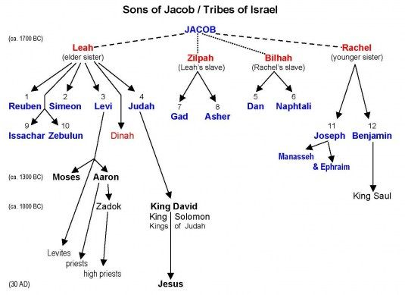
PT—By this symbolic act, a person transferred a spiritual power or position to another. This rite was part of the ceremony of dedicating a person or group either to a responsibility or to some type of office and role (Numbers 27:18, 23; Deuteronomy 34:9). This was the fourth consecutive generation of Abraham’s descendants in which the normal pattern of the first one born assuming prominence over the second born was reversed: Isaac over Ishmael, Jacob over Esau, Joseph over Reuben, and Ephraim over Manasseh.

Verse 15—He blessed Joseph, and said, “The God before whom my fathers Abraham and Isaac walked”—Jacob’s blessing began with the threefold invocation, beginning with God as the God of the fathers Abraham and Isaac. This reality had steadied Jacob’s faith at times in his life (28:13; 31:5, 42; 32:9; 46:3). The fathers had walked before God, living out their faith in their daily lives—a record of which we have.
- The God who has been my shepherd all my life to this day—This is the second of the threefold invocation of the same God who had protected and guided him all my life to this day. Looking back, he could discern the hand of his Sovereign God preserving his life in fulfillment of the Promise.

An Application—We cannot know what God is up to in the details of life. His plan is only discernable after the fact—when we can look back to discover His handiwork, and marvel at the fusion of our daily circumstances with God’s sovereign work in our lives to fulfill His plan.

Verse 16—The angel who has redeemed me from all evil—This is the third of the threefold invocation where Jacob closely associated God with an angelic protective presence. This does not mean that Jacob viewed his God as a mere angel, but it does suggest that he was aware of an angelic presence sent by God to protect him.
PT—These remarkable descriptions reveal Jacob’s faith—one that had matured through the years and that had learned to trust the Lord in the difficulties of life.

- Bless the lads—This is the official beginning of the transfer of Jacob’s blessing to the two sons of Joseph.
- And may my name live on in them—Jacob wanted his name to be associated with the favor God would shower upon the sons of Joseph. In essence, he is asking that his name be recalled as their posterity experiences the blessings of the promise.
- And the names of my fathers Abraham and Isaac—Those blessings would always be associated with the patriarchal forefathers who were the forerunners of the blessings passed on to Jacob, and now on to his son’s children.
- And may they grow into a multitude in the midst of the earth—Jacob reiterated the specific promise of numerous descendants from the loins of Ephraim and Manasseh. The great fruitfulness of these tribes is illustrated in the two census calculations taken at the beginning and end of the wilderness wandering. In Numbers 1, the total population of Ephraim and Manasseh is 75,900 compared to the 74,600 of next largest tribe, Judah. In Numbers 26, their total population was 85,200, while Judah’s was 76,500.

Verse 17—When Joseph saw that his father laid his right hand on Ephraim’s head, it displeased him—This was Jacob’s decision to bless the younger Ephraim before the elder Manasseh, in spite of Joseph’s displeasure. The Ephraimites would take the lead among the ten northern tribes and flourished to the extent that the Jews used the name Ephraim equally with the name Israel.
- and he grasped his father’s hand to remove it from Ephraim’s head to Manasseh's head—Joseph’s displeasure was such that he intervened by holding up his father’s hand to rearrange the way Jacob would then bless his children.

Verse 18—Joseph said to his father, “Not so, my father, for this one is the firstborn. Place your right hand on his head”—Joseph’s words here would have brought back to Jacob’s memory the struggles for the rights of the firstborn.

Verse 19—But his father refused and said, “I know, my son, I know; he also will become a people and he also will be great”—Jacob’s response was thus to persist in the order of blessing he had chosen and thereby to silence his son Joseph. His statement, “I know, my son, I know,” expressed the full confidence of faith in conferring the blessing contrary to human expectations. God’s plan had to be initiated by faith.
- he also will become a people and he also will be great—Jacob refers to the numerous descendants of Manasseh as well as the land allotment his tribe would receive. Manasseh was great in that his posterity had the largest land allotment of any tribe, actually settling on both sides of the Jordan with an eastern and a western branch. The double emphasis of he also will become assures that the promised portion of blessing of descendants and land will come to pass.
- However, his younger brother shall be greater than he, and his descendants shall become a multitude [or fullness] of nations”—Jacob surmised that God’s blessing was not to follow ordinary conventions. Ephraim’s status with the blessing of the firstborn would elevate him above Manasseh. Ephraim produced greater individuals (i.e., Joshua, Moses’ successor). The prominence of Ephraim is illustrated by the fact that the entire Northern Kingdom often was called by that name alone in many of the later prophets (Hosea 12:1; Jeremiah 31:9, 20). The Hebrew phrase translated a multitude (group) of nations appears only here in the Old Testament and probably means a company of peoples, namely, numerous.

Verse 20—He blessed them that day, saying, “By you Israel will pronounce blessing”—The deed is done. The prominence of Ephraim is officially set with Israel’s pronouncement at the benediction of the rite of blessing. The reference to Israel applies to the nation in the future from Jacob’s viewpoint.
- saying, ‘May God make you like Ephraim and Manasseh!’”—Note, however, that both children are named in the blessing formula. Each tribe would carry the favor of the blessing into the land.
- Thus he put Ephraim before Manasseh—Jacob’s blessing of Ephraim and Manasseh also carried prophetic significance and force. Under the inspiration of God, Jacob deliberately gave Ephraim the privileged firstborn blessing and predicted his preeminence.
Verse 21—Then Israel said to Joseph, “Behold, I am about to die, but God will be with you, and bring you back to the land of your fathers”—Jacob assures Joseph that God’s presence and protection will shield him in such a way that he, too, will return to Canaan.
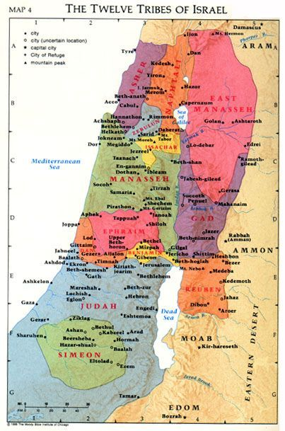

Verse 22—"I give you one portion more than your brothers, which I took from the hand of the Amorite with my sword and my bow”—Jacob reiterated that when God would restore the family to the land, the double portion would go to Joseph. The word portion could refer to Shechem in Hebrew, the place where Joseph would be buried as a sign of the possession of his portion or inheritance or bequest. The allusion to the hand of the Amorite may refer to some type of skirmish that occurred there between Jacob and Canaanites.
PT—Jacob is one of the few men we read about who started spiritually weak and got better with age. There are some like Joseph and Daniel, who started well and are steady as a rock their whole lives. Many start well and finish poorly, like Saul and Solomon. There are only a few, like Jacob, who start poorly and end well. Jacob went from a deceptive liar, to a man of God, to a patriarch, who obeyed God and led his family in purity and worship. He ended his life with a godly sense of justice and righteousness. Learn from the mistakes, the sins, the foolishness of your youth. Conform yourself to the Word of God and become a man. Then as your flock ages and increases, shepherd them in the direction of purity.
An Application—Believers learn throughout life to accept God’s crossing up of the normal conventions and expectations, for God’s ways are no the ways of humankind. Death itself is part of the mysterious plan of God, for we enter the promise through death. Many of Jesus’ teachings, with the apparent paradoxes, exemplify this principle and call for a faith that looks beyond the grave and to live from an eternal vantage point.
Implications for the 12 Tribes
- That the 12 tribes could know for certain that the promise will find its fulfillment in the land of Canaan.
- That God’s ways may not be according to the usual workings of mankind and will require faith to go forward in the direction God is working.
- That there would be differing capacities of favor and blessing for each of the tribes as they work out the will of God while experiencing the outworkings of the promise.
- That believers who have matured in the faith through a lifetime of experiences shepherded by God, no matter how difficult the maturing process may have been, can discern with confidence the purpose and plan of God for them and for the future.
PT—The maturing of the faith of Jacob would be instructive as to the value God places on a mature faith. A mature believer is familiar with God’s ways, knows God’s plan, and can prepare for life with a certain expectation. Maturity is that process of full comprehensive development into the image of Jesus Christ which is reached through continual growth. That process is one on which Jacob had been engaged all of these years, the fruit of which culminated in Genesis 48.

An Application—The ultimate perspective is to see life from God’s point of view. This is one of the great lessons from Joseph’s famous comment to his brothers. “Do not be afraid, for am I in God’s place? As for you, you meant evil against me, but God meant it for good in order to bring about this present result” (Genesis 50:19-20). We might call it 50/20 vision. It is better than 20/20 vision. It is not just seeing what is there but seeing what is there from God’s point of view. Genesis 50:20 is the most significant thing Joseph said.
Genesis 49 — The Shaping of Destiny
It is a fundamental principle in God’s economy that the actions of individuals will affect the lives of their descendants. This pattern is clear in the patriarchal narratives, for the deeds and dispositions of the patriarchs were passed on in one way or another to their children.

Genesis 49 exemplifies this theme with the deathbed oracle of Jacob’s blessing. Then Jacob summoned his sons and said, “Assemble yourselves that I may tell you what will befall you in the days to come” (Genesis 49:1). Jacob’s 12 sons, born over a period of approximately 23 years through four different mothers, gathered reverently around the aged patriarch.

The backdrop to this solemn gathering was their great-great grandfather Abraham, who God had called from Ur of the Chaldees, and who had come into the land of Canaan without even knowing his exact destination.

This began a journey of faith where Abraham would become a paradigm of faith—one God meant his posterity to adopt as they, too, sojourned with God in the Land of Promise.
Jacob had through deceit stolen his brother Esau’s birthright and blessing (Genesis 27). To spare his life from Esau’s rage, Jacob migrated east across the Jordan River for twenty years (Genesis 31:36-42). There he secured his wives, Leah and Rachel, 11 of his children, and wealth while laboring for Laban, the father of his two wives. Then he returned to the Land of Canaan with his entire entourage (Genesis 33).

Now they were in Egypt—all 12 of the brothers with their families and Jacob their father. They had been reunited with their brother Joseph, whom they had sold into slavery in Egypt 20 years before. They now understood that the hand of God had overruled their evil deed, for Joseph had eventually risen to the position of vice-regent in Egypt and was caring for their needs while famine raged in the land of Canaan (Genesis 42:1-9).

So what would the future now hold for Jacob’s sons and their families? The moment now arrived when they would have that answer. Jacob requested the sons to gather together and hear, O sons of Jacob; and listen to Israel your father (Genesis 49:2).

Some Preliminary Considerations
- Jacob discerned enough of his son’s traits to make reasonable predictions, but in some cases his words went beyond his experience and were more like prophetic insights into the ancestry of the Jewish people who trace their history back to these 12 sons.
- The blessing of Jacob’s sons is an example of fulfilled prophecy. As each of the prophecies are examined regarding the 12 sons, it is an amazing example of the prophetic literal accuracy of God’s Word. So we can also conclude that prophecy not yet fulfilled will also be literally fulfilled.
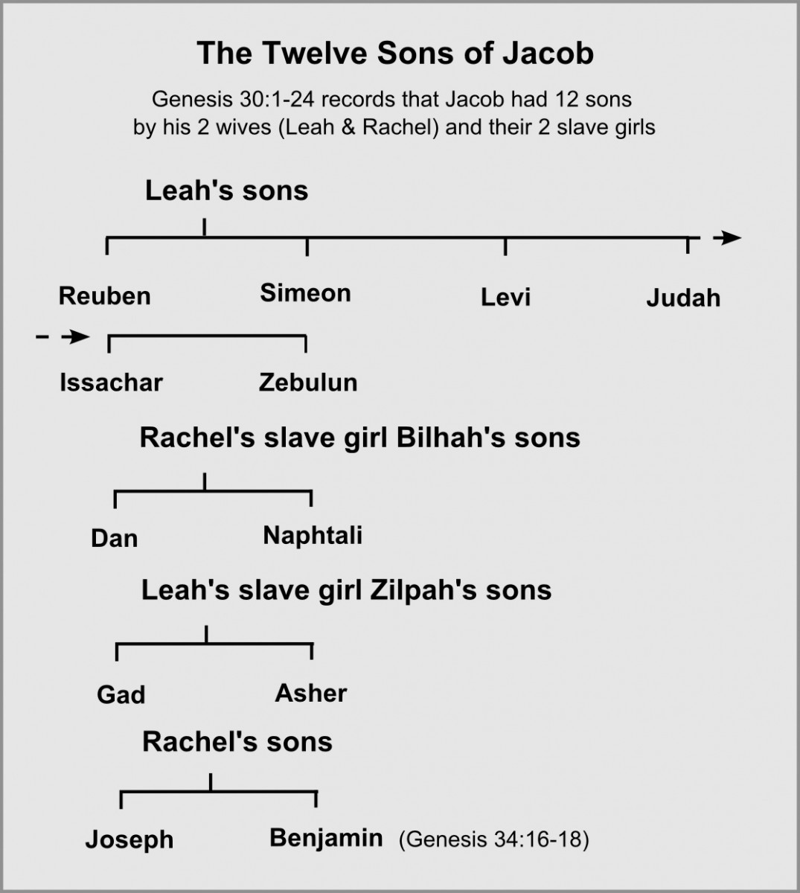
- The purpose of this prophetic oracle was for Jacob to reveal to his 12 sons what was to happen to each of them in the days to come or “in the last days” (v. 1). This most likely means an undetermined time in the future, early or late, from the near future to the eschatological kingdom of Messiah.
- Most of these blessings were fulfilled during the period of the judges, approximately 600-700 years after Jacob’s death.

- Jacob’s words serve to advance the record of God’s blessing from the original patriarchs who had received the promise in faith, to the subsequent generations of tribes who would experience the outcome of the promise as they also lived by faith.
- Tell it like it is—morality matters. When Jacob was about to die, he pronounced blessings, or more accurately, predictions, upon his 12 sons. In each case, he dealt with them accurately and without ‘nice-ing it over.’ You might think at the time of his death he would want to be remembered fondly, so he would just overlook the boys’ past sins and destructive tendencies. But Jacob tells it like it is—or was—and uses that as a basis for his prayers and predictions for his sons.
PT—For example, there is his limited blessing on Reuben for his adultery with Bilhah (35:22). There is also his scattering prediction for Simeon and Levi because of their anger and vengeful wrath, killing the men and animals of Shechem (34:25). And by contrast, there is his blessing on Joseph, for his resiliency under attack and fruitfulness while suffering.

An Application—Of course, we cannot make the predictions Jacob did. But we can call it like it is. We must talk with our children and grandchildren and our extended family and friends about the way things actually are. Do not sugarcoat sin or tolerate godless actions. On the other hand, do not overlook the righteous acts of godly people. Give both as living examples to your children. Do not gossip, just state the obvious actions everybody knows about in their true biblical light. Morality matters, and “the flock among you” should be reminded of that.

Jacob Blesses Reuben
“Reuben, you are my firstborn; My might and the beginning of my strength, Preeminent in dignity and preeminent in power. Uncontrolled as water, you shall not have preeminence, Because you went up to
your father's bed; Then you defiled it—he went up to my couch (Genesis 49:3-4).
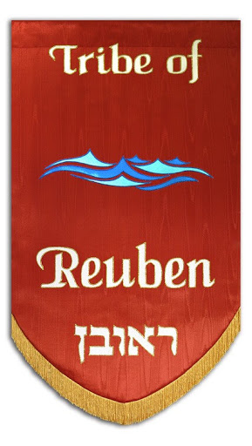

Verse 3—Reuben, you are my firstborn—The patriarch began with his firstborn son, who should have been heir of the promise. He was entitled to leadership and the double inheritance. According to Moses, he shall acknowledge the firstborn…by giving him a double portion of all that he has, for he is the beginning of his strength; to him belongs the right of the firstborn (Deuteronomy 21:17).
PT—That meant that if a father had 12 sons, he divided his inheritance into 13 parts, and the firstborn received twice the amount received by each of the brothers.

- My might and the beginning of my strength—Jacob began Reuben’s blessing by heaping praise on him acknowledging his firstborn position in the family.
- Preeminent in dignity and preeminent in power—As the firstborn, Reuben would become the natural leader of his brothers and be preeminent in such dignity and honor. He was entitled to this leadership position and the double portion that went along with it.

Verse 4—"Uncontrolled as water, you shall not have preeminence—However, because Reuben had the ungoverned impulse of boiling water, he would fail in leadership. Reuben’s character was as unstable and destructive as raging water and so he would not excel in his leadership.
- Because you went up to your father’s bed—Jacob now publicly revealed the sin which Reuben had committed, recorded in Genesis 35:22. It came about while Israel was dwelling in that land, that Reuben went and lay with Bilhah his father’s concubine, and Israel heard of it. By sleeping with his father’s concubine, he would be attempting to take over leadership of the clan—something Absalom foolishly attempted later on in Israel’s history with David, his father (2 Samuel 16:21-22).
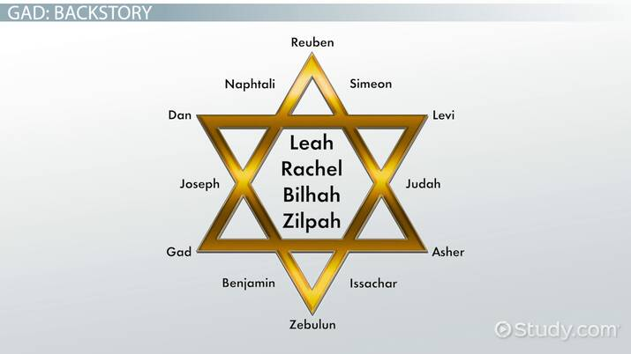
- Then you defiled it—he went up to my couch—This defiant act of not observing his father’s sacred right meant that Reuben and his family lost the birthright. According to 1 Chronicles 5:1-2, now the sons of Reuben the firstborn of Israel (for he was the firstborn, but because he defiled his father’s bed, his birthright was given to the sons of Joseph the son of Israel; so that he is not enrolled in the genealogy according to the birthright. Though Judah prevailed over his brothers, and from him came the leader, yet the birthright belonged to Joseph). Essentially, Reuben destroyed his right to inherit. The switch to the third person he [Reuben] went up to my couch may be the moment Jacob revealed to the other brothers Reuben’s shameful deed, or let them know that he, Jacob, knew about it all along.
PT—The family of Reuben would not have the character to lead, and this failure of character was first seen in the ancestor’s sin. Sin is always a compromise that leads to failure.

A Review of the History of the Tribe of Reuben
The instability of the tribe of Reuben can be illustrated in some of the events of their subsequent history.
- The most prominent persons to appear in the tribe of Reuben were two individuals: Dathan and Abiram. They joined the rebellion of Korah the Levite in Numbers 16.

Numbers 16 in Review
Verse 1-2—Korah…Dathan and Abiram took action…and they rose before Moses—This took some planning and much discussion because Korah, a Levite, was joined by two hundred and fifty leaders of the congregation, chosen in the assembly, men of renown (v. 2).

Verse 3—They have four things to say:
- You have gone far enough—That is, your sole leadership should come to an end. The meaning of it is something like “you have assumed far too much authority.” It simply means “much to you,” perhaps “you have gone too far,” or “you are overreaching yourselves.” He is objecting to the exclusiveness of the system that Moses has been introducing.
- for all the congregation are holy, every one of them—It sounds like they thought that meant they were a democracy. Though it was true that all the congregation was holy (cf. Ex. 19:6 and you shall be to Me a kingdom of priests and a holy nation), they failed to recognize that Moses and Aaron were God-appointed leaders.
- and the LORD is in their midst—But they failed to recognize that the word of God came to them through and only through Moses. Rejecting Moses was not just rejecting God’s leader, it was rejecting the only source of God’s revelation.
- So why do you exalt yourselves above the assembly of the LORD?”—Usually people who complain, accuse their enemies of doing the very thing they are doing. Korah said to Moses, “you exalt yourselves above the assembly of the LORD” because that is what he was doing. [Like the old example of the lady who said, “This church is full of gossips.” She just thinks accusing you of doing it exonerates her.]

Then…
Verses 23-24—Then the LORD spoke to Moses, saying, speak to the congregation, saying, ‘Get back from around the dwellings of Korah, Dathan and Abiram’—God gave Moses the “rapture principle,” separation of the righteous from the wicked, as God did at the Flood and the destruction of Sodom and Gomorrah, Rahab’s family, and deported Jews to Babylon. Proximity to sinners and their sin can jeopardize your own well-being. It is not that we just do not sin but that we are not associated with or in proximity of those who do. Stay away from sinful willful sinners.
PT—But also specifically applicable to life today, separate yourself from those who want to be leaders over the people of God. Notice the difference between Moses and Korah. Moses wanted to follow God but did not want to lead the people. Korah wanted to lead the people but did not want to follow God.

Verses 26-27—Touch nothing…lest you be swept away in their sin—The touching would include not identifying in a personal way with these rebellious ones by agreeing with or supporting them. Dathan and Abiram came out and stood at the doorway with family is a defiant stance, for the word is often used in the sense of taking a stand for or against something. There they stand isolated and self-assured.

Verses 28-30—For this is not my doing—is Moses saying that the things he has done have not come “from the will of man” so to speak—and certainly not from some secret desire on his part to seize power. The accusations against him and their innuendos are lies. If they suffer the fate of all men (and die a natural death), then the Lord has not sent me (Moses). But if the Lord brings an entirely new thing…like the ground opens up and swallows them, it will be so different everyone will know it is of God. The figures are personifications, but they vividly describe the catastrophe to follow—which was very much like a mouth that will be swallowing them.

Verses 31-35—That is exactly what happened. The earth opened its mouth and swallowed them up…they went down alive to sheol…the earth closed over them and they perished—Sheol is the grave, the realm of the departed or death in general. Since they will go down there alive, it is likely that they will sense the deprivation and the separation from the land above on the way down. The people fled at their outcry…and fire also came forth from the LORD and consumed the two hundred and fifty men who were offering the incense. So God killed them separately. Ironically, this group questioned the leadership of Moses and Aaron, and God’s judgment upon them was swift and sure—the earth swallowed them and their families, who perished in the rebellion of Korah (Jude 11).

An Application—Do not rebel against those to whom God has given His written Word (the patriarchs, prophets, and apostles of the Bible). Rebelling against the Word of God is the worst kind of sin because there is no remedy. Today, everything is an attack on the Bible. Sometimes those attacks are engineered from the inside. It’s the Word of God, nothing more, nothing less, nothing else. But to this one I will look, to him who is humble and contrite of spirit, and who trembles at My Word (Isaiah 66:2).
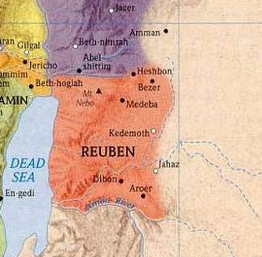

- Later, when the tribes were about to cross into the Promised Land, conquer it, and receive their respective portions, Reuben joined with Gad and half of Manasseh in requesting portions on the east side of the River. They said, “If we have found favor in your sight, let this land be given to your servants as a possession; do not take us across the Jordan” (Numbers 32:5).

Numbers 32 in Review
Verses 1-2—Now the sons of Reuben and the sons of Gad had an exceedingly large number of livestock. So when they saw the land of Jazer and the land of Gilead, that it was indeed a place suitable for livestock, the sons of Gad and the sons of Reuben came and spoke to Moses and to Eleazar the priest and to the leaders of the congregation—The tribes of Reuben and Gad asked Moses if they could settle in the Transjordan highlands because there was a lot of grassy flat land there, ideal for raising livestock, for they had an exceedingly large number of livestock.

Verse 14—Now behold, you have risen up in your fathers’ place, a brood of sinful men, to add still more to the burning anger of the Lord against Israel—Moses’ response was based in the fear of God. God had punished their fathers by making them wander in the wilderness for refusing to go in to the Land. So Moses thought this would discourage the other tribes, thus inciting the wrath of God. Moses falsely accused Reuben and Gad of evil motives when he said, “you have risen up in your fathers’ place, a brood of sinful men.”

Verses 20-22—So Moses said to them, “If you will do this, if you will arm yourselves before the Lord for the war, and all of you armed men cross over the Jordan before the Lord until He has driven His enemies out from before Him, and the land is subdued before the Lord, then afterward you shall return and be free of obligation toward the Lord and toward Israel, and this land shall be yours for a possession before the Lord.” This led to a discussion with Moses. We are not sure who represented the Reubenites and the Gadites, but the people (anyway the leadership) of those tribes seemed to be in agreement. They said they would help conquer Canaan but requested that they first be able to build cities for the protection of their families and pens for their livestock. Moses agreed to this with a warning for them to keep their word.
PT—It seems that, although they reasoned that the land was better suited for their cattle and in spite of the fact that their men did help to conquer the west side of the Jordan along with their brothers, this request was impulsive. They were unwilling to wait for the Land that God eventually would have given to them, thus settling for land that would prove to make them vulnerable to the gods of the surrounding nomadic nations. This action would also later result in misunderstanding and near civil war which was only averted after the sons of Reuben and Gad had explained themselves. The word pleased the sons of Israel, and the sons of Israel blessed God; and they did not speak of going up against them in war to destroy the land in which the sons of Reuben and the sons of Gad were living (Joshua 22:33).
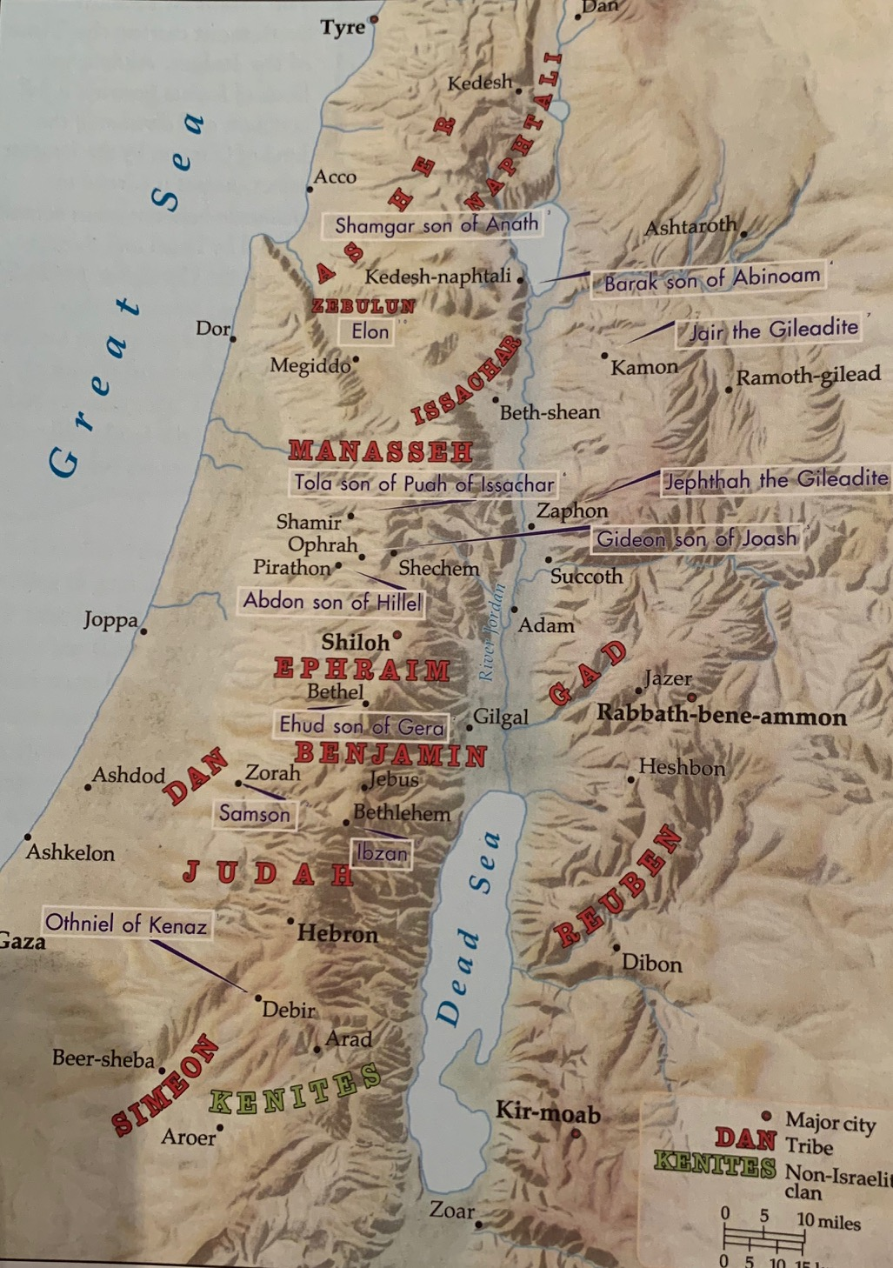

An Application—Fully fulfill your obligations to the Lord. If you choose to get married, then determine to fully participate in the marriage. Do not attempt to compromise that commitment for some expedient excuse that seems far better and more advantageous. This goes for any obligation God imposes upon us from His word.

- A blatant example of Reuben’s instability is recorded in the beautiful “Song of Deborah and Barak” found in Judges 5, which speaks of the tribes who volunteered (v. 2) in the battle against Sisera described in Judges 4.

Judges 5 in Review
Verses 6-8— In the days of Shamgar the son of Anath, in the days of Jael, the highways were deserted, and travelers went by roundabout ways. The peasantry ceased, they ceased in Israel, until I, Deborah, arose, until I arose, a mother in Israel. New gods were chosen; Then war was in the gates. Not a shield or a spear was seen among forty thousand in Israel. —Shamgar in is the third judge, the one before Deborah. The situation in northern Israel was dire. Outside of the fortified walls of the northern tribes, life in the villages and on the highways was precarious and at a standstill, because of the oppression of the Canaanites. This oppression came right up to the entrance of the city gates of these walled cities then war was in the gates. Sisera’s chariot-fitted Canaanite army controlled the roads so they had to travel via the hills and dales, the highways were deserted. The peasantry ceased gleaning the fields for food, they ceased in Israel. The reason for the oppression and no resistance to this evil oppression by the tribes was the inclusion of gods amongst the people—new gods were chosen. The oppression of Sisera was so successful that not a shield or a spear was seen among forty thousand in Israel. Jabin and Sisera had a stranglehold on the entire region for twenty years.

An Application—Some difficulties come and go because life is just that way. And some distress we cause ourselves. Israel increased the oppression and baggage because of sidelining God. They forgot God but did not forget their idols! It is too easy to place God on the back burner of our lives, marginalizing Him, setting Him aside, and replacing His will with our own. Some dire times in our lives, we just have to plainly admit, are the result of our own decisions, our own rebellion, and our own disobedience.

Verses 12-13—Awake, awake, Deborah; Awake, awake, sing a song! Arise, Barak, and take away your captives, O son of Abinoam. “Then survivors came down to the nobles; The people of the Lord came down to me as warriors”—The people came to Deborah, their judge, for help. Some decided to pursue God’s help and they knew where to go for that. Survivors of the oppression, the people came ready to take possession—came down to me as warriors. They had initiated this move to address the oppression of the surrounding enemies.

Verse 14—From Ephraim those whose root is in Amalek came down, following you, Benjamin, with your peoples; From Machir commanders came down, and from Zebulun those who wield the staff of office—Such tribes as Ephraim, Benjamin, Zebulun, and Naphtali (v. 18) were praised in Deborah’s song for their willingness to risk their lives in battle.

Verses 15-16—Among the divisions of Reuben there were great resolves of heart. “Why did you sit among the sheepfolds, to hear the piping for the flocks? Among the divisions of Reuben there were great searchings’ of heart”—Reuben, however, was criticized for his hesitating instability. Why did you sit among the sheepfolds? Reuben had great searchings’ of heart, but sat around and did nothing. Reuben may have considered and deliberated sending troops, a commitment they had made when Moses gave them their land allotment, but his concern for the bleatings of his own sheep overrode any resolve to fulfill his patriotic commitment.

An Application—You can either determine to pursue God and His will in your dire situation, or you can ignore God’s prescription because you have second thoughts about doing it God’s way. Reuben is an example of hesitating obedience, weighing the alternatives and then deciding against the will of God.

Observations from the Tribe of Reuben
- Reuben never excelled in his tribal development. In the census of the tribes at the end of the wilderness journey, Reuben’s population had already begun to decrease. In the first census, their numbered men of the tribe of Reuben were 46,500 (Numbers 1:21). At the end of the wilderness wandering, a second census was taken, and those who were numbered of them were 43,730 (Numbers 26:7).
- By the time Moses blessed the tribes before he died, Reuben may have been in danger of extinction, since Moses prayed: “May Reuben live and not die, nor his men be few” (Deuteronomy 33:6).
- Reuben produced not one single prophet, military leader, judge, or significant person in the history of Israel. Reuben had indeed lost both his birthright and leadership position due to being uncontrolled as water, you shall not have preeminence, an example of which was that he went up to your father's bed; Then you defiled it, he went up to my couch (Genesis 49:4). Reuben’s inability to make proper discretionary decisions doomed himself and his descendants to a future of obscurity.
- Reuben had to live with the results of his sin no matter how he had tried to make up for it by attempting to protect Joseph from his brother’s murderous plot (Genesis 37:20-30). James said, a double-minded man [is] unstable in all his ways. Long-range tragic effects can result from the fleeting act of sin.

Jacob Blesses Simeon and Levi
“Simeon and Levi are brothers; Their swords are implements of violence. Let my soul not enter into
their council; Let not my glory be united with their assembly; Because in their anger they slew men, and in their self-will they lamed oxen. Cursed be their anger, for it is fierce; And their wrath, for it is cruel. I will disperse them in Jacob, and scatter them in Israel (Genesis 49:5-7).

Verse 5—Simeon and Levi are brothers—Simeon and Levi would not replace Reuben in the leadership of the nation. The mentioning of brothers seems to mean more than biological, but that they were in this blessing together due to being in league with one another. Simeon was the second son born to Jacob and Leah. Leah had given this name because of the hope she expressed at his birth. Then she conceived again and bore a son and said, “Because the Lord has heard that I am unloved, He has therefore given me this son also.” So she named him Simeon (Genesis 29:33).

Levi was the third son born to Jacob and Leah. Leah had given this name because of a hope expressed at his birth. She conceived again and bore a son and said, “Now this time my husband will become attached to me, because I have borne him three sons.” Therefore, he was named Levi (Genesis 29:34). Jacob’s mentioning of them together is a reminder of their closeness in age and most likely, similar interests. They were brothers in particular by joining together in common actions. In this case, the adage “partners in crime” would be apropos.
- Their swords are implements of violence—They were men of anarchy and not justice. Their implements were used as instruments of violence. These implements of violence would have been the knives of circumcision they had used against Shechem who had seduced Dinah, the only daughter of Jacob and Leah, the sister of Simeon and Levi, and who now desired to marry her but Jacob’s sons answered Shechem and his father Hamor with deceit, because he had defiled Dinah their sister. They said to them, “We cannot do this thing, to give our sister to one who is uncircumcised, for that would be a disgrace to us. Only on this condition will we consent to you: if you will become like us, in that every male of you be circumcised” (Genesis 34:13-15).
PT—The circumcision was merely a ruse so that Simeon and Levi could slaughter the people. Now it came about on the third day, when they were in pain, that two of Jacob’s sons, Simeon and Levi, Dinah’s brothers, each took his sword and came upon the city unawares, and killed every male. They killed Hamor and his son Shechem with the edge of the sword, and took Dinah from Shechem’s house, and went forth. Jacob’s sons came upon the slain and looted the city, because they had defiled their sister. They took their flocks and their herds and their donkeys, and that which was in the city and that which was in the field; and they captured and looted all their wealth and all their little ones and their wives, even all that was in the houses (Genesis 34:25-29).

Verse 6—Let my soul not enter into their council; Let not my glory be united with their assembly—Because of the violence of Simeon and Levi, Jacob would have nothing to do with their deeds or thoughts. Both their council and their assembly were filled with violence and rage. Jacob separated himself entirely from their scheme. Jacob most likely remembered the distress his son’s actions had brought upon him when he had heard about their revengeful atrocity. “You have brought trouble on me by making me odious among the inhabitants of the land, among the Canaanites and the Perizzites; and my men being few in number, they will gather together against me and attack me and I will be destroyed, I and my household” (Genesis 34:30). Jacob had sensed that the people in the land would find this act terribly repulsive. It would leave a foul stench all around and possibly lead to the clan’s ruin.
- Because in their anger they slew men, and in their self-will they lamed oxen—They had acted in pride and anger and, in their self-will (in their pleasure, signifying they had desired to do it), destroyed the community and even hamstrung the oxen. Their rampage had been violent and ruthless. Their attack was cruel vengeance and unusual punishment making unprofitable for others what they chose not to take for their own use.

An Application—We should not act under the impulse of uncontrolled anger. Solomon warned, like a city that is broken into and without walls is a man who has no control over his spirit (Proverbs 25:28). The point is the need for self-control. Like a broken down city incapable of defending itself from intrusion is one who is vulnerable without self-control. He has no defenses. So the lesson is that an undisciplined person is vulnerable to all kinds of trouble which, when it arrives, is capable of destroying his or her life.
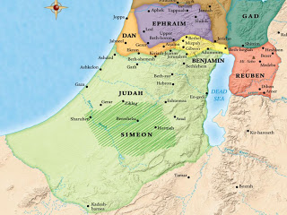

Verse 7—Cursed be their anger, for it is fierce and their wrath, for it is cruel—Their anger and fierce wrath was cursed, meaning that they were cursed within or expelled from the community. They had gotten out of control, due to their rage that motivated the revengeful slaughter. This was unacceptable. Such ruthless violence eliminated those tribes from the leadership of the nation as well.
- I will disperse them in Jacob, and scatter them in Israel—As a result of the actions that characterized these families, they would be divided and scattered throughout Israel. Simeon was later swallowed up in the tribe of Judah, and Levi received an honorable dispersion as the priestly tribe.
PT—God makes a moral judgment on the wicked vengeance and ruthless slaughter of Simeon and Levi. By doing so, God distinguished holy war from such hostile and vindictive behavior.

A Review of the History of the Tribe of Simeon
The scattering of the tribe of Simeon amongst the other tribal allotments in the land can be seen in their subsequent history.
- Joshua chapters 1-12 describe the initial conquest of the land of Canaan by Israelite forces, and chapters 13-21 record the division of the land among the victorious tribes. Special allocations, however, were made for the tribes of Simeon and Levi.

Joshua 19 in Review
Verse 1—Then the second lot fell to Simeon, to the tribe of the sons of Simeon according to their families, and their inheritance was in the midst of the inheritance of the sons of Judah—Here begins the description of Simeon’s allotment in the land of Canaan. Jacob’s prophecy was fulfilled by Simeon’s portion being subsumed within the larger inheritance of Judah.

Verses 2-8—So they had as their inheritance Beersheba… and all the villages which were
around these cities as far as Baalath-beer, Ramah of the Negev. This was the inheritance of the tribe of the sons of Simeon according to their families—Seventeen cities and their surrounding villages are then mentioned that would belong to Simeon.

Verse 9—The inheritance of the sons of Simeon was taken from the portion of the sons of Judah, for the share of the sons of Judah was too large for them; so the sons of Simeon received an inheritance in the midst of Judah's inheritance—Judah’s portion was the southernmost of all the tribes and stretched from the Mediterranean Sea on the west to the Dead Sea on the east, and from below Jerusalem on the north to below Beersheba in the south. This made the cities within Judah that were assigned to Simeon located in the arid and barren region known as the Negev. This was a most inhospitable area for cultivation and the settled life. This divided existence, without a centralized tribal organization, was an appropriate fulfillment of Jacob’s words, “I will disperse them in Jacob, and scatter them in Israel” (Genesis 49:7).

An Application—Once again we are reminded of the revengeful violence that precipitated this unfortunate outcome for the tribe of Simeon. This sin is a stark reminder for how God’s people should respond whenever an injustice is experienced. Never pay back evil for evil to anyone. Respect what is right in the sight of all men. If possible, so far as it depends on you, be at peace with all men. Never take your own revenge, beloved, but leave room for the wrath of God, for it is written, “Vengeance is Mine, I will repay,” says the Lord. “But if your enemy is hungry, feed him, and if he is thirsty, give him a drink; for in so doing you will heap burning coals on his head.” Do not be overcome by evil, but overcome evil with good (Romans 12:17-21).

PT—The shares of the sons of Judah was too large for them, so Simeon got an inheritance in the midst of Judah. What if what we have to do is too much? God may give part of it to someone else. It’s not a reprimand or criticism, it’s just the way it is. We should not see it as competition.
An Application—Don’t be jealous or regretful if you have an abundance of ministry and God gives some of it to others. Nobody can do everything for people. Let the different gifts of the body work—even if they are not part of your organization or group. Only be sure they are not false teachers.
- The tribe of Simeon played a prominent role in an unfortunate incident of sexual worship related to Midianite idolatry.

Numbers 25 in Review
Verse 1—While Israel remained at Shittim, the people [the Israelites] began to play the harlot with the daughters of Moab. This apparently meant that the men were having sex with the Midianite women as part of the religious ritual of idolatry worship. It was actually Midianite women living in Moab. One of the sons of Israel came and brought to his relatives a Midianite woman (v 6).

Verse 2—For they invited the people to the sacrifices of their gods, and the people ate and bowed down to their gods. These young women were doing what the armies of Sihon, king of the Amorites, and Og, king of Bashan, could not do (Numbers 21:21-35). They were conquering the young men, but now with a pagan sex-oriented worship of a false god. Behold, these (the Midianite women at Moab) caused the sons of Israel, through the counsel of Balaam, to trespass against the LORD in the matter of Peor (Numbers 31:6). Revelation 2:14 says Balaam taught Balak to cast a stumbling block before the children of Israel to eat things sacrificed to idols, and to commit fornication.
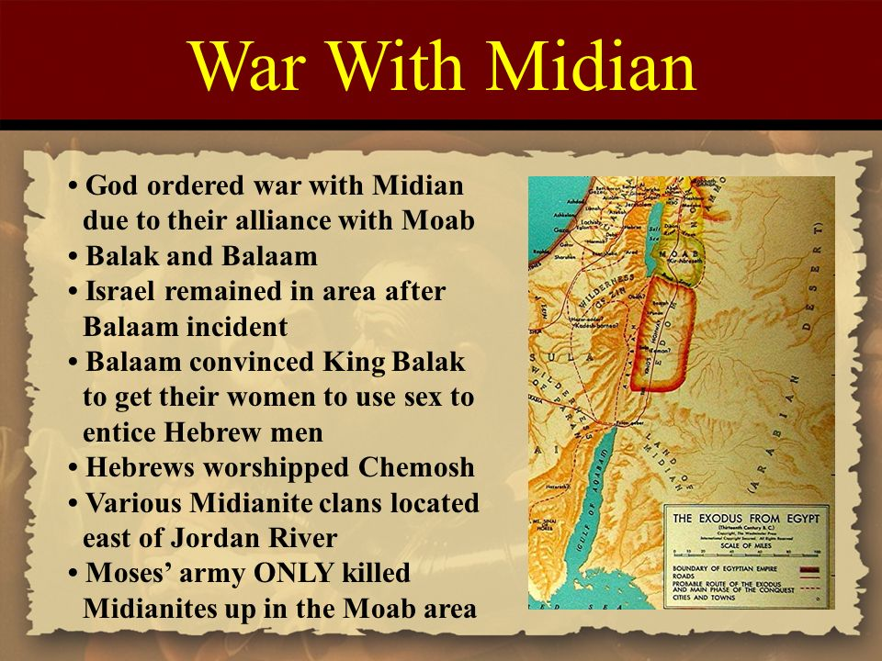

Verse 3—So Israel joined themselves to Baal of Peor, and the Lord was angry against Israel. Joining themselves to Baal is a pejorative relating to sexual ritual idolatry. It certainly showed that these young Israelite men acknowledged the reality of the local false god. The evidence indicated that Moab was part of the very corrupt Canaanite world. So the Lord was angry against Israel about this, and why not? We are also told of the fierce anger of the Lord (v. 4) and my [God’s] wrath (v. 10).

Verse 4—The Lord said to Moses, “Take all the leaders of the people and execute them in broad daylight before the Lord, so that the fierce anger of the Lord may turn away from Israel.” God said to arrest all the leaders of the people behind the apostasy who had participated in the idolatry and had failed in their duty to protect Israel lawfully. The leaders were executed in broad daylight before the Lord as a public spectacle. The rest of the guilty died by the plague, and those who died by the plague were 24,000 (v. 9).

An Application—The point is that sin must be dealt with, not ignored, not tolerated, nor excused, because it requires accountability to God.

Verse 5—So Moses said to the judges of Israel, “Each of you slay his men who have joined themselves to Baal of Peor.” Moses (apparently correctly) understood this execution to be each of you slay his men who have joined themselves to Baal of Peor. Since the whole nation had sinned, God executed punishment on its leaders, who stood for the people. The leaders, who had joined themselves to Baal of Peor, led the way for young men to prostitute themselves, who had been deceived through the counsel of Balaam.
PT—Israel’s judges carried out this order, which is what God is always looking for—people who agree with the ways and interests of God. Sin works to undermine what is in God’s interests. God looks for people to stand strong for His judgments.

Verses 6-7—Then behold, one of the sons of Israel came and brought to his relatives a Midianite woman, in the sight of Moses and in the sight of all the congregation of the sons of Israel, while they were weeping at the doorway of the tent of meeting. When Phinehas the son of Eleazar, the son of Aaron the priest, saw it, he arose from the midst of the congregation and took a spear in his hand. Here one defied the judgment of God and another took a stand for the judgment of God. Zimri (v. 14) brought to his relatives a Midianite woman (Cozbi, the daughter of the leader of Midian, v. 18) in the sight of Moses and in the sight of all the congregation “while” people were weeping over the sin and its consequences.
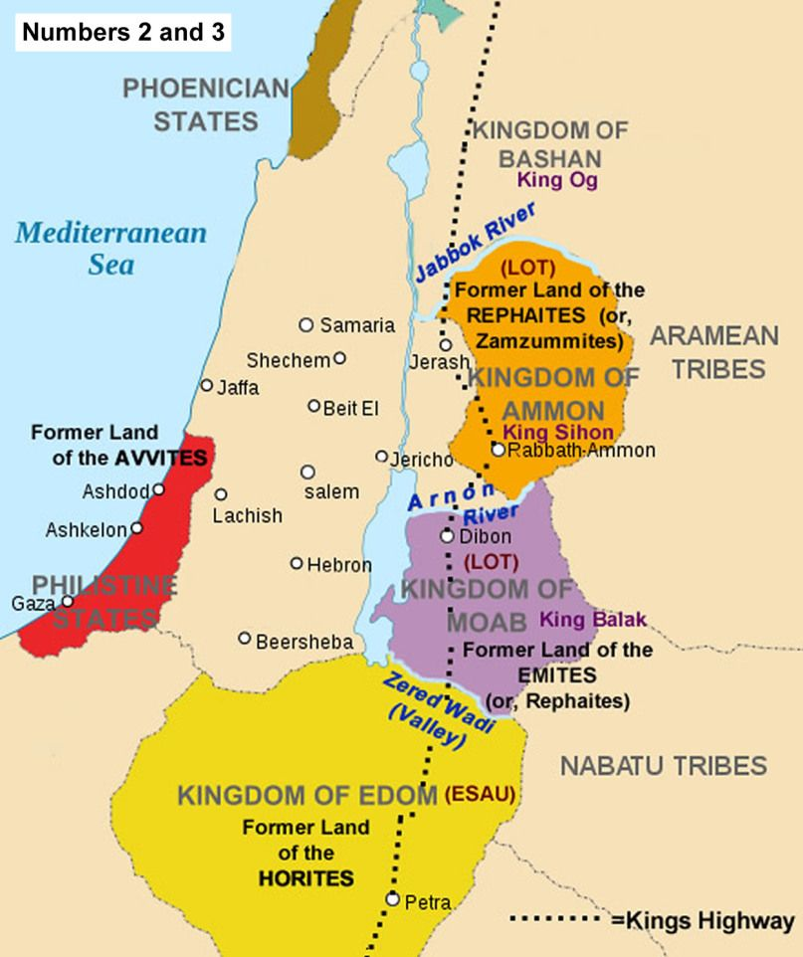

Verses 8-9—and he went after the man of Israel into the tent and pierced both of them through, the man of Israel and the woman, through the body. So the plague on the sons of Israel was checked. Those who died by the plague were 24,000. Phinehas put a quick end to their sexual immorality while they were in the act. He had seen that the Lord Himself had had the guilty put to death. Some plague was breaking out in the camp that had to be stopped. Those who died by the plague were 24,000. In his zeal, he dramatically put an end to this incident. This is referenced in Deuteronomy 4:3-4; Psalm 106:26-29; Hosea 9:10; and 1 Corinthians 10:8. First Corinthians says it was 23,000 who died in one day but probably does not include those who died of the wounds over the following days leaving a total dead of 24,000.

Verses 10-11—Then the Lord spoke to Moses, saying, “Phinehas the son of Eleazar, the son of Aaron the priest, has turned away My wrath from the sons of Israel in that he was jealous with My jealousy among them, so that I did not destroy the sons of Israel in My jealousy. God then stated Phinehas…has turned away my wrath…in that he was jealous with My jealousy…so that I did not destroy the sons of Israel in My jealousy. What made Phinehas the hero was his strong intensity to protect or preserve God’s interests. He was jealous with God’s jealousy. Not only was God’s jealousy good, but it was good for Phinehas to share it by being jealous with God’s jealousy. God’s jealousy is His exclusivity. He will not be inclusive of adherence to another God.

Verses 12-13—Therefore, say, ‘Behold, I give him My covenant of peace; and it shall be for him and his descendants after him, a covenant of a perpetual priesthood, because he was jealous for his God
and made atonement for the sons of Israel.’ God rewarded Phinehas by promising that his descendants would enjoy peace My [God’s] covenant of peace and would occupy the office of the high priest forever, a covenant of a perpetual priesthood (Psalm 106:30-31). This was because he was jealous for his God and made atonement for the sons of Israel. Phinehas continued as priest into Joshua’s day (Judges 20:28), and his priesthood continued with the exception of a short interruption in Eli’s days. The Romans finally broke up the Israelite priesthood in 70 AD.
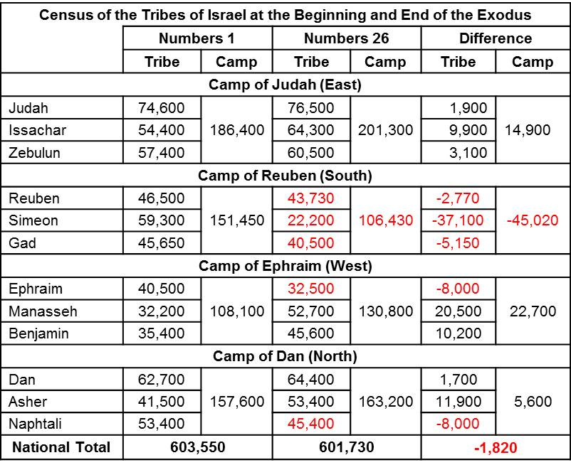

Verses 14-15—Now the name of the slain man of Israel who was slain with the Midianite woman, was Zimri the son of Salu, a leader of a father’s household among the Simeonites. The name of the Midianite woman who was slain was Cozbi the daughter of Zur, who was head of the people of a father’s household in Midian. The passage makes it clear that Zimri was a leader, one who was supposed to be preventing this thing from happening. Zimri the son of Salu, a leader of a father’s household among the Simeonites. The judgment was swift and severe, because the crime was so great, and the danger of it spreading was certain. A little leaven, leavens the entire lump. Paul refers to this horrible incident when he reminded Christians not to do similar things. Now these things happened as examples for us, so that we would not crave evil things as they also craved. Do not be idolaters, as some of them were; as it is written, “The people sat down to eat and drink, and stood up to play.” Nor let us act immorally, as some of them did, and twenty-three thousand fell in one day (1 Corinthians 10:6-8).

Verses 17-18—Then the Lord spoke to Moses, saying, “Be hostile to the Midianites and strike them; for they have been hostile to you with their tricks, with which they have deceived you in the affair of Peor and in the affair of Cozbi, the daughter of the leader of Midian, their sister who was slain on the day of the plague because of Peor.” God’s commandment, be hostile to the Midianites and strike them, is the idea of causing trouble and harassing. The reason God gave was for they have been hostile to you with their tricks with which they have deceived you, and God repeats, to be hostile. So the punishment is talionic—the principle of retaliation that a punishment inflicted should correspond in degree and kind to the offense—an eye for an eye, tooth for a tooth. Cozbi’s father, Zur, was one of five Midianite kings who eventually succumbed to Israel (Numbers 31:8).

An Application—Crafty underhanded devices usually accompany deception. Balaam had inspired this episode by conniving with the Moabites to seduce these Israelite young men. They were then misled in deception to the fake worship of idolatry, and the trick was to use sexual religious seduction to do that. The enticement worked, and idolatry was reinforced amongst the Israelites as it had been ever since Egypt. The tricks continued (the Gibeonites [Joshua 9:3f] acted craftily by wearing old fake clothes to deceive Joshua into thinking they were not Canaanites), eventually precipitating the demise of the nation. This is why we are warned to test the spirits (1 John 4:1-6) and guard yourselves from idols (1 John 5:21) due to the tricks designed to deceive.

Observations from the Tribe of Simeon
- The tribe of Simeon decreased in number from the beginning to the end of the wilderness wandering. In Numbers 1:23 their adult male population was recorded as 59,300, while in Numbers 26:14 (the second census nearly 40 years later) it was at 22, 200. Though it is not clear why, it’s possible that they suffered more severely than the other tribes from the plagues in Numbers 25 where those who died by the plague were 24,000 (Numbers 25:9).
- It’s difficult to know what happened to Simeon when the United Kingdom was divided into the northern and southern kingdoms during the reign of Rehoboam, son of Solomon. Certain Israelites who were faithful to the Lord God migrated into Judah at that time. Some of them were Simeonites those from all the tribes of Israel who set their hearts on seeking the Lord God of Israel followed them to Jerusalem, to sacrifice to the Lord God of their fathers (2 Chronicles 11:16). The outcome was They strengthened the kingdom of Judah and supported Rehoboam the son of Solomon for three years, for they walked in the way of David and Solomon for three years (v. 17).
- During the reign of Hezekiah, a large group from the tribe of Simeon migrated farther south to the land of Edom, where they conquered and displaced Amalekites who dwelt there. From them, from the sons of Simeon, five hundred men went to Mount Seir, with Pelatiah, Neariah, Rephaiah and Uzziel, the sons of Ishi, as their leaders. They destroyed the remnant of the Amalekites who escaped, and have lived there to this day (1 Chronicles 4:42-43).
- Certain later references suggest the possibility that many Simeonites had also migrated to the Northern Kingdom, for they are mentioned in conjunction with the tribes of Ephraim and Manasseh. He [King Asa] gathered all Judah and Benjamin and those from Ephraim, Manasseh and Simeon who resided with them, for many defected to him from Israel when they saw that the Lord his God was with him (2 Chronicles 15:9; 34:6). Regardless of the outcome of the tribe, their small number and few references are testimony to the truth of Jacob’s prophecy.

A Review of the History of the Tribe of Levi
The story of the tribe of Levi records a history consistent with the oracle Jacob pronounced upon the tribe when they, too, were destined to be scattered without inheritance in the Land.
- How is it that the prophecy which proved to be a curse for the tribe of Simeon actually turned into a blessing for the Levites? Levi’s exploits in Exodus 32 may provide that answer.

Exodus 32 in Review
Verses 1-6—Now when the people saw that Moses delayed to come down from the mountain, the people assembled about Aaron and said to him, “Come, make us a god who will go before us; as for this Moses, the man who brought us up from the land of Egypt, we do not know what has become of him”…and fashioned it with a graving tool and made it into a molten calf; and they said, “This is your god, O Israel, who brought you up from the land of Egypt”—The Israelites crafted a golden calf to be worshiped by the people. Aaron encouraged this idolatry while his brother was on the mountain receiving the Law from the Lord. The idea of making this calf may have come from their memory of the Egyptian gods. When Aaron saw that they had made a golden calf, he proposed a mixture of worship, making an altar and proclaiming tomorrow shall be a feast to the Lord (v. 5). The next day they: (1) offered burnt offerings, and brought peace offerings, (2) sat down to eat and to drink, and (3) rose up to play – the word for play suggests sexual activity (1 Corinthians 10:8).

Verses 7-14—Then the Lord spoke to Moses, “Go down at once, for your people, whom you brought up from the land of Egypt, have corrupted themselves… Now then let Me alone, that My anger may burn against them and that I may destroy them; and I will make of you a great nation.”…Then Moses entreated the Lord his God, and said, “O Lord, why does Your anger burn against Your people whom You have brought out from the land of Egypt with great power and with a mighty hand?”... So the Lord changed His mind about the harm which He said He would do to His people—When Moses came down from the mountain and saw the shameful sight, he shattered the tablets of stone in righteous anger and protest. When God told Moses what the people had done, He referred to them as your people whom you brought up out of the land of Egypt. God said they are an obstinate [or literally, hard] people (v. 9). Then He told Moses to be at rest (NASB, KJV let Me alone) that I may destroy them, and I will make you a great nation.
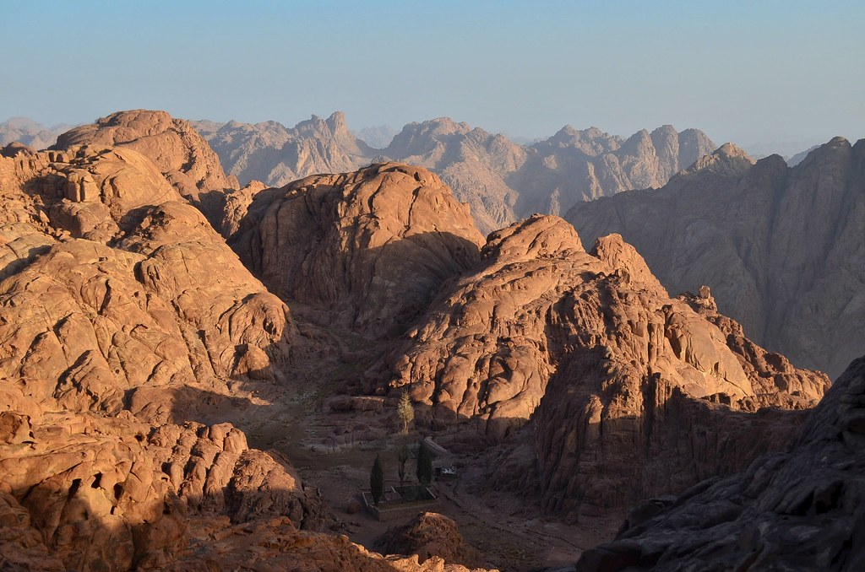
Moses appealed for the people with two arguments:
- The Egyptians will say, “With evil intent He brought them out to kill them.” Notice the assumption that the world is watching.
- “Remember Abraham, Isaac, and Israel, your servants to whom You swore by Yourself, and said to them, ‘I will multiply your descendants as the stars of the heavens…in the land’” (Genesis 15:18–21; 22:17; 26:4; 28:13; 32:13).
The result was that God changed His mind [KJV repented]. This word is to “be sorry, repent, regret, be comforted, comfort.” It’s the same word translated sorry in Genesis 6:6, when before the Flood, The Lord was sorry that He had made man on the earth. Moses’ first argument here seems to be his own speculation. But his second argument was a good one, and the reason God changed His declaration. What God proposed was possible if only the descendants of Levi were to survive through Moses. But that was not God’s plan.

An Application—God has an eternal plan which cannot be altered, but at the same time, the effective prayer of a righteous man can accomplish much (James 5:16). God’s change of mind was real and in His eternal plan. Predestination and free will are both 100%. How can God have a predetermined plan and still change His mind or be sorry [KJV repent]? Because the fact that God’s changed His mind [KJV repented or was sorry] was already in His predetermined plan. God really changed His mind, and His real change of mind was in His sovereign eternal plan.

Verses 15-30—Now when Moses saw that the people were out of control—for Aaron had let them get out of control to be a derision among their enemies—then Moses stood in the gate of the camp, and said, “Whoever is for the Lord, come to me!” And all the sons of Levi gathered together to him. He said to them, “Thus says the Lord, the God of Israel, ‘Every man of you put his sword upon his thigh, and go back and forth from gate to gate in the camp, and kill every man his brother, and every man his friend, and every man his neighbor.’” So the sons of Levi did as Moses instructed, and about three thousand men of the people fell that day—After personally destroying the calf, Moses decided that radical spiritual surgery had to be performed on the people. The zeal of Levi had earlier resulted in the death of the Shechemites—a deed deplored by Jacob. Now through their obedience to Moses, the Levites demonstrated their zeal in a righteous cause. As a result, they were awarded the special place as the priestly tribe throughout Jewish history. While later reflecting upon this incident, Moses reminded the people at that time the Lord set apart the tribe of Levi to carry the ark of the covenant of the Lord, to stand before the Lord to serve Him and to bless in His name until this day (Deuteronomy 10:8).

The prophet Malachi reiterated this favor upon Levi at the end of Old Testament history. “Then you will know that I have sent this commandment to you, that My covenant may continue with Levi,” says the Lord of hosts. “My covenant with him was one of life and peace, and I gave them to him as an object of reverence; so he revered Me and stood in awe of My name” (Malachi 2:4-5). In this case, My covenant refers to the priestly covenant through Aaron and his grandson Phinehas (see Exodus 6:16-20; Numbers 25:10-13; Jeremiah 33:21-22). The point here is to contrast the priestly ideal with the disgraceful manner in which it was being carried out in postexilic times.

An Application—It is appropriate to have zeal for the Lord, His will, and His Word. We should eagerly desire and contend for righteousness. Romans 12:10-11 says, be devoted to one another in brotherly love; give preference to one another in honor; not lagging behind in diligence (zeal). Christ gave Himself for us…to purify for Himself a people for His own possession, zealous for good deeds (Titus 2:14). Be eager to study the Bible. Be dedicated to loving God will all your heart. Be passionate about living with an eternal perspective. Be devoted to making disciples of Jesus Christ.

PT—Certainly, Simeon and Levi were zealous, but their zeal was not channeled into godly paths. Zeal in itself is not sufficient, even for ministry on behalf of the Lord. It has been taught that activity,
devotion, commitment, and sincerity are the only necessities in serving the Lord. But such zeal can be misdirected and even hinder service. Paul testified about his Jewish kinsmen for I testify about them that they have a zeal for God, but not in accordance with knowledge (Romans 12:2). Even Paul encountered an unproductive zeal in his own life as to zeal, a persecutor of the church; as to the righteousness which is in the Law, found blameless (Philippians 3:6). Just as Levi redirected his zeal into godly channels, Paul redirected his zeal into service for the Messiah, whom he had been previously zealous to oppose. The point is to focus our zeal on God’s program and purposes, not our own selfish plans.
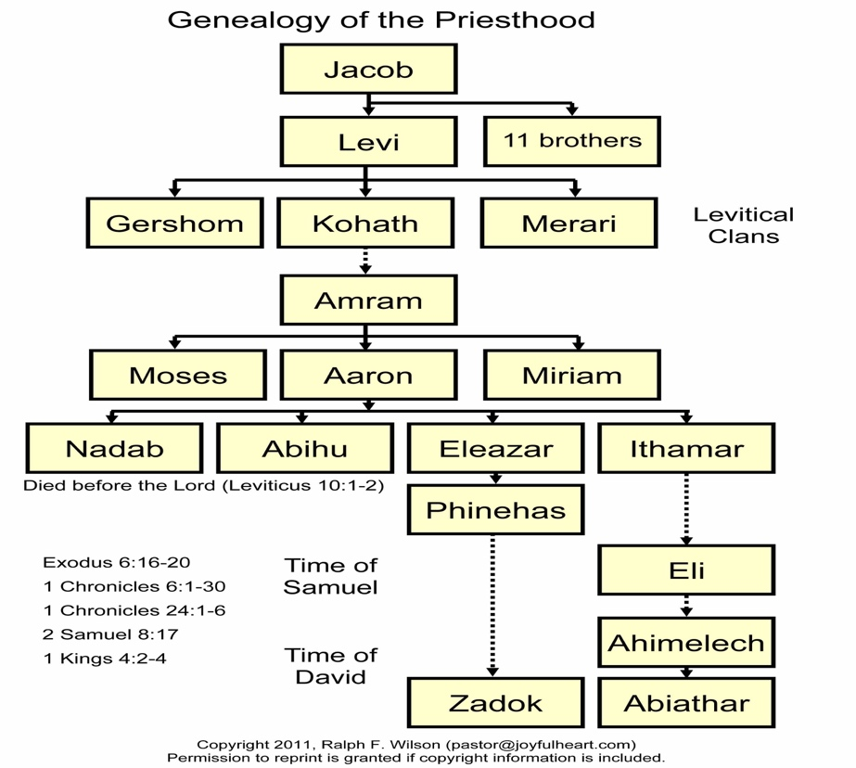

- The blessing we have here is the blessing of Moses given just before his death. It was a customary thing for a father to pass on a blessing just before his death. We see that with Isaac blessing his sons, or Jacob’s blessing in Genesis 49. Moses the leader of the exodus and the mediator at Mt Sanai was in a very real sense the Israel’s father. God wants to bless His children and He wants to do that here with each of the tribes of Israel.

Deuteronomy 33 in Review
Verses 8-11—Of Levi he said, “Let Your Thummim and Your Urim belong to Your godly man Whom You proved at Massah, with whom You contended at the waters of Meribah; Who said of his father and his mother, ‘I did not consider them’; And he did not acknowledge his brothers, nor did he regard his own sons, for they observed Your word, and kept Your covenant. They shall teach Your ordinances to Jacob, And Your law to Israel. They shall put incense before You, and whole burnt offerings on Your altar. O Lord, bless his substance, and accept the work of his hands; Shatter the loins of those who rise up against him, and those who hate him, so that they will not rise again.”

Deuteronomy 33 records the blessings of Moses on the tribes before his death. It’s striking that Simeon is the only tribe omitted from his blessings, while the longest blessing is given to Levi, of Levi he said, “Let Your Thummim and Your Urim belong to Your godly man” (v. 8). These terms, whose meaning is uncertain, refer to sacred stones carried in a pouch on the breastplate of the high priest and examined on occasion as a means of ascertaining God’s will or direction (see Exodus 28:30; Leviticus 8:8; Numbers 27:21; 1 Samuel 28:6). The blessing also noted of Levi, who said of his father and his mother, ‘I did not consider them’; And he did not acknowledge his brothers (v. 9). This statement no doubt alludes to the Levites’ destruction of their own fellow tribesmen following the golden calf incident (Exodus 32:25-29). Moses said of Levi at that time, they observed Your word, and kept Your covenant (v. 9).

Their influence included teaching the people the Law of God. Moses in his final blessing of the tribes had said to Levi in Deuteronomy 33:10, he teaches Your precepts to Jacob and Your Law to Israel. They were to instruct the people where they lived in the Law of the Lord so that the knowledge of God’s Word would be maintained among the people of the nation. The Levite cities in the north and the east were placed there as deterrents against idolatry that could easily infiltrate from Tyre and Sidon, and from the Midianites, Ammonites, and Moabites. So the entire nation had someone near enough who knew the Law of God that they could easily visit and get advice, counsel and instruction. It was essential that the nation stay faithful to the Law of God in all areas of their lives because their propensity to stray and forget God would forfeit the privileges they enjoyed in covenant with God.

- God not only found a special place of service for Levi and His posterity, He also ensured their spiritual presence amongst the people.

Joshua 21 in Review
Verses 1-40—So the sons of Israel gave the Levites from their inheritance these cities with their pasture lands, according to the command of the Lord. Then the lot came out for the families of the Kohathites…the sons of Gershon… [and] the sons of Merari—The tribe of Levi steps forward to claim their inheritance. This is the last allotment to take place. Moses had promised them an inheritance: “command the sons of Israel that they give to the Levites from the inheritance of their possession cities to live in; and you shall give to the Levites pasture lands around the cities” (Numbers 35:2). The distribution of the territory is according to the three main branches of the tribe of Levi. These correspond to the three sons of Levi, Kohath, Gershon, and Merari.

The sons of Kohath were given twenty-three cities from six different tribes (vv. 4-5). The sons of Gershon received thirteen cities from four of the tribes (v. 6). The sons or Merari were given twelve cities from three different tribal territories (v. 7). Then verse eight concludes: These cities and their pasture lands the people of Israel gave by lot to the Levites as the Lord had commanded through Moses. Of these three sons, the Kohahites were more prominent and had the most cities assigned to them they were for the sons of Aaron, one of the families of the Kohathites, of the sons of Levi, for the lot was theirs first (v. 10). The reason was because Moses and Aaron were sons of Kohath. So the Aaronic priesthood came from this branch of the Levites.

Since they were to be spiritual leaders of the nation at large, the Levites were trans-tribal, not
bound by any borders or boundaries. It was clear they did not own these cities or the grazing land
surrounding them. According to Numbers 35:6-7, Levi’s allotment included the six cities of
refuge, which you shall give for the manslayer to flee to; and in addition to them you shall give forty-two cities. All the cities which you shall give to the Levites shall be forty-eight cities, together with their pasture lands. The cities and the surrounding countryside would provide for the tribe of Levi, but they were to focus on the spiritual influence they were to have amongst the people.

PT—Levi’s allotment included the six cities of refuge. Apparently, the Lord meant for the verdict of justice to be decided by the Levitical priests. The point is that God established due process to control vigilantism. For forty years of wandering and seven more in conquest, anytime somebody accidentally killed someone he could apparently seek refuge at the altar in the Tabernacle (Exodus 21:12-14). This worked well since the Tabernacle was always located in the center of encampment and one could immediately go there for protection. However, once tribes settled in the land, they needed new places of refuge scattered amongst them. Six cities were chosen, places of compassion, where anyone who unintentionally killed someone could flee. Three of the cities were outside the border of the land and three within the borders. All six were within the territory occupied by the people. So there was easy access for anybody needing to seek refuge.
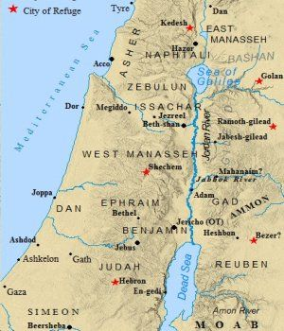

An Application—Premeditated sin is worse than other sin because it involves our intention. It assumes we know what is sin and do it anyway. But believers who claim to be unaware of some particular sin should be informed, not disciplined or punished. All people accused of anything who claim to be innocent should be assumed innocent until proven guilty. Provisions should be made to protect unknowing sinners—such as new believers—from the attacks of other believers.
Verses 43-45—Not one of the good promises which the Lord had made to the house of Israel failed; all came to pass—Looking back at the beginning, then summarizing the conquest and division of land, Joshua emphasized God’s faithfulness in all of it. The Lord gave Israel all the land which He had sworn to give to their fathers, and they possessed it and lived in it (v. 43). God gave victory over their enemies and then the Lord gave them rest on every side (v. 44). God keeps His promises, as they all came to pass (v. 45). There was still territory the tribes needed to possess, and while Israelites lived there many Canaanites still did, too. There was still much trouble ahead and tragedies that would develop during the judges and the kings. But those would be Israel’s fault, not God’s. God was faithful to the promises He made to the tribes.

Observations from the Tribe of Levi
- Although landless regarding their inheritance in the land, the Levites actually were the most privileged of all the tribes. Moses declared this privilege. Therefore, Levi does not have a portion or inheritance with his brothers; the Lord is his inheritance, just as the Lord your God spoke to him (Deuteronomy 10:9). The Lord himself was their apportionment, that is, service to Him would be their full-time and lifelong privilege (Numbers 18:20, 24; Deuteronomy 18:2; Joshua 13:33). They had the honored position of representing the other tribes before the Lord and the right to bear the Ark of the Covenant as well as care for the holy articles of the tabernacle. But you shall appoint the Levites over the tabernacle of the testimony, and over all its furnishings and over all that belongs to it. They shall carry the tabernacle and all its furnishings, and they shall take care of it; they shall also camp around the tabernacle (Numbers 1:50).
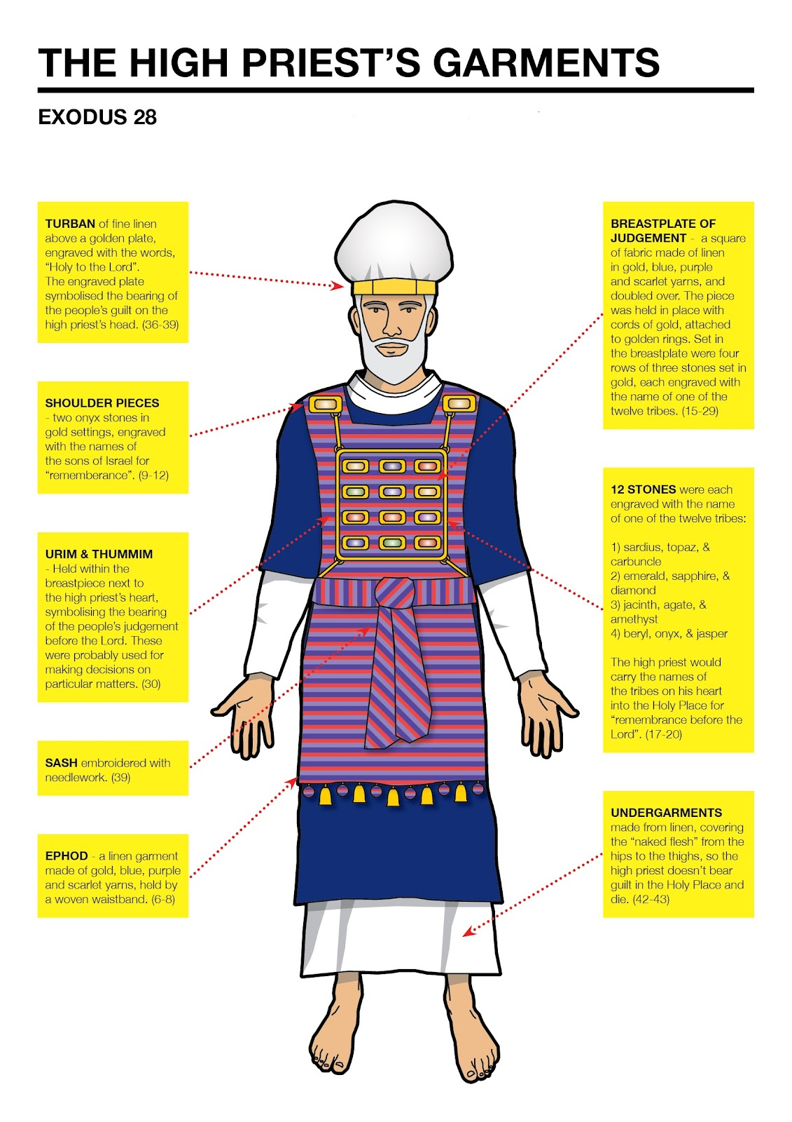
- From the family of Aaron, within the tribe of Levi, came the priests who were privileged to offer the sacrifices of the people. Both priests and Levites were financially supported by the tithes of the people, thus enabling them to give their full time to ministering before the Lord. The Levitical priests, the whole tribe of Levi, shall have no portion or inheritance with Israel; they shall eat the Lord’s offerings by fire and His portion. They shall have no inheritance among their countrymen; the Lord is their inheritance, as He promised them (Deuteronomy 18:1-2).
- The responsibility for the tabernacle was serious business, as it represented God amidst the Israelites as they journeyed. Approaching God is like approaching a hot fire—you get close enough to warm yourself but never too close that you get burned. “So when the tabernacle is to set out, the Levites shall take it down; and when the tabernacle encamps, the Levites shall set it up. But the layman who comes near shall be put to death” (Numbers 1:51). “The sons of Israel shall camp, each man by his own camp, and each man by his own standard, or flag, according to their armies.” This was to keep morale among the troops, as they had comradery with their kin, as they fought together in the larger military unit. They would be numbered separately and each warrior would be registered individually. “But the Levites shall camp around the tabernacle of the testimony, so that there will be no wrath on the congregation of the sons of Israel. So the Levites shall keep charge of the tabernacle of the testimony” (v. 52). The point here was to prevent any unnecessary profane approach or activity around the Tabernacle which represented sacredness and holiness never to be taken lightly. The Levites, like godly people today, were the sentry posts of protection for the people from the wrath of God.
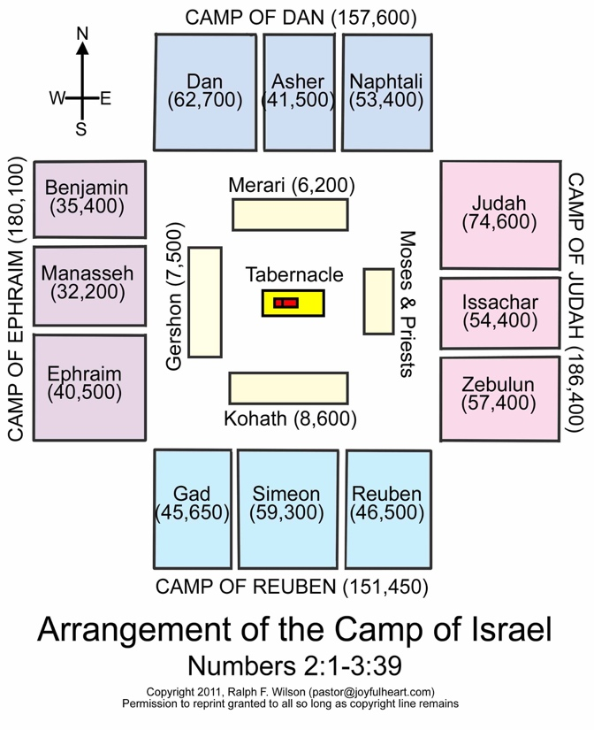

An Application—Similarly, we belong to the household of God—a collection of individuals united together as a family, each distinct and individual in gifts, opportunities, and responsibility. In this sense, the church is never called a community—a conglomeration of individuals for the common good. Even in Israel, they fought as an army of tribes—each distinct, but contributing to the overall battle strategy together.

- Unfortunately, it seems the influence of the Levites diminished over time. They do not seem to have lived up to their potential, nor fulfilled the mission God had given them. Idolatry and corruption eventually spread throughout the nation, and even the priesthood became corrupted, until God had to judge His nation and people. God commanded Ezekiel to “dig through the wall of the entrance to the court." So I dug through the wall, and behold, an entrance. And He said to me, “Go in and see the wicked abominations that they are committing here” (Ezekiel 8:7-8). When Ezekiel looked he saw every form of creeping things and beasts and detestable things, with all the idols of the house of Israel, were carved on the wall all around. Standing in front of them were seventy elders of the house of Israel (vv. 10-11). Even though God ensured a spiritual influence among His people, that was no guarantee that the influence would produce what it was designed to. Just because the body of Christ teaches the Bible, prays, sings, and meets does not guarantee devoted believers.

An Application—Today we might say of churches and ministries, dig through the wall and you will see they justify divorce and remarriage. Dig through the wall and you will see women clergy. Dig through the wall and you will see they encourage homosexuality. Dig through the wall and you will see them cohabitating and fornicating. Dig through the wall and you will see their spiritual immaturity and biblical ignorance.

Jacob Blesses Judah
“Judah, your brothers shall praise you; Your hand shall be on the neck of your enemies; Your father’s sons shall bow down to you. Judah is a lion's whelp; From the prey, my son, you have gone up. He couches, he lies down as a lion, and as a lion, who dares rouse him up? The scepter shall not depart from Judah, Nor the ruler’s staff from between his feet, Until Shiloh comes, and to him shall be the obedience of the peoples. He ties his foal to the vine, and his donkey’s colt to the choice vine; He washes his garments in wine, And his robes in the blood of grapes. His eyes are dull from wine, And his teeth white from milk” (Genesis 49:8-12).

Verse 8—Judah, your brothers shall praise you—Jacob’s blessing provides a miniature preview of the kingship of Judah that would span the years until Messiah should come. It is appropriate that Judah would be praised by his brothers since his name means “praise.” Leah stated at his birth, “This time I will praise the Lord.” Therefore, she named him Judah (Genesis 29:35). Thus, Judah, whose name means praise, will be praised by his brothers who will do so in recognition of his leadership. Jacob intended this effect with the repetition of this concept as he began his blessing of Judah.
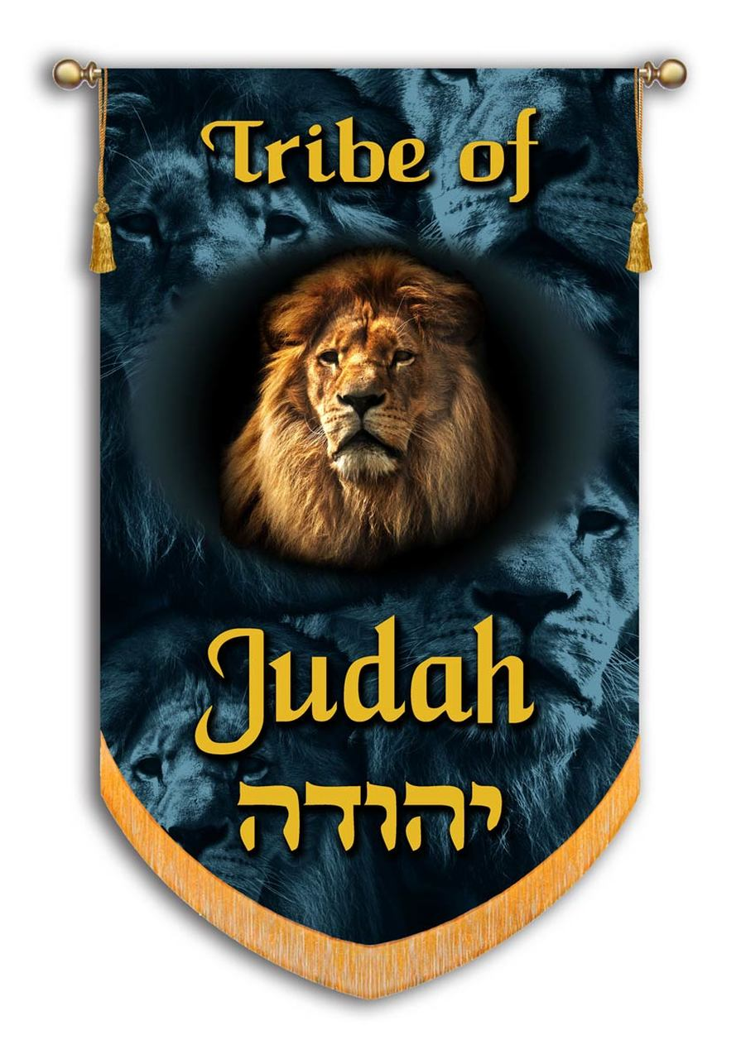

PT—Because Reuben, Simeon, and Levi had disqualified themselves, Judah received the leadership of the tribes and the blessing that normally went to the first-born. This is how the leadership of the tribes and the Messianic line fell to Judah. Jacob evidently forgave Judah’s earlier sins because he repented and later sacrificed himself for Jacob’s wellbeing (Genesis 44:30-34). Judah had wished himself to be put in Benjamin’s place, and to undergo perpetual exile and servitude, rather than convey to his father tidings which would be the cause of his destruction.

An Application—Two lessons emerge from Judah’s sensitivity—he was willing to lose everything and achieved greatness but many who are first will be last; and the last, first (Matthew 19:30). In giving up his life, Judah also actually found it. For whoever wishes to save his life will lose it; but whoever loses his life for My sake will find it (Matthew 16:25). Such is the way of our heavenly Father. The principle is to leave everything behind as you prioritize eternal rewards in your life. The path of discipleship is the pursuit of heavenly profit by denying yourself as your following Christ. Judah received the leadership inheritance that would lead to his brother’s submission.

- Your hand shall be on the neck of your enemies—This is a graphic reference to the humiliation of one’s enemies in battle. The oracle finds reinforcement in Judah’s name, as if to say that Judah would experience what his name meant. He would show himself powerful over the enemies and be praised for it. To expose the neck of one’s enemy was a symbolic gesture signifying that the enemy had been conquered. When they brought these kings out to Joshua, Joshua called for all the men of Israel, and said to the chiefs of the men of war who had gone with him, “Come near, put your feet on the necks of these kings.” So they came near and put their feet on their necks (Joshua 10:24).
- Your father’s sons shall bow down to you—The praise that Judah would receive will also be incorporated into submission and homage due to the exertion of his leadership in the family. This initial description prefigures the kingly role of the tribe expanded in the remainder of the blessing.

Verse 9—Judah is a lion’s whelp; From the prey, my son, you have gone up—Jacob uses the metaphor of the lion’s cub to portray Judah as powerful. The figure of a lion is used for the monarchy in many cultures. The image recalls the ferociousness of Judah’s powerful leadership. He is seizing his prey and bringing it back to the den.
- He couches, he lies down as a lion, and as a lion, who dares rouse him up?—In addition to the seizing and bringing back the prey, Judah is pictured as reclining over the prey back in the den. Satiated with the battle and kill, he will be mighty in battle and kingly in repose, and as a lion, who dares rouse him up?
PT—It is interesting to note that five different animals are associated with various tribes in Jacob’s blessing. Judah is compared to a lion, Issachar is associated with a donkey (v. 14), Dan with a serpent (v. 17), Naphtali with a deer (v. 21), and Benjamin with a wolf (v. 27).
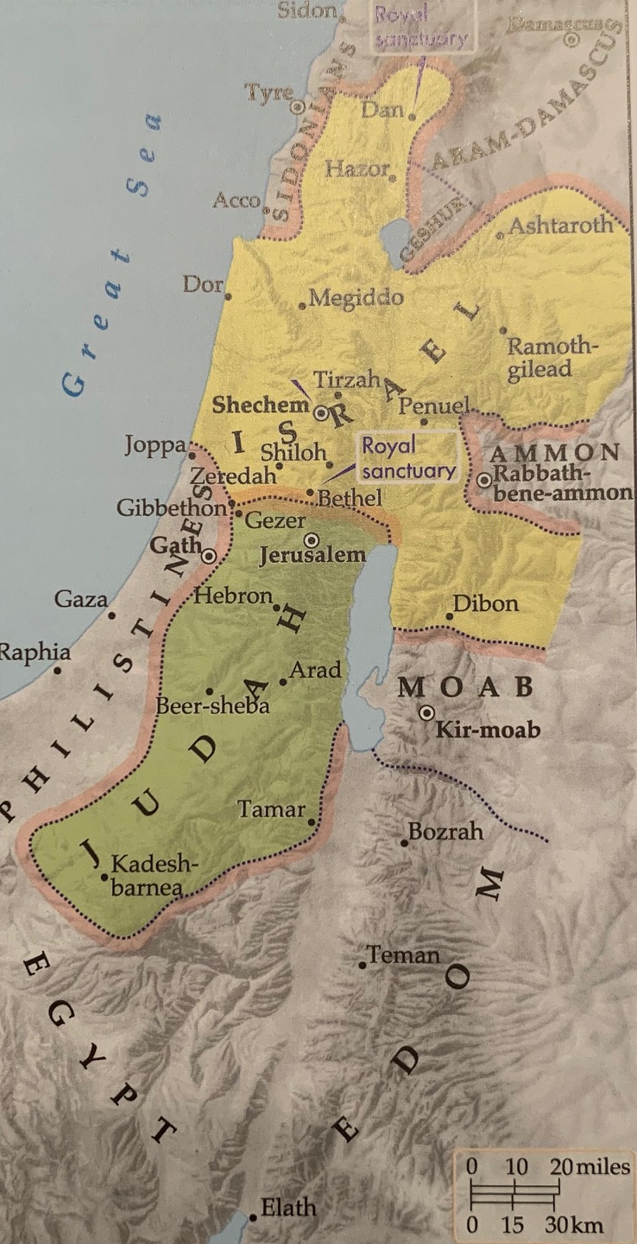

Verse 10—The scepter shall not depart from Judah—This verse moves into promise for the eschatological future, looking beyond the normal period of Israel’s history to the dawn of the messianic age. The scepter was the symbol of kingship—it would be Judah’s. Although the early government of Israel was a theocracy rather than a monarchy, the Lord anticipated that there one day would be kings in Israel. “When you enter the land which the Lord your God gives you, and you possess it and live in it, and you say, ‘I will set a king over me like all the nations who are around me’” (Deuteronomy 17:14).
- Nor the ruler’s staff from between his feet—This ownership of this ruler’s staff strengthens the idea that the theocratic administration would remain with Judah. The symbols of royalty, the scepter and the lawgiver’s staff, reveal that rulership will never depart from Judah. The right to reign as king will always be with the tribe of Judah. No legitimate king could rise from another tribe. The figure from between his feet could refer to the descendants who would come from his genitals. Only these would rule.
- Until Shiloh comes—The scepter and staff, that is, the theocratic administration—would remain in the tribe of Judah until the one comes to whom it belongs. The point is that in Shiloh, the one to come to whom rulership belongs, the scepter will reach its greatest glory and extent. Without much detail, this prophecy provides a hint at the coming of the Messiah. Later in Israel’s history, God chose a descendant of Judah, David, to be the family through whom the Messiah would come your house and your kingdom shall endure before Me forever; your throne shall be established forever (2 Samuel 7:16).

Then the genealogy narrowed once more when a specific town within Judah, Bethlehem, was chosen as the site of Messiah’s birth. From you One will go forth for Me to be ruler in Israel. His goings forth are from long ago, From the days of eternity (Micah 5:2). Finally, in his genealogy of Jesus, Matthew confirmed that Jesus possessed all of the credentials to be the Messiah. Jacob was the father of Joseph the husband of Mary, by whom Jesus was born, who is called the Messiah (Matthew 1:1-16). The fact is, there is only one who meets all of the qualifications and fulfills all of the prophecies who is described the throne room of heaven as the Lion that is from the tribe of Judah, the Root of David (Revelation 5:5). This is a reference to the Lord Jesus Christ, whose descent is from the tribe of Judah.
- and to him shall be the obedience of the peoples—The character of Shiloh’s rule will be such that obedience of the peoples or nations will dominate that rule. The prophet Isaiah noted of Messiah’s future Kingdom rule then in that day the nations will resort to the root of Jesse, who will stand as a signal for the peoples; And His resting place will be glorious (Isaiah 11:10). The Apostle Paul declared that the Father’s ultimate purpose is for all peoples everywhere and from all time, at the name of Jesus every knee will bow—in heaven and on earth and under the earth, and every tongue confess that Jesus Christ is Lord to the glory of God the Father.

Verse 11—"He ties his foal to the vine, and his donkey’s colt to the choice vine”—The language here reveals an abundance in the Land of Promise. This prophecy is catching the mood of the time when the curse will have little effect and the Land will have great blessing. Binding a foal to a vine speaks of a time of great plenty and splendor.
- He washes his garments in wine, and his robes in the blood of grapes—These expressions speak of abundance—it will be a golden age for sure. So much so, that commodities such as wine and the grapes they are made from will be bountiful. The sense of the imagery is that wine, the symbol of prosperity and blessing, will be so plentiful that even the choicest vines will be put to such everyday use as tethering the animals of burden and vintage wine will be as commonplace as wash water. Jesus turned water into wine at the marriage of Cana in Galilee (John 2:1-11). By the miracle Jesus was signifying that the kingdom was at hand—the creation of the abundance of wine signaled the Messiah was present.

Verse 12—His eyes are dull from wine, and his teeth white from milk—These images reveal that Israel’s experience of thorns and sweat will give way to shouting and feasting. Judah will have abundance of which to satiate their appetites. Understood as a symbols of abundance, the dark or red eyes would be from drinking wine, and the white teeth from drinking milk. This one is a picture of vigor and strength. This prophecy is the first of many that follow in the Old Testament that associates bumper crops with the golden age of future blessing.

An Application—Everything in the Bible is leading to the emergence of the kingdom of Jesus Christ. Everything God is doing in the world is moving to that conclusion. Believers should focus on the supremacy of Jesus Christ and His ushering in of that kingdom rule. Believers should be living in such a way that they are preparing for that eternal rule by how they conduct their lives here in earth. The only thing you are taking with you into eternity is your own discipleship.

A Review of the History of the Tribe of Judah
The blessing of Jacob upon Judah was a series of prophecies pronounced upon him about his life and future. Judah’s subsequent history is a marvelous record of God’s plan to inaugurate the Messiah, who would be the fulfillment of the promises made to the patriarchs and their posterity.

- Judah and his brothers had tried to prevent Joseph from gaining prominence over them by selling him into Egypt. Now Judah attempted to prevent Tamar from fulfilling her levirate rights in his family. Tamar intervened with her disparate actions which God used as a corrective for Judah. God’s plans cannot so easily be thwarted—whether the ones he had for Joseph, or the ones He had for Judah’s line.

Genesis 38 in Review
Verses 1-4—Judah saw there a daughter of a certain Canaanite whose name was Shua; and he took her and went in to her (v. 2)—The verse presents the complication that Tamar faced to resolve her need to have a son in the family. Judah had separated himself from his brothers and married a Canaanite woman. This act was out of harmony with the will of the patriarchs not to marry a Canaanite woman. From this marriage Judah had three sons. At this point, if it had been left up to Judah, the family would have assimilated with Canaanites.

Verses 6-11—Now Judah took a wife for Er his firstborn, and her name was Tamar.... Then Judah said to Onan, “Go in to your brother’s wife”… then Judah said to his daughter-in-law Tamar, “Remain a widow in your father’s house until my son Shelah grows up”; for he thought, “I am afraid that he too may die like his brothers.” So Tamar went and lived in her father’s house—Er and Onan both did evil in the sight of the Lord. Er, Judah’s firstborn, was evil in the sight of the Lord, so the Lord took his life (v. 7). No details are given but that he was wicked enough to warrant his untimely death. This word evil describes something deserving of divine judgment as in Genesis 6:5 where God said, “every intent of the thoughts of his [mankind] heart was only evil (deserving of judgment) continually.” Whatever Er was doing brought divine justice. Judah asked Onan to take Tamar, and he was willing to use the custom of marrying the elder brother’s widow, Tamar, to have her sexually to gratify himself, but not raise up a child through it and spilled his seed on the ground. God took his life also. Both fought against God’s plan in some way. Judah withheld his youngest son from marrying Tamar, fearing that he might lose this son as well.

An Application—Evil is a wickedness that God will judge. He did so at the Flood. Then the Lord saw that the wickedness of man was great on the earth, and that every intent of the thoughts of his heart was only evil continually. The Lord was sorry that He had made man on the earth, and He was grieved in His heart (Genesis 6:5-6). Two of the six things God hates is a heart that devises wicked plans, feet that run rapidly to evil (Proverbs 6:18). Paul warned believers to abstain from every form of evil (1 Thessalonians 5:22). Enough said. But if you ignore this warning, expect God to hold you accountable.

Verses 12-23—So she removed her widow’s garments and covered herself with a veil, and wrapped herself… for she saw that Shelah had grown up, and she had not been given to him as a wife… So he [Judah] gave them to her and went in to her, and she conceived by him—The scene continues to show Judah as profane, while portraying Tamar as taking a great risk to obtain what was her right. After the death of Judah’s wife, Tamar lured Judah into what was for him an immoral union with an unknown prostitute. Judah had negotiated with Tamar for a kid from the flock for the tryst. Until he could send the payment, though, he had to give his pledge—his tokens of identification—his seal, cord, and staff. The result of the transaction was that Tamar conceived. Even though she did what justice and the death of her husband demanded of her—it was a very dangerous scheme.
PT—Scripture does not cast any moral judgment upon Tamar. She is presented in the Bible in a favorable light. Boaz said of her, “moreover, may your house be like the house of Perez whom Tamar bore to Judah, through the offspring which the Lord will give you by this young woman” (Ruth 4:12). What we can say is that she had the right to have a child by the nearest kin to her deceased husband. She played on the vice of Judah to bear this child, and her deception worked.
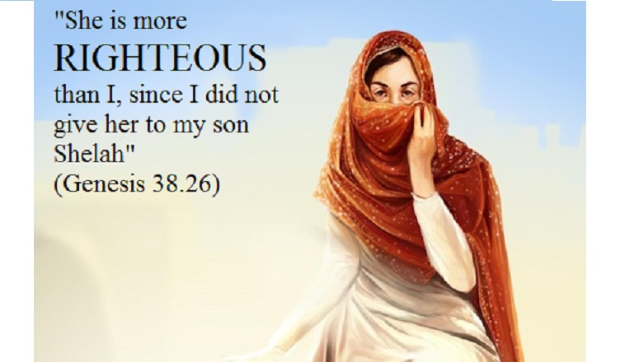

Verses 24-26—Now it was about three months later that Judah was informed, “Your daughter-in-law Tamar has played the harlot, and behold, she is also with child by harlotry.” Then Judah said, “Bring her out and let her be burned!” And she said, “Please examine and see, whose signet ring and cords and staff are these?” Judah recognized them, and said, “She is more righteous than I, inasmuch as I did not give her to my son Shelah”—This scene adds hypocrisy to Judah’s lack of integrity. Judah condemned her to be burned until he found out he was the guilty party. Then, rather than be included in any punishment, he simply exonerated her by saying she is more righteous than I, for he did not fulfill his responsibilities. Although Tamar’s method was desperate, she did nothing the law did not entitle her to. By this, she won the right to be the mother of Judah’s children and in the process was held up as more righteous.

PT—Tamar’s risky ploy came to light, but she was exonerated by being in the right. Judah’s reputation suffered another blow—he was both immoral and hypocritical. As is often the case. A desperate act to set things right will reveal the reason for the act, namely, that someone else has been responsible or faithless.

Verses 27-30—It came about at the time she was giving birth, that behold, there were twins in her womb. ne put out a hand, and the midwife took and tied a scarlet thread on his hand, saying, “This one came out first.” But it came about as he drew back his hand, that behold, his brother came out. Then she said, “What a breach you have made for yourself!” So he was named Perez. Afterward his brother came out who had the scarlet thread on his hand; and he was named Zerah—God granted twins to Tamar—the line of Judah continued because of her. The births, however, were unusual. The second child broke out first and was name Perez, ‘he who breaks through’ signifying the completion of Tamar’s struggle and depicted the destiny of the predominance of Perez’ tribe. The second child, whose hand had been the first to emerge from the womb was named Zerah. In Judah’s family, in spite of Judah’s irresponsible ways, twins were born and the younger surpassed the elder.

PT—Through this exceptional birth, God worked out the principle that His plan for the younger to be subservient to the elder could not be frustrated. Whether that had to do with Judah and his brothers’ submission to Joseph, or Judah’s jeopardizing of his line by marrying Canaanite women. God was providentially protecting the tribal family from the corruption in the family line, thereby ensuring the line’s integrity. God’s plan could not so easily be set aside.

An Application—We should not engage in any attempt to subvert the revealed will of God. We may attempt to modify God’s will by actively engaging in schemes to concoct an alternative outcome. But that outcome will be a violation of God’s will, and force God to act to preserve His revealed will in spite of one’s resistance to it. James said, therefore whoever wishes to be a friend of the world makes himself an enemy of God. Or do you think that the Scripture speaks to no purpose: “He jealously desires the Spirit which He has made to dwell in us”? (James 4:4-5). The world urges us to love ourselves, to put our pleasures before God’s pleasures. God does not want you to have the pleasures from the association with the world. God jealously desires your spiritual ability to choose righteousness rather than the world.
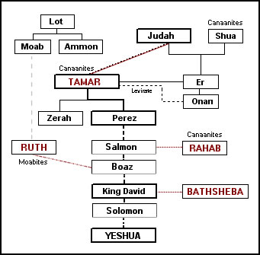
- Judah intercedes on behalf of Benjamin, which demonstrates his great love for his brother and great concern for his father. This appeal of Judah before Joseph, before the brothers knew it was Joseph, showed himself a changed person, one much more fit now for leadership.

Genesis 44 in Review
Verses 18-20—Then Judah approached him, and said, “Oh my lord, may your servant please speak a word in my lord’s ears…We have an old father and a little child of his old age. Now his brother is dead, so he alone is left of his mother, and his father loves him”—Judah’s speech begins with the fear and trembling of one who stands condemned. Joseph has as much power as Pharaoh, either to condemn or to pardon. Judah will make his appeal, wording his speech in such a way as to appeal to Joseph’s compassion for the father, whom he mentions no less than fourteen times in the speech. Judah has changed.

Verses 21-29—…”Bring him down to me that I may set my eyes on him.” But we said to my lord, “The lad cannot leave his father, for if he should leave his father, his father would die.”… Our father said, “Go back, buy us a little food.” But we said, “We cannot go down. If our youngest brother is with us, then we will go down… If you take this one also from me, and harm befalls him, you will bring my gray hair down to Sheol in sorrow”—Judah appealed to Joseph on the basis of the evil that would come upon his father if he returned without Rachel’s son—actually, Judah surmised that Jacob would die. The expression bring my gray hair down to Sheol is figurative, using a part for the whole—they would put Jacob in the grave. But the gray head signifies a long life of worry and trouble. Interesting that they had not considered that consequences before and were overwhelmed when they could not console Jacob over his son. So Jacob tore his clothes, and put sackcloth on his loins and mourned for his son many days. Then all his sons and all his daughters arose to comfort him, but he refused to be comforted. And he said, “Surely I will go down to Sheol in mourning for my son.” So his father wept for him (Genesis 37:34-35).

Verses 30-34—“Now, therefore, when I come to your servant my father, and the lad is not with us, since his life is bound up in the lad’s life, when he sees that the lad is not with us, he will die…. Now, therefore, please let your servant remain instead of the lad a slave to my lord, and let the lad go up with his brothers”—It appears that the anguish of Jacob had been felt by all of the brothers. Judah exhibits self-sacrificial loyalty by requesting that he be kept instead of Benjamin. “for how shall I go up to my father if the lad is not with me—for fear that I see the evil that would overtake my father?” (v. 34). Judah explained the whole story. He did not try to hide or excuse the brothers’ guilt. This is the longest speech in Genesis. Rather than hating their father for favoring Joseph and then Benjamin, the brothers were now working for his welfare.

PT—The supreme proof of Judah’s repentance, and the moral high point of his career, was his willingness to trade places with Benjamin and remain in Egypt as a slave. In this great test, the brothers, through Judah’s leadership, demonstrated they had changed, that they were repentant over their sin against their brother, Joseph. No future nation could long survive without such care and compassion. Consequently, Joseph would make himself known to them (Genesis 45:3).

An Application—If believers have been envious, jealous or hateful of others in the past, then God might have to put the through stressful situations to make them realize how much they must do to avoid such attitudes and behavior toward one another. To recognize the need to serve the greater good of one another may require coming to the point of laying down one’s life for others, by which they discover there is no greater love. God calls each of us to such self-sacrificing love for one another. We know love by this, that He laid down His life for us; and we ought to lay down our lives for the brethren (1 John 3:16).

- David, of the tribe of Judah, is given what has been called the Davidic Covenant. This covenant defines David’s descendants, prescribes the line of Christ, the Messiah of Israel, and guarantees a future for the people of Israel.

2 Samuel 7 in Review
Verses 8-9—Now therefore, thus you shall say to My servant David, “Thus says the Lord of hosts, ‘I took you from the pasture, from following the sheep, to be ruler over My people Israel. I have been with you wherever you have gone and have cut off all your enemies from before you’”—Nathan, after reminding David that God said He had never dwelt in a house, and He never asked David to build one for Him (apparently, God is not house-oriented [Isaiah 66:1-2]), reminds David of God’s provision in his life. That included taking him from following the sheep, to be ruler over My people Israel. God had been with him all along the way, and God had cut off David’s enemies.
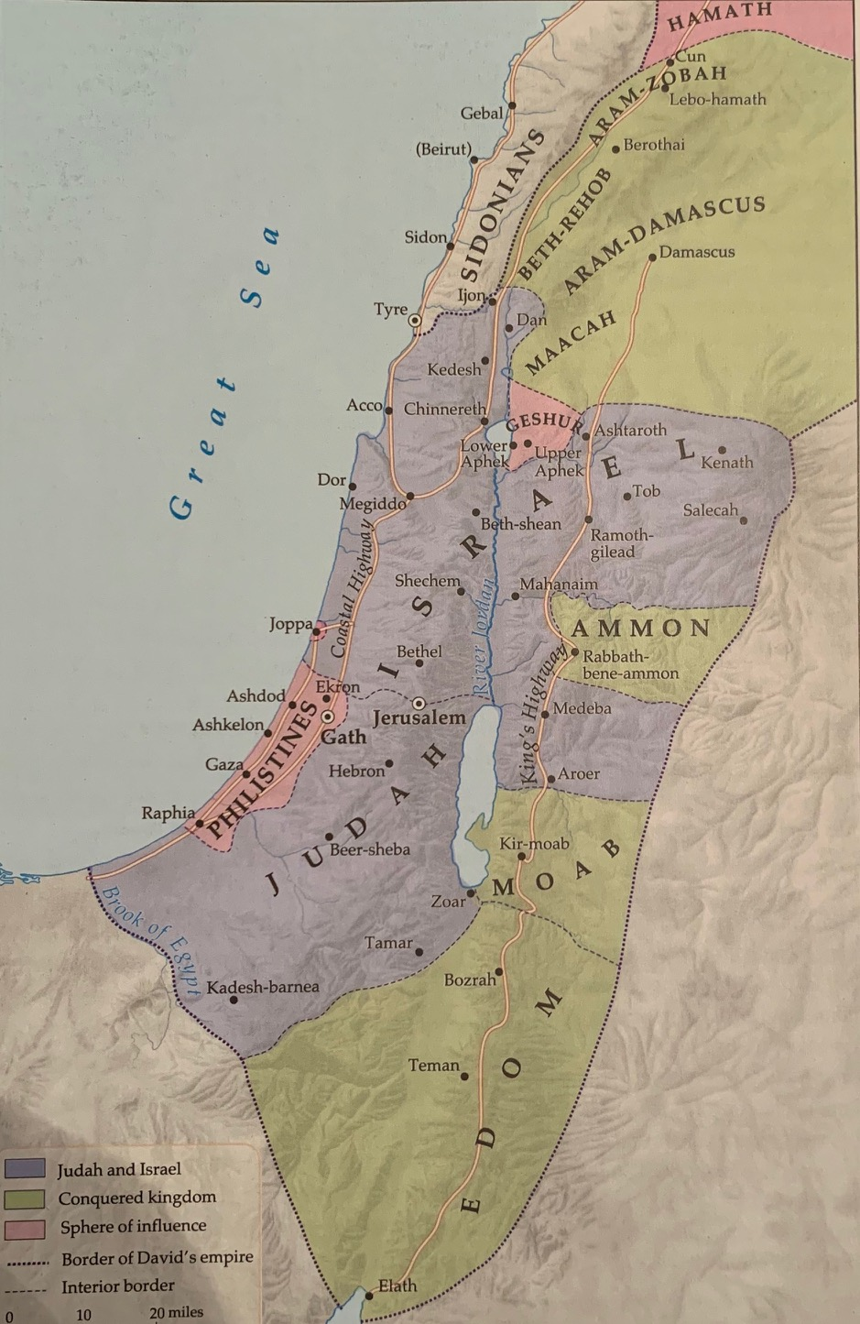

Verses 10-11— … and I will make you a great name, like the names of the great men who are on the earth. I will also appoint a place for My people Israel and will plant them, that they may live in their own place and not be disturbed again, nor will the wicked afflict them any more as formerly, even from the day that I commanded judges to be over My people Israel; and I will give you rest from all your enemies. The Lord also declares to you that the Lord will make a house for you.—Then God talked about what He was going to do.
- I will make you a great name, like the names of the great men who are on the earth.
- I will also appoint a place for My people Israel so they will not be disturbed again
- I will give you rest from all your enemies.
- The LORD also declares to you that the LORD will make a house for you—a dynasty.
Some of God’s promises to David would find fulfillment during his lifetime (vv. 8-11a) and others after his death (vv. 11b-16). The promise of a great name is reminiscent of God’s covenant with Abraham (Genesis 12:2), and suggests (though the word ‘covenant’ nowhere appears in these verses) that the Davidic kingship is being incorporated into the Abrahamic covenant. This is reinforced by the reference to God’s people Israel dwelling in their own place, undisturbed by enemies (v. 10), a reference to Genesis 15:18-21 and Deuteronomy 11:24. There will be an everlasting royal dynasty and kingdom for David and his heirs.

Verses 12-17—I will raise up your descendant after you, who will come forth from you, and I will establish his kingdom. He shall build a house for My name, and I will establish the throne of his kingdom forever…Your house and your kingdom shall endure before Me forever; your throne shall be established forever. The rest of Nathan’s revelation was an elaboration on this fourth promise, the David Covenant. The covenant included five basic promises:
- David’s descendants would establish a kingdom after his death. The future kings of Israel would always be of the bloodline of David, as Jesus was through David and Bathsheba’s son Nathan (Luke 3).
- David’s son (Solomon) shall build a house for My name
- I will establish the throne of his (Solomon’s) kingdom forever. So, all of the future kings of Israel would be connected to the throne of Solomon (as Jesus was through Joseph’s marriage to Mary). The angel intervened to ensure the marriage happened.
- Whenever any of this line of kings commits iniquity, I will correct him with the rod of men and the strokes of the sons of men but My lovingkindness [loyalty to the blood line of David] shall not depart from him, as I took it away from Saul (v. 15).
- Unlike every other kingdom of the earth, David’s kingdom shall endure before Me forever; your throne shall be established forever (v. 16). This last promise is finally fulfilled by Jesus Christ (Luke 1:31-33) who will take the throne at His Second Coming (Matthew 1:11; 19:28; Acts 15:16-18) and reign on earth for a thousand years (Revelation 20). Forever here is in the sense of as long as the earth lasts, since it is destroyed after Christ’s 1000-year reign (Revelation 21:1-3).
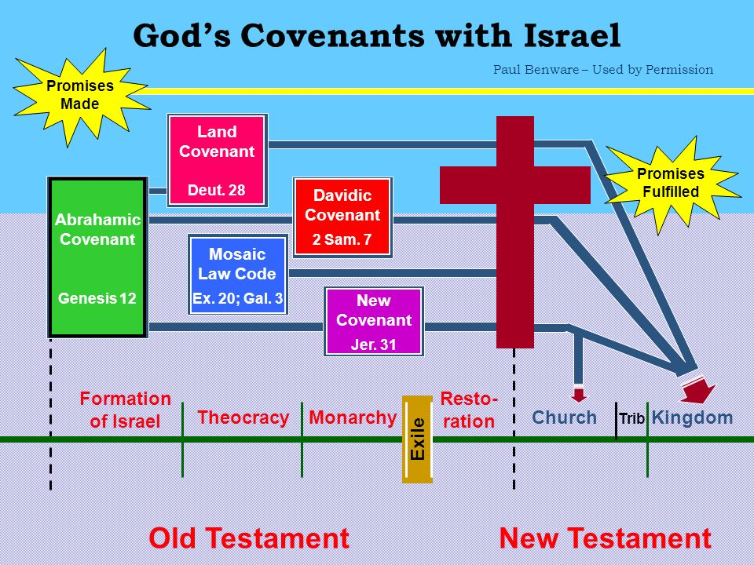

This was not a promise of uninterrupted rule. It has been interrupted since the Babylonian captivity, because of the sins of the kings. Rather this was a promise that the right to rule as king over Israel would always be with someone from David’s genealogy, from the tribe of Judah, as Jesus mother Mary was that direct genealogical descendant through David and Bathsheba’s son Nathan (Luke 3).

PT—The Davidic Covenant guarantees, not just a king but a kingdom, not just a future for David’s line, but a future for the genealogical nation of Israel in their ancient homeland. It is fulfilled in Jesus, but not as Jesus walked the earth, nor as Jesus is building His church today.

An Application—The church does not fulfill the Davidic covenant, progressively or any other way. The throne of David will be established on earth during the 1000-year kingdom described in Revelation 20, after the church has been removed (1 Thessalonians 4:13-18; Romans 11:17-24).

Observations from the Tribe of Judah
- While the tribes were marching through the wilderness, it was the tribe of Judah that went first the standard of the camp of the sons of Judah, according to their armies, set out first (Numbers 10:14). The standard of the camp (v 14, 18, 22, 25) was apparently some kind of a symbol put up on a pole to signify the tribal hosts.
- After the Israelites conquered the land of Canaan and began to possess it the lot for the tribe of the sons of Judah according to their families was allocated and received first (Joshua 15:1). The tribe of Judah also received and possessed one of the largest and most important sections in the southern part of the land of Canaan (Joshua 15:2-63).
- The census of Numbers 1 at the beginning of the wanderings, and the list in Numbers 26 at the end have the largest numbers of tribal population for Judah their numbered men of the tribe of Judah were 74,600 (Numbers 1:27) and these are the families of Judah according to those who were numbered of them, 76,500 (Numbers 26:22).
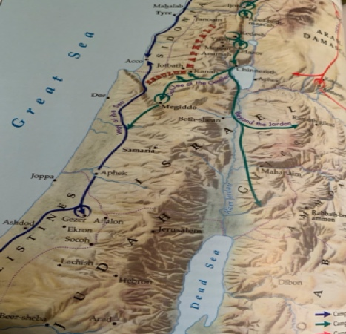
- The greatest conqueror in the history of Israel was King David of the tribe of Judah. He extended the boundaries of Israel when he subdued the Philistines, the Moabites, the Ammonites, and the Edomites so David made a name for himself… and the Lord helped David wherever he went… So David reigned over all Israel; and David administered justice and righteousness for all his people (2 Samuel 13-15). David’s son, Solomon, extended the boundaries of the kingdom to their greatest limits as he consolidated his father’s conquests. Now Solomon ruled over all the kingdoms from the River to the land of the Philistines and to the border of Egypt; they brought tribute and served Solomon all the days of his life (1 Kings 4:20-25).

- All legitimate kings of Israel throughout their history were descendants of David. The succession of 20 kings in the northern kingdom, beginning with Jeroboam in 930 BC and ending with Hoshea in 721 BC, were illegitimate and rejected by God. Even though some of Judah’s kings were evil, they were still in the royal line of succession. The prophecy of Jacob stating the symbols of royalty, the scepter and the lawgiver’s staff, would never depart from Judah did not mean that a king will always reign in Judah. However, the right of kingship will always be in this tribe and in no other.
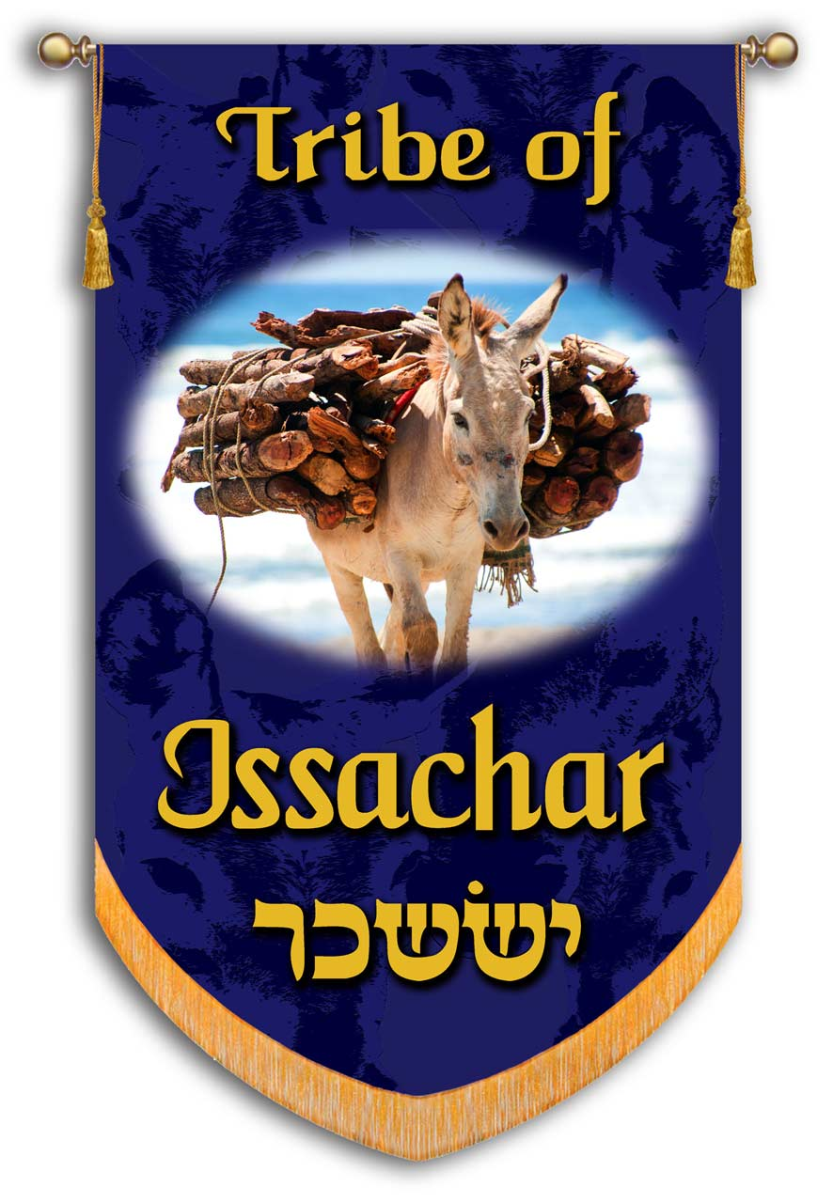
Jacob Blesses Zebulun and Issachar
Zebulun will dwell at the seashore; And he shall be a haven for ships, and his flank shall be toward Sidon. Issachar is a strong donkey, Lying down between the sheepfolds. When he saw that a resting place was good and that the land was pleasant, He bowed his shoulder to bear burdens, and became a slave at forced labor (Genesis 49:13-15).

Verse 13—Zebulun will dwell at the seashore—The descendants of Zebulun indicated that they would live near the seas, a reference to their tribal allotment between the Mediterranean Sea and the Sea of Galilee.
- And he shall be a haven for ships—Zebulun’s tribe would be known as maritime traders and dwell close to the commercial shoreline. The tribe would become enriched by seaborne trade passing through and in the region.

PT—Located in the western end of the valley of Jezreel, the tribe of Zebulun was traversed by one of the great trade routes of antiquity, the Via Maris (the way of the sea). This caravan route reached from Damascus in the northeast to Egypt in the southwest. Lying between two seas and also on a major trade route, Zebulun was heavily involved in commercial ventures. Moses’ later blessing on the tribes in Deuteronomy 33 reflects this characteristic. Among other things, he said, “for they will draw out the abundance of the seas, and the hidden treasures of the sand” (Deuteronomy 33:19).

- and his flank shall be toward Sidon—Sidon was a significant northern Canaanite city in the land later called Phoenicia. According to the tribal allotments, Zebulun’s territory was separated from Sidon by the tribe of Asher. Asher’s territory turned eastward toward Beth Dagon, touched Zebulun and the Valley of Iphtah El to the north (Joshua 19:27). Asher, however, was never able to dislodge the Canaanites who dwelt in that coastal region north of Mount Carmel and Haifa Bay. It is possible that according to this prophecy, the tribe of Zebulun in later days began to filter onto this coastal area bordering Phoenicia, thus fulfilling the prophecy that Sidon should be on Zebulun’s flank. Moses blessing included, “Rejoice, Zebulun, in your going forth, and, Issachar, in your tents” (Deuteronomy 33:18) and is a merism, meaning, in all that you do.

Verse 14—Issachar is a strong donkey—Jacob closes his series of blessings on his sons through Leah comparing her fifth born son, Issachar, to a burden-bearing donkey. Issachar means “hire” or “wage,” and he was given this name because of his mother’s exclamation at his birth: God gave heed to Leah, and she conceived and bore Jacob a fifth son. Then Leah said, “God has given me my wages because I gave my maid to my husband.” So she named him Issachar (Genesis 30:17-18). Donkeys in ancient Israel were very valuable animals of service. They carried most of the cargo that was transported. So, too, Issachar would become a burden bearer for others.
- Lying down between the sheepfolds—Issachar would desire an agricultural way of life and what it produced rather than political supremacy among the tribes. Lower Galilee, including the valley of Jezreel, which Issachar obtained, was a pleasant and productive farming area. The mention of sheepfolds refers to enclosures for holding the animals that would be needed due to the abundance of grazing in that area.

Verse 15—When he saw that a resting place was good and that the land was pleasant—Issachar would prefer abundance and luxury. The richness of the area and the plenty it would generate would content this tribe in the region.
- He bowed his shoulder to bear burdens, and became a slave at forced labor—Issachar would be too willing to trade his liberty for the material things of life. The future of the tribe seeks to be forced labor, for after seeing that rest was good and the land was pleasant, Issachar would become a servant, lowering his shoulder to accept the burden. Bearing burdens and forced labor describe compulsory labor of subservient people. Issachar would become unpaid labor like prisoners of war when you approach a city to fight against it, you shall offer it terms of peace. If it agrees to make peace with you and opens to you, then all the people who are found in it shall become your forced labor and shall serve you (Deuteronomy 20:10). The difference here, though, is the reversal of the relationship that should have prevailed between Israel and the Canaanites. In this case, Issachar would work for the Canaanites for that food and rest they desired. Jacob’s oracle considered the gain of rest and abundance as a mockery due to Issachar’s enslavement.
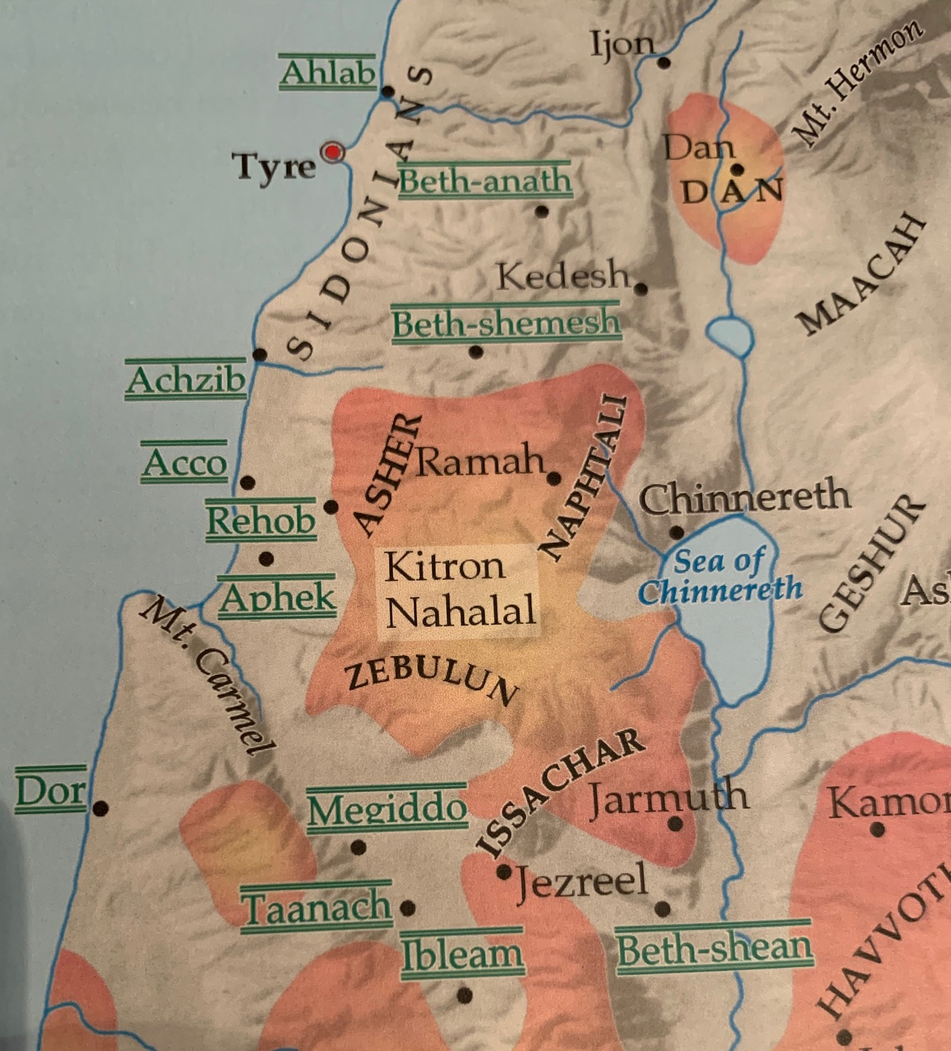

An Application—We are meant to take possession of our position in life. God has given each of us certain possessions—our personality, gifts, talents, opportunities, physical situation and so on. We must take these and move our lives with them in a godly direction. Issachar and his tribe settled for less than their calling by resisting those resources God gave them to possess their calling in life.
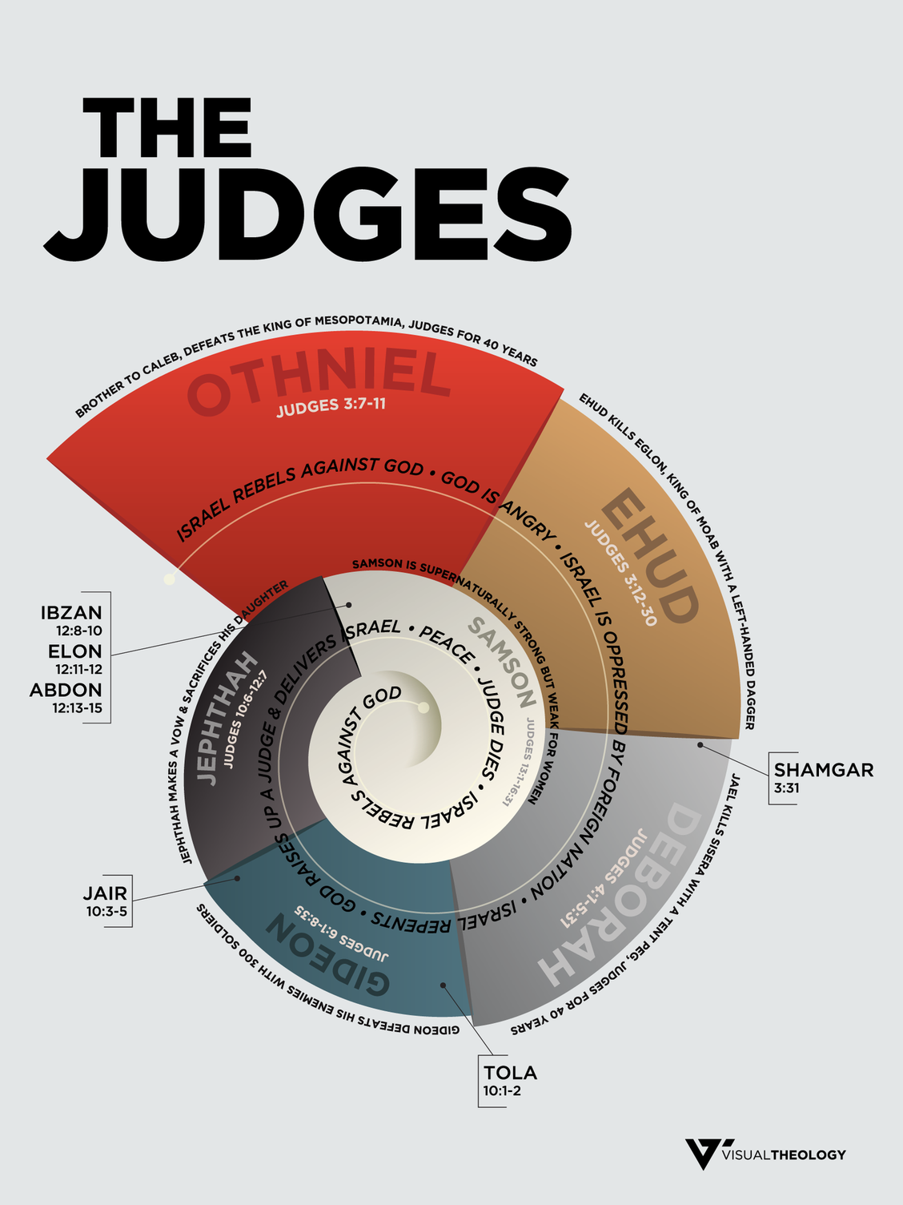

A Review of the History of the Tribe of Zebulun
There are only a few notable accomplishments mentioned in the Bible about the tribe of Zebulun. There is an individual mentioned and a few scattered accomplishments by the entire tribe.

- It seems that Zebulun was a committed tribe to whatever tasks it was assigned. That even included jeopardizing their lives if necessary.

Judges 5 in Review
Verse 14—And from Zebulun those who wield the staff of office—Zebulun is memorialized in the “Song of Deborah and Barak.” This song was composed to memorialize God’s deliverance of the Israelites from the army of Jabin, king of Hazor, whose commanding officer was Sisera. The battle, recorded in Judges 4, took place in the valley of Jezreel—in Zebulun’s territory. Then Deborah arose and went with Barak to Kedesh. Barak called Zebulun and Naphtali together to Kedesh, and ten thousand men went up with him; Deborah also went up with him (Judges 4:9-10). Evidently, each tribe had the opportunity to send a contingent of volunteers to the conflict. Zebulun was one of the tribes commended in the song for their willingness to volunteer for the battle. The staff of office may refer to official leaders of the tribe who made special contributions to the campaign.
Verse 18—Zebulun was a people who despised their lives even to death—The conduct of the tribe during the struggle with Sisera, when they fought with desperate valor side by side with their brethren of Naphtali, was such as to draw down the special praise of Deborah, who singles them out from all the other tribes. Deborah commended them for their bravery.
- And Naphtali also, on the high places of the field—This testimony of the Naphtali’s bravery and willingness to risk their own lives unto the death in the high places of the field serves as a stirring example of commitment to victory at all costs. The Canaanites were a determined enemy which required full resolve to meet in battle.

PT—This bravery and willingness to risk their own lives for God’s cause reminds us of the need to serve as faithful soldiers in the work of God. The Jerusalem church recognized such bravery and zeal with their word of commendation for Paul and Barnabas. It seemed good to us, having become of one mind, to select men to send to you with our beloved Barnabas and Paul, men who have risked their lives for the name of our Lord Jesus Christ (Acts 15:25-26).

An Application—We could probably argue that it is not possible to remove every last Canaanite, yet that is exactly what was needed and leaving any of them would be their eventual downfall. The solution for us today, is to be committed to a lifestyle of spiritual warfare. There is always sin in our lives left unconquered. So the spiritual life is a constant spiritual warfare if we are progressing and possessing. No warfare means no spiritual progress.

- One of the judges of Israel, the 12th judge Elon, was a member of the tribe of Zebulun.

Judges 12 in Review
Verses 11-12—Now Elon the Zebulunite judged Israel after him; and he judged Israel ten years. Then Elon the Zebulunite died and was buried at Aijalon in the land of Zebulun. Elon is the most famous Zebulunite who judged Israel for 10 years. He was the 12th judge in Israel. The writer noted no special deeds of his either because he performed none, or because the author chose not to feature Elon in his narrative.
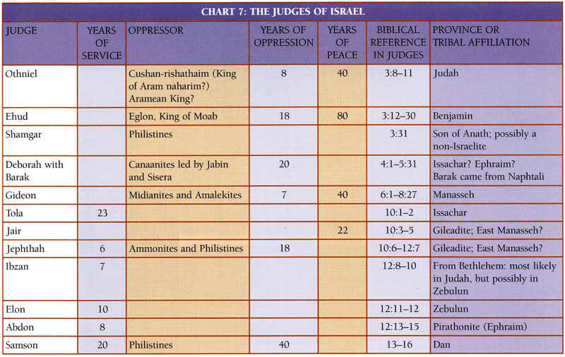

Observations from the Tribe of Zebulun
- Zebulun was one of the tribes which did not drive out the Canaanites, but only made them tributary. Zebulun did not drive out the inhabitants of Kitron, or the inhabitants of Nahalol; so the Canaanites lived among them and became subject to forced labor (Judges 1:30).
- The tribe of Zebulun took little interest in public affairs. It responded, however, readily to the summons of Gideon. …and he sent messengers to Asher, Zebulun, and Naphtali, and they came up to meet them (Judges 6:35), and afterwards assisted in enthroning David at Hebron of Zebulun, there were 50,000 who went out in the army, who could draw up in battle formation with all kinds of weapons of war and helped David with an undivided heart… [they] brought food on donkeys, camels, mules and on oxen, great quantities of flour cakes, fig cakes and bunches of raisins, wine, oil, oxen and sheep. There was joy indeed in Israel (1 Chronicles 12:33, 40).

PT—Singleness of heart and mind enabled Zebulun to be stable and successful. They kept rank and did not flee from battle due to their focused attitude of determination and undivided loyalty.

Application—We need courage to face the obstacles and conflict which is due to an unswerving commitment to the end game, goal and objective. We need to hate evil and love good—never afraid to take a stand if it means trusting God and taking on the world, just like Zebulun. But this one thing I do… (Philippians 3:13).

- Along with the other northern tribes, Zebulun was carried away into the land of Assyria by Tiglath-pileser king of Assyria [who] came and captured Ijon and Abel-beth-maacah and Janoah and Kedesh and Hazor and Gilead and Galilee, all the land of Naphtali; and he carried them captive to Assyria (2 Kings 15:29).

A Review of the History of the Tribe of Issachar
Generally, the Scriptures take a positive and commendatory stance with the tribe of Issachar. A few scattered references to the tribe make this point.

- Tola was a judge of Israel from the tribe of Issachar. He was the 6th judge of the tribes.

Judges 10 in Review
Verse 1—Now after Abimelech died, Tola the son of Puah, the son of Dodo, a man of Issachar, arose to save Israel; and he lived in Shamir in the hill country of Ephraim. —Tola (meaning “worm” in Hebrew) arose to save Israel from the tribe of Issachar sometime after Abimelech died. One of the patriarch Issachar’s sons was also named Tola (Genesis 46:13; Numbers 26:23; 1 Chronicles 7:1-2). The writer did not record how the judge Tola rose to power or exactly when. Specifically, no mention of the Lord raising him up appears, as was true also of Abimelech.

Verse 2—He judged Israel twenty-three years. Then he died and was buried in Shamir—This brief notation of his contribution to Israel’s national life pictures him as a worthy individual who enjoyed an orderly and stable tenure. He judged Israel 23 years.

PT—Two interesting facts about Tola’s judgeship stand out. First, he followed Gideon, one of the most prolific of the judges. It is not an easy thing for anyone to follow on the heels of such a champion. Second, Tola judged Israel for 23 years. That is the most years recorded for each of the judges whose years are enumerated. He must have had some success in both following after such a giant as Gideon and sustaining that judgeship for so long without mention of any failures.

- An examination of the tribal allotment to Issachar reveals that he was assigned the fertile eastern end of the Jezreel Valley.

Joshua 19 in Review
Verses 17-18—The fourth lot fell to Issachar, to the sons of Issachar according to their families. Their territory was to Jezreel and included Chesulloth and Shunem—Issachar was the fourth tribe to receives allotment from Joshua in the land of Canaan. Issachar received rich fertile territory in the midst of the Jezreel Valley in the north of Israel.

Verse 22—The border reached to Tabor and Shahazumah and Beth-shemesh, and their border ended at the Jordan; sixteen cities with their villages. —The Jordan River on the east, the borders of Manasseh on its south and southwest, Zebulun on its northwest, and Naphtali on its north prescribed its territory. Issachar received 16 towns. Issachar’s boundary on the north was Mt. Tabor and on the south Mt. Gilboa. Thus, these two mountains on either side of the valley mimicked the large ‘burdens’ on the sides of Issachar who bowed his shoulder to bear burdens, and became a slave at forced labor.

- Here we learn of another aspect of Issachar’s character spelled out in the review of the tribe’s history by the chronicler.

1 Chronicles 7 in Review
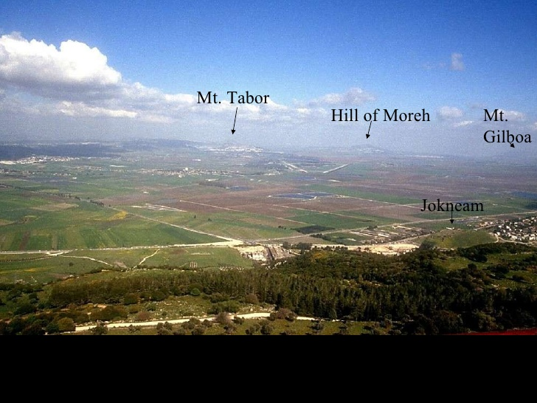
Verses 1-2—Now the sons of Issachar were four: Tola, Puah, Jashub and Shimron. The sons of Tola were Uzzi, Rephaiah, Jeriel, Jahmai, Ibsam and Samuel, heads of their fathers’ households. The sons of Tola were mighty men of valor in their generations; their number in the days of David was 22,600—The eldest son of Issachar, whose posterity are only reckoned by name. They are the principle men of the family. These men who sprang from Issachar were such mighty men, and from them a numerous tribe arose. They were famous for their courage and military exploits. Tola seemed to be the most prominent of Issachar's children, as far as their involvement with the other tribes.

Verses 4-5—With them by their generations according to their fathers’ households were 36,000 troops of the army for war, for they had many wives and sons. 5 Their relatives among all the families of Issachar were mighty men of valor, enrolled by genealogy, in all 87,000—These 36,000 men were in addition to the men of Tola. These are from the family of Uzzi. The explanation of why they had more soldiers, is in the verse above itself. They had more wives and children than Tola did. All of the other sons, along with the sons of Tola and Uzzi, had 87,000 men. This is a little more than 1/10 of all the troops mentioned (in 2 Samuel 24:8-9). It is important to know that they grew and became a strong tribe.

Observations from the Tribe of Issachar
- The chronicler noted about Issachar that of the sons of Issachar, men who understood the times, with knowledge of what Israel should do, their chiefs were two hundred; and all their kinsmen were at their command (1 Chronicles 12:32). The men of Issachar were not only knowledgeable of God’s Word, they were knowledgeable of God’s world. They understood the trends of the age so that they knew how to apply God’s Word to life. They did not have their heads in the sand.

PT—Jesus condemned some Pharisees and Sadducees for their lack of such insight into their age. do you know how to discern the appearance of the sky, but cannot discern the signs of the times? (Matthew 16:3).
- After God stimulated Deborah and Barak into action against the Canaanites, several Israelite survivors of the oppression followed their lead into the Valley of Jezreel. Deborah spoke of Issachar in her song: “And the princes of Issachar were with Deborah; As was Issachar, so was Barak; Into the valley they rushed at his heels” (Judges 5:15). Most of Issachar’s territory laid in the valley where this battle took place. When the times required bold action, Issachar’s leaders stood up to the challenge in some way that benefited the war effort of Deborah and Barak.

An Application—When we fight the spiritual battle, it requires valiant warriors who know what they are up against and how to wage war to victory. When you are strong, use your strength to drive out the things in your life that will cause you to sin! Like the men of Issachar, God’s people must take the advantage against sin by fighting for complete victory. That will require mighty men of valor…who understood the times… willing to enter the valley [as] they rushed at his heels. Bold action, decisive strategy, and a determination to fight and win. Don’t hesitate and complain.

Jacob Blesses Dan
Dan shall judge his people, as one of the tribes of Israel. Dan shall be a serpent in the way, a horned snake in the path, that bites the horse’s heels, so that his rider falls backward. For Your salvation I wait, O Lord (Genesis 49:16-18).

Verse 16—Dan shall judge his people—Jacob now turns his blessing toward the four sons born to him by the two handmaids, Bilhah and Zilpah. His oracle sets high hopes for the tribe. Bilhah was Rachel’s maid who she gave to Jacob because of her own inability to conceive. then Rachel said, “God has vindicated me, and has indeed heard my voice and has given me a son.” Therefore, she named him Dan (Genesis 30:6). Although Dan would be smaller than the other tribes, its calling was to help its fellow tribes against the suppression of a mighty enemy.
- as one of the tribes of Israel—Jacob wanted to assure Dan, possibly due to his birth of a handmaiden, that he would also be included and blessed as a tribe. Dan, born of a concubine and not as privileged as the others, as a judge, would in some way help its people get their rites.

Verse 17—Dan shall be a serpent in the way, a horned snake in the path, that bites the horse's heels, so that his rider falls backward—This explains how this vindication of his people would happen. As a snake can strike at the legs of a horse and overthrow the mightier animal, so too would Dan be able to exert itself as one of the tribes. This image suggests that the principle aspects of Dan’s conquests would be accomplished by cunning rather than by military confrontation.

Verse 18—For Your salvation I wait, O Lord—As Jacob sees the conflicts that lie ahead for Dan and Gad (see v. 19), he offers a brief prayer for their security. Jacob expressed his longing for God’s deliverance for Dan. The tribes of Israel would be a minority in Canaan, as they were in Egypt, and Dan would be one of the smaller tribes. But if this blessing should come true by the power of God, then Dan would be a victorious tribe over others that might seem more powerful. God would vindicate his people in some form possibly for Dan or by means of the tribe of Dan.

A Review of the History of the Tribe of Dan
The blessing of Jacob would guarantee a future for Dan and his posterity. That future had the potential to place Dan in a position of strength provided that Jacob’s prayer for God’s deliverance to secure that future for Dan was answered.
- Dan’s territory became a hotbed of struggle due to the Philistines constant pressure to keep the Danites out of the valley and up into the hills which finally led to Dan looking for new territory.

Joshua 19 in Review
Verse 40-45—The seventh lot fell to the tribe of the sons of Dan according to their families—Dan was the last tribe to receive its inheritance in the Promised Land. The allotment of the tribe of Dan was along the southwest Mediterranean coast of Canaan.
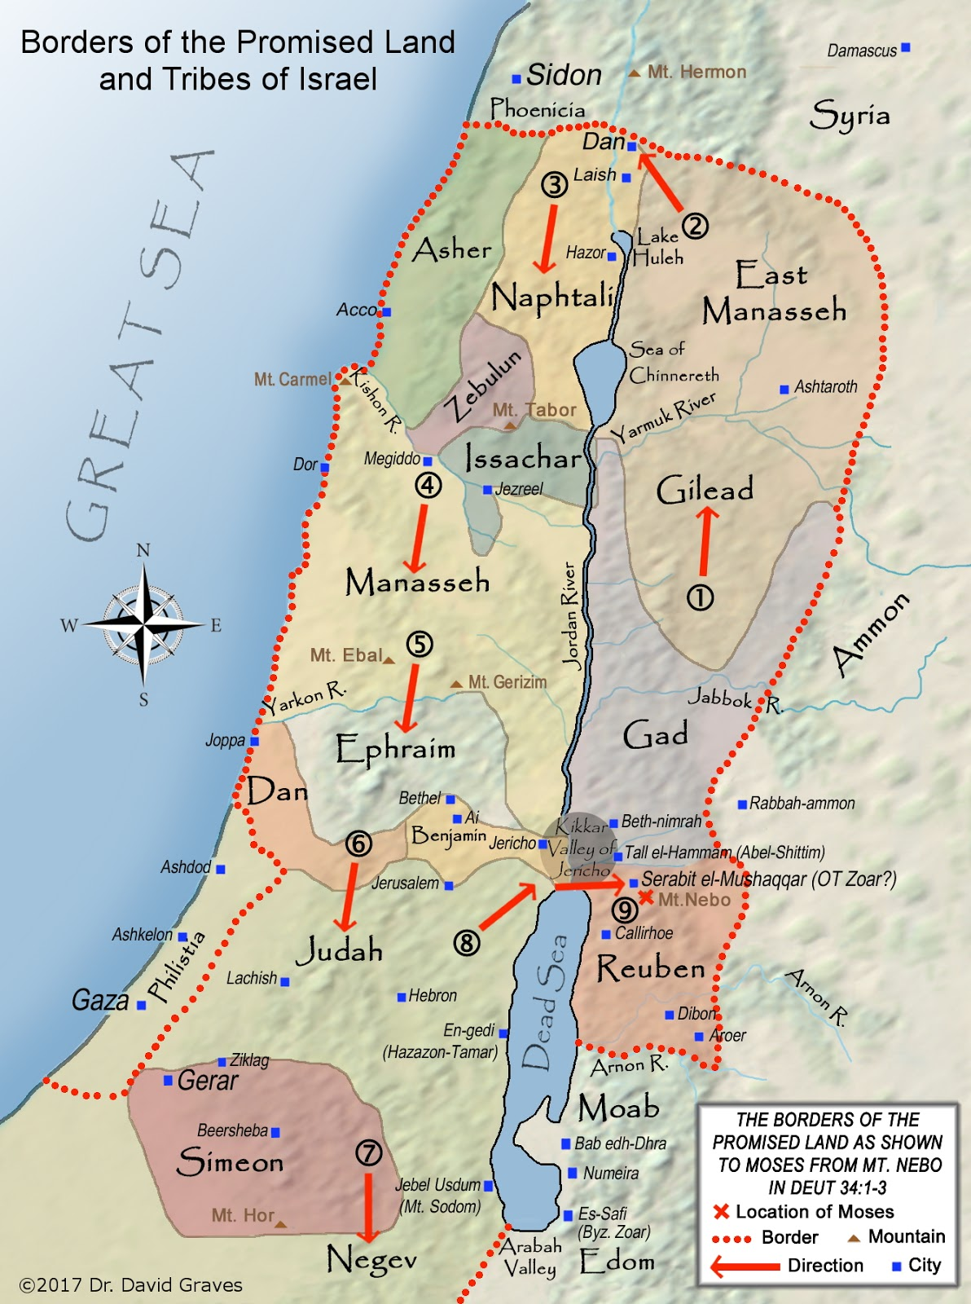

Verse 46—…with the territory over against Joppa. Dan received territory primarily in the Shephelah and Coastal Plain west of Benjamin, between Judah and Ephraim. Its land was extremely fruitful.

Verse 47—The territory of the sons of Dan proceeded beyond them—The point is that Dan failed to conquer their territory. The Amorites, who settled portions of the Philistine plain, drove the Danites out of the plains and into the hills. then the Amorites forced the sons of Dan into the hill country, for they did not allow them to come down to the valley (Judges 1:34). They did not even allow the Danites to occupy the coastal areas of their possession. They forced them to stay in the eastern hill country of their territory.

PT—The International Coastal Highway passed directly through Dan’s territory. This meant that any attempt to take control of the region automatically cut the main land link between Africa (Egypt) and Asia (Mesopotamia). Local centers and peoples in the area would be expected to resist any Danite offensive action to control the region. God knew this and expected Dan to recognize who God was and act accordingly. That meant advancing against the Canaanites and taking possession of their entire territory.

An Application—We will find ourselves often in difficulty, not because of sin, but because we have directly obeyed the revealed will of God. Doing that can frequently get us in trouble, or be the risky or dangerous direction to take. God did not lead His people to Australia, or perhaps New Zealand, or places like Greenland, or maybe Great Britain where possibly settlement would have been easier or frequent battles unnecessary. God brought them directly to a land between the great superpowers, and through which traversed the great caravan routes. It would require faith in God and His Word of Promise to secure the land and settle in it safely. We, too, will need faith to settle our lives in accordance with the revealed will of God in spite of the danger possible.

- for the sons of Dan went up and fought with Leshem and captured it. Then they struck it with the edge of the sword and possessed it and settled in it; and they called Leshem Dan after the name of Dan their father––Unfortunately, to resolve their difficulties of securing the land according to God’s will, they decided on an alternative plan. Due to the Danite farms and villages constantly oppressed by the Philistines who resented a foreign presence so near to their own centers of life, the Danites sought a different location to settle.

PT—This oppression led to God raising up the greatest son of Dan, Samson the judge, to confront the Philistines. There was a certain man of Zorah, of the family of the Danites, whose name was Manoah; and his wife was barren and had borne no children. Then the angel of the Lord appeared to the woman and said to her, “Behold now, you are barren and have borne no children, but you shall conceive and give birth to a son”…then the woman gave birth to a son and named him Samson; and the child grew up and the Lord blessed him. And the Spirit of the Lord began to stir him (Judges 13:2-3, 24).

The exploits of Samson recorded in Judges 13-16 are famous examples of nontraditional warfare demonstrating the success of the few against the many and the small against the large. Jacob’s prophecy that Dan shall be a serpent on the way, an adder in the path was partially fulfilled in Samson and his strategy of warfare against the Philistines. Samson’s bites [of] the horse's [Philistines] heels, so that his rider falls backward was short-lived, however. This pagan enemy continued to oppress the Danites, eventually precipitating their plans to leave their territory.

- Many of the tribe of Dan either did not wait for God to give them what He had promised (Joshua 13:1-7), or they were unwilling to fight the Amorites so they could inhabit it. then the Amorites forced the sons of Dan into the hill country, for they did not allow them to come down to the valley (Judges 1:34). In any case, they felt that they did not have an adequate inheritance.

Judges 18 in Review
Verses 1-6—And in those days the tribe of the Danites was seeking an inheritance for themselves to live in, for until that day an inheritance had not been allotted to them as a possession among the tribes of Israel (v. 1)—Evidently the men of Dan had grown weary of defending their little stretch of shore from the marauding’s of the Philistines. So the sons of Dan sent from their family five men out of their whole number, valiant men from Zorah and Eshtaol, to spy out the land and to search it (v. 2). They wanted to find a better location so they sent out five military scouts to survey other regions in the Promised Land.

Verses 7-13—Then the five men departed and came to Laish and saw the people who were in it living in security, after the manner of the Sidonians, quiet and secure; for there was no ruler humiliating them for anything in the land, and they were far from the Sidonians and had no dealings with anyone (v. 7). These scouts traveled north to the foot of Mt. Hermon, near the border of modern-day Lebanon, and found a sleepy little town called Laish.
- Then from the family of the Danites, from Zorah and from Eshtaol, six hundred men armed with weapons of war set out (v. 11). —They returned with a report that this would be an easy town to conquer and in which to relocate. Six hundred fighting men then departed for the town.

Verses 14-26—Now the five men who went to spy out the land went up and entered there, and took the graven image and the ephod and household idols and the molten image, while the priest stood by the entrance of the gate with the six hundred men armed with weapons of war (v. 17)—They stopped at Micah’s house, noted his images and ephod, and pondered what they should do (v. 14). What they should have done was execute Micah and the Levite since they were idolaters but that prophet or that dreamer of dreams shall be put to death, because he has counseled rebellion against the Lord your God to seduce you from the way in which the Lord your God commanded you to walk. So you shall purge the evil from among you (Deuteronomy 13:5). But they too had departed from God. Instead, they stole Micah’s images and his priest.
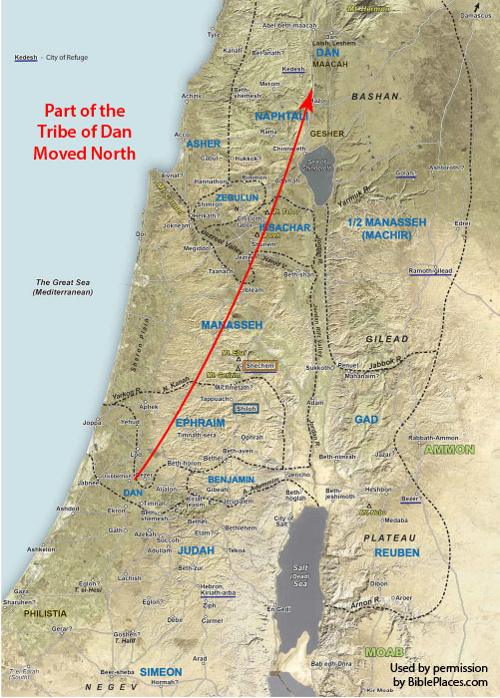
- They said to him, “Be silent, put your hand over your mouth and come with us, and be to us a father and a priest. Is it better for you to be a priest to the house of one man, or to be priest to a tribe and a family in Israel?” The priest’s heart was glad, and he took the ephod and household idols and the graven image and went among the people (vv. 19-20)—On their way they persuaded the renegade Levite in Ephraim to join them, and he brought along a graven image from the house of Micah, his former employer. Here was an opportunity for a larger ministry. It did not matter to him that it involved violating God’s will concerning ordinary Levites serving as priests.

Verses 27-31—Then they took what Micah had made and the priest who had belonged to him, and came to Laish, to a people quiet and secure, and struck them with the edge of the sword; and they burned the city with fire… and they rebuilt the city and lived in it (vv.27-28)—The 600 men army smote the town of Laish, which received no help from its ally, Sidon and there was no one to deliver them, because it was far from Sidon and they had no dealings with anyone, and it was in the valley which is near Beth-rehob. This town was easy pickings for Dan that fit their desire to live at peace and not be bothered with the need to dominate their territory against a strong and determined foe such as the Philistines.
- They called the city Dan… The sons of Dan set up for themselves the graven image… So they set up for themselves Micah’s graven image which he had made, all the time that the house of God was at Shiloh—Having renamed the town Dan, they then turned the city into a cult center for idolatrous worship in the land.

PT—There seem to be two issues that emerge from this incident which explain Dan’s unwillingness to pursue what God had determined was in the tribes’ best interest.

First, was the external threat of the Philistines. The placement of the Philistines throughout the coastal plain meant they would become a ‘thorn in the flesh’ for the tribes, including Dan. The valleys of the Shephelah were the first step in Philistine penetration into the Hill Country. Two lines in the story of Samson, the Danite Judge, stand out above all others. One is a simple statement of fact: now at that time the Philistines were ruling over Israel (Judges 14:4). The other is a rhetorical question in Judges 15:11. It was posed to Samson by the men of Judah after he had upset the delicate status quo and fragile conditions of Philistine occupation. Samson’s exploits were certain to bring Philistine reprisals unless Samson surrendered. The men of Judah asked Samson, “do you not know that the Philistines are rulers over us? What then is this that you have done to us?”

The tribes’ unwillingness to address the Philistine problem once and for all eliminated any possibility that they could settle in peace in the region. The tribe of Dan took matters into their own hands by forging a new path of settlement far away from the Philistines and the problems their presence had created. All of this, of course, was in violation of the will of God who had made clear that they were to possess their possession.

An Application—The Danites’ fear of the Philistines is like the generally righteous person’s fear of the world. In both cases, that fear often prevents righteousness from being an influence or making a difference. Possibly you know people like the tribe of Dan. Good people, generally. Those who hate evil and love good. But they are too afraid to take a stand if it means trusting God and taking on the world. They will talk against the bad guy, but not stand up to them. They seem to be afraid, but it’s not a fear of God.

Second, was the internal threat of spiritual decay. Though the threat from the outside was temporarily checked by Samson in his many exploits, the inside threat was harder to define and much more difficult to solve. The attitudes of the day were conveyed by the tribe of Dan moving away from their allotted territory. The priestly apostasy of the Levite in Micah’s house was only a generation of two removed from Moses himself. All of this pointed to internal spiritual decay, both in the relationships between men and with God.
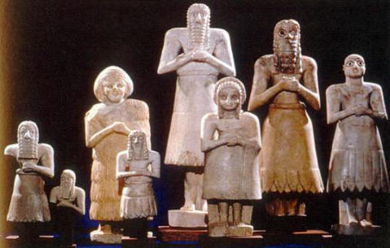

The internal decay of the tribes outweighed the external threats to the tribes. The last chapters of Judges point that fact out with the move of the tribe of Dan. The underlying lesson of the history of the 12 tribes of Israel is “recognize who God is.” In stark contrast to that is the phrase of Micah, a man from the Hill Country of Ephraim. Namely, “You have taken away my gods which I made, and the priest, and have gone away, and what do I have besides?” (Judges 18:24). This, more than anything else, explains the downward spiritual slide of the 12. Idolatry had become a common practice of the people of Israel.

A Word about Idolatry
By definition: Sin is anything contrary to the character of God. So, I suggest, the more contrary it is to the character of God, the worse it is. If we look to Scripture, not only are some sins worse than others, it seems the differences are because of their violation of the character of God. The Bible does not give us a list of sins in order from least to worst. That’s impossible because circumstances, attitudes of the heart, and intentions all play a part in determining the greatness of the sin.

But we can determine from Jesus that sins directly against God are worse. A lawyer once asked Jesus “Teacher, which is the great commandment in the Law?” And He said to him, “‘You shall love the Lord your God with all your heart, and with all your soul, and with all your mind,’ this is the great and foremost commandment. The second is like it, ‘you shall love your neighbor as yourself’” (Matthew 22:36-39). Jesus gave two basic categories for commandments. That would seem to mean breaking the commands to love the Lord your God is greater than breaking the love your neighbor ones.
But we also know that the reason the love your neighbor ones are sinful is because they offend God. After David committed adultery and murder, he prayed, “Against You, You only, I have sinned and done what is evil in Your sight, so that You are justified when You speak and blameless when You judge” (Psalm 51:4). But what about Bathsheba? Didn’t David sin against her? No. She was a victim or collateral damage of the sin David committed against God for which David was also accountable.

Let’s go back to Jesus’ great and foremost commandment. In both testaments, the worst sin was idolatry. The Bible has constant, consistent, repeated, warnings about idolatry, calling it not just a sin but a great sin. [Remember, although David was an adulterer and murderer, he was not an idolater.]
- Exodus 20:3-5 You shall have no other gods before Me... for I, the LORD your God, am a jealous God, visiting the iniquity of the fathers on the children, on the third and the fourth generations of those who hate Me.
- Exodus 32:21 What did this people do to you, that you have brought such great sin upon them?
- Deuteronomy 16:22 You shall not set up for yourself a sacred pillar which the LORD your God hates.
- 2 Kings 17:21 Then Jeroboam drove Israel away from following the LORD and made them commit a great sin.
- 1 Corinthians 10:14 Therefore, my beloved, flee from idolatry.
But idolatry does not usually bring “guilt” to the idolater or “damage” to others. Sins that increase the “damage” to others are violations of love your neighbor. Therefore, they do offend God. But sins against God do not necessarily observably “damage” people, although they are the worst sins. So we must conclude that the seriousness of sins cannot be determined by how they impact people. The acronym COEXIST sanctions idolatry and the worship of false gods, yet it does no observable damage. However, it is a great sin.

An Application—The severity of sin can only be determined by what God says about the sin. Those called greater sin, those God says He hates, those that are called an abomination, those in the Mosaic Law requiring the death penalty, those we are told to flee from, and anything resembling the tolerance of other gods, should be a warning that we are approaching a great sin. The conclusion, when all has been heard, is: fear God and keep His commandments, because this applies to every person. For God will bring every act to judgment, everything which is hidden, whether it is good or evil (Ecclesiastes 12:13-14).

Observations from the Tribe of Dan
- When Jeroboam rebelled against Rehoboam and split the kingdom into northern and southern divisions, he officially promoted idolatry as a means of preventing pilgrimages south to Jerusalem. So the king consulted, and made two golden calves, and he said to them, “It is too much for you to go up to Jerusalem; behold your gods, O Israel, that brought you up from the land of Egypt.” He set one in Bethel, and the other he put in Dan (1 Kings 12:28-30). Dan became a cultic center of idolatry. Idolatry plagued the tribe all throughout its history.
- 200 years later, following an outward reformation under King Jehu, idolatry was embedded within and stilled reigned in Dan. however, as for the sins of Jeroboam the son of Nebat, which he made Israel sin, from these Jehu did not depart, even the golden calves that were at Bethel and that were at Dan (2 Kings 10:29).
- In the 20 different listings of the tribes, Dan is generally far down and often being the last in the list. An example of such was the order of march in the wilderness: then the standard of the camp of the sons of Dan, according to their armies, which formed the rear guard for all the camps, set out, with Ahiezer the son of Ammishaddai over its army (Numbers 10:25). Dan was also the last tribe to receive its inheritance in the Promised Land (Joshua 19:47-49). There was also the total omission of Dan from the extensive tribal genealogies of 1 Chronicles 2-10.
- One other interesting fact is Dan’s omission in the 144,000 Jews sealed in the Tribulation period. The tribe of Dan is absent in this list perhaps because that tribe was the first to establish idolatry in Israel. However, the Danites will receive a portion of land in the Millennium (Ezekiel 48:1-2).

Jacob Blesses Gad, Asher, and Naphtali
As for Gad, raiders shall raid him, but he will raid at their heels. As for Asher, his food shall be rich, and he will yield royal dainties. Naphtali is a doe let loose, He gives beautiful words (Genesis 49:19-21).
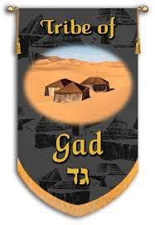

Verse 19—As for Gad, raiders shall raid him but he will raid at their heels—Even though Gad will be raided by marauding bands, he will fight valiantly. That border raids would be the lot of Gad is emphasized by the word plays in the verse—four of the six words play on the name Gad. The rendering would be “Gad, a troop shall troop upon him, but he shall troop on their heels.” Gad will be harassed by bands of hostile enemies but will eventually repel their advances.

PT—A map of Israel in biblical times vividly displays the precarious position of Gad in relation to some of Israel’s ancient enemies. Gad, along with Reuben and half of Manasseh, was allotted a portion of the land on the east side of the Jordan River (Joshua 13:24-28). This made the tribe susceptible to the Moabites and Ammonites to the east and north and the Edomites to the south. Hostile bands from these enemies bordered the entire territory keeping Gad on their toes, ready to defend themselves whenever necessary.

Verse 20—As for Asher, his food shall be rich, and he will yield royal dainties—Jacob’s oracle predicted that Asher would be fertile and productive, so much so that he would provide delicacies to royalty. The second phrase describes what Asher would do with his abundant produce—deliver it to the court. The term dainties signify that the produce was delightful or pleasurable. It is probably not ordinary food but delicacies that kings could afford. So Asher will enjoy the rich products of a fertile land, teeming with those things which contribute to the sustenance of life, and also will, from the ample produce, supply those tasty morsels to royalty.
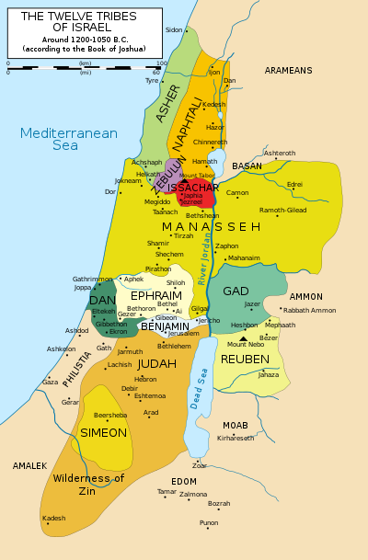

PT—During Solomon’s reign, each of the 12 tribes in turn provided the royal provisions for one month each year. Solomon had twelve deputies over all Israel, who provided for the king and his household; each man had to provide for a month in the year (1 Kings 4:7). Receiving Asher’s share of the monthly supply would ensure delicacies and morsels fit for royalty. These were surly excellent gourmet delights.

Verse 21—Naphtali is a doe let loose, He gives beautiful words—Naphtali would be a free mountain people. But the specific point of this oracle is that Naphtali would be a messenger with a message of victory. The imagery of Naphtali as a hind let loose conveys swiftness and agility, especially in battle. Consider David’s acknowledgement of God’s help during his flight from Saul. He makes my feet like hinds’ feet, and sets me upon my high places (Psalms 18:33). David had apparently observed the hind as she fled from hunters in the desolate and savage wilderness where David also was fleeing from his hunter, Saul. The second clause reveals what the message is—words of beauty. In this case, it means simply that he gives the words of the message. If beautiful is retained as the reading, then it suggests good news.

A Review of the History of the Tribe of Gad
- The geographical name for the territory of Gad is Gilead—a name in the Old Testament that often stood for the tribe of Gad. Judges 5:17 referred to the tribe this way. Gilead remained across the Jordan. Apparently, the people of Gilead remained on the other side of the river and did not participate in the battle. Gilead, area of ancient Palestine east of the Jordan River, corresponding to modern northwestern Jordan. The region is bounded in the north by the Yarmuk River and in the southwest by what were known in ancient times as the “plains of Moab.” To the east there is no definite boundary. Sometimes Gilead is used in a more general sense for all the region east of the Jordan River.
- The book of Judges portrays the tribe of Gad’s perilous existence they [Philistines] afflicted and crushed the sons of Israel that year; for eighteen years they afflicted all the sons of Israel who were beyond the Jordan in Gilead in the land of the Amorites (Judges 10:8). The Philistines were shattering and crushing the tribes east of the Jordan. They sustained their oppression until it eventually included tribes on the West side of the Jordan as well.
- It was this constant exposure to hostile enemies that resulted in Gad’s developing a reputation as fierce warriors, constantly ready to defend their land. In David’s days, as a fugitive from Saul, the Gadite warriors who joined him at Ziklag were described in the following way: from the Gadites there came over to David in the stronghold in the wilderness, mighty men of valor, men trained for war, who could handle shield and spear, and whose faces were like the faces of lions, and they were as swift as the gazelles on the mountains (1 Chronicles 12:8).
- Moses’ blessing on Gad also describes their ferocity. of Gad he said, “Blessed is the one who enlarges Gad; He lies down as a lion, And tears the arm, also the crown of the head.” Gad was a warring tribe that was very aggressive in conquering and subduing the land. They even rebuilt and fortified cities as well as provisioning for their people. The sons of Gad built Dibon and Ataroth and Aroer… as fortified cities, and sheepfolds for sheep (Numbers 32:34-35).
- Scripture mentions nothing about any prominent individuals in this small but strategically located tribe. The most famous Gadite mentioned in the Old Testament was Jair, who judged Israel twenty-two years (Judges 10:3-5).

A Review of the History of the Tribe of Asher
- Evidently, Asher sacrificed any military capability for his agricultural fame. According to Judges 1:31-32, the tribe never dislodged the Canaanite/Phoenician inhabitants of the northwestern coast of Israel. Asher did not drive out the inhabitants of Acco, or the inhabitants of Sidon, or of Ahlab, or of Achzib, or of Helbah, or of Aphik, or of Rehob. So the Asherites lived among the Canaanites, the inhabitants of the land; for they did not drive them out.
- Moses’ blessing of Gad mentioned “More blessed than sons is Asher; May he be favored by his brothers, and may he dip his foot in oil” (Deuteronomy 33:24). To dip his foot in oil is a metaphor for prosperity, one especially apt in light of the abundance of olive groves in the area settled by Asher. The lesson of the prophecy is that Asher will be blessed with an abundance which he will share with others.
- The most famous Asherite in the Bible was Anna, the prophetess who greeted the infant Jesus in the Temple and there was a prophetess, Anna the daughter of Phanuel, of the tribe of Asher. She was advanced in years (Luke 2:36). This brief reference is evidence that Jews of our Lord’s time still maintained their tribal identity. Anna also provides evidence that representatives of the 10 northern tribes still existed over 700 years after the Assyrian captivity. So, the 10 tribes were not really lost just assimilated into the Southern Kingdom originally as refugees from the north.
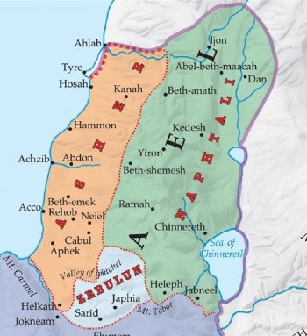

A Review of the History of the Tribe of Naphtali
- Jacob’s prophetic blessing was that Naphtali would be characterized by the speed and agility of a doe. This primarily refers to the swiftness characteristic of the tribe of Naphtali. The beautiful words of this tribe have been associated with the “Song of Deborah and Barak” recorded in Judges 5-31. While some of the tribes were distinguished for their heroic deeds during the battle with Jabin’s Canaanite forces, it is interesting to note that Barak was from the tribe of Naphtali. now she sent and summoned Barak the son of Abinoam from Kedesh-naphtali (Judges 4:6).
- The great battle between the Israelite and Canaanite forces described in Judges 4 prompted the tribes to send volunteers. While such tribes as Reuben, Dan, and Asher refused to send their contingents, tribes such as Naphtali were swift to rush their troops to battle.
- When Jesus began His ministry in Galilee, Matthew 4:13-15 states and leaving Nazareth, He came and settled in Capernaum, which is by the sea, in the region of Zebulun and Naphtali. He called His disciples in the very region of the tribe of Naphtali. Hence, His first disciples were from the region allotted to this ancient tribe. Those early disciples carried the beautiful words of the gospel swiftly as hinds let loose.

Jacob Blesses Joseph
“Joseph is a fruitful bough, a fruitful bough by a spring; Its branches run over a wall. The archers bitterly attacked him, And shot at him and harassed him; But his bow remained firm, And his arms were agile, From the hands of the Mighty One of Jacob (From there is the Shepherd, the Stone of Israel), From the God of your father who helps you, And by the Almighty who blesses you with blessings of heaven above, Blessings of the deep that lies beneath, Blessings of the breasts and of the womb. The blessings of your father Have surpassed the blessings of my ancestors up to the utmost bound of the everlasting hills; May they be on the head of Joseph, And on the crown of the head of the one distinguished among his brothers (Genesis 49:22-26).

Verse 22—Joseph is a fruitful bough, a fruitful bough by a spring. Its branches run over a wall—The Word bough was chosen over ‘son’ because Joseph is pictured here as a vine extending over a wall, an image of prosperity. The theme of fruitfulness has appeared before in the line of Rachel: God at first withheld fruit from her womb (30:2) but later made her fruitful (v. 22). Then Joseph himself was made fruitful with the birth of Ephraim (41:52). In spite of the obstacles placed in his path, Joseph was faithful and fruitful in overcoming each one. The picture is made complete with the explanation that he is by a well and extending over a wall. Joseph, then, would be healthy and fruitful.

Verse 23—The archers bitterly attacked him, and shot at him and harassed him—But Joseph’s prosperity spurs attacks from his enemies. His enemies showed bitterness toward him, shot their arrows at him, and hated him. It is clear that people tries to destroy Joseph’s prosperity. The pressure began in Joseph’s life with his brothers, of course. The oracle of Jacob extends that envy into the future as a prediction. Joseph as a prosperous tribe would be attacked by his enemies.

Verse 24—But his bow remained firm, and his arms were agile—Joseph was aimed and shot at, as it were, by the bitter and reviling words of his brothers, and still more deeply wounded by their cruel treatment. He was sold into Egypt through envy, and imprisoned by a lie. His virtue was violently assaulted by his mistress, his innocence wronged by his master, yet Joseph’s bow remained firm, and his arm were agile. In spite of his suffering at the hands of his brothers, his trust in God was unswerving.
- From the hands of the Mighty One of Jacob (From there is the Shepherd, the Stone of Israel)—The image of the hands of the Lord is frequent in passages of judgment and deliverance. Here it is strengthened by the term Mighty One. The title speaks of how powerful God is. Joseph himself acknowledged that his power came from God. God sent me before you to preserve for you a remnant in the earth, and to keep you alive by a great deliverance (Genesis 45:7). The God who defends Joseph is a Shepherd, one who is able to lead and defend His people. He is also the Stone of Israel, that is, one who is stable and unchanging.

Verse 25—From the God of your father who helps you—He is the God of your father, a description that reminds the reader of the ancestral calling and promised blessing.
- And by the Almighty who blesses you with blessings of heaven above—The God of the father would save him, and the Almighty would bless him. Without the help and blessing of God, Joseph could not have made it as far as he had, and his descendants would not make it further.
- Blessings of the deep that lies beneath, blessings of the breasts and of the womb—Jacob envisions God imparting both agricultural (blessings from the sky above, blessings from the deep that lies below) and human fertility (blessings of the breasts and womb) to Joseph and his family. The word blessing is used to describe the lavish treatment of Joseph. To bless someone, means to give success to someone, and especially success in fertility. Jacob declared that God would bestow His power on Joseph so that the latter could continue to be successful and fruitful.

Verse 26—The blessings of your father Have surpassed the blessings of my ancestors up to the utmost bound of the everlasting hills—This blessing would exceed anything given to any of the progenitors. The surpassing blessing would include the hills, select places of choice agricultural lands. In short, the blessing on Joseph would be so great that it would exceed anything that anyone could imagine from a very fertile land.
- May they be on the head of Joseph, and on the crown of the head of the one distinguished among his brothers—Just as Joseph had overcome hatred and opposition to become successful in Egypt by the power of God, so too would his tribe continue to have the greatest of blessings. All of the sons of Jacob were blessed to carry the Abrahamic Covenant forward, for they all became founders of tribes that went up to Egypt as the seed of Abraham. Joseph and Judah came to the fore, as indeed they had in the story of Joseph. Joseph received the double portion so that Ephraim and Manasseh would have equal shares with the other sons. Kingship was reserved for Judah.

PT—The various promises made to Abraham were channeled to the tribes, all sharing in some way in accord with their lives and traits. Jacob’s blessing clearly anticipated favor and responsibility in the tribes of Israel. Joseph especially could expect a significant role.

A Review of the History of the Tribe of Joseph
After Jacob’s blessing of the two sons of Joseph, Ephraim and Manasseh, Joseph’s tribe becomes known as the tribes of Ephraim and Manasseh. Joseph’s name diminished as the history of the 12 tribes of Israel unfolded.
- Ephraim could be described as the ‘bully’ tribe, always trying to shove their weight around. Conflict ensued between Ephraim and the Gileadite tribes.

A Review of Judges 12
Verse 1—Then the men of Ephraim were summoned, and they crossed to Zaphon and said to Jephthah, “Why did you cross over to fight against the sons of Ammon without calling us to go with you? We will burn your house down on you”—Ephraim’s superiority complex is found in this story of the champion, Jephthah who was a Gileadite of the tribe of Manasseh. His victory over the Ammonites brought this obstinate reaction from the tribe of Ephraim. The Ammonites had overcome the Israelites in Transjordan, and the invaders were poised for an attack west of the Jordan Valley. They afflicted and crushed the sons of Israel that year; for eighteen years they afflicted all the sons of Israel who were beyond the Jordan in Gilead in the land of the Amorites. The sons of Ammon crossed the Jordan to fight also against Judah, Benjamin, and the house of Ephraim, so that Israel was greatly distressed (Judges 10:8-9).
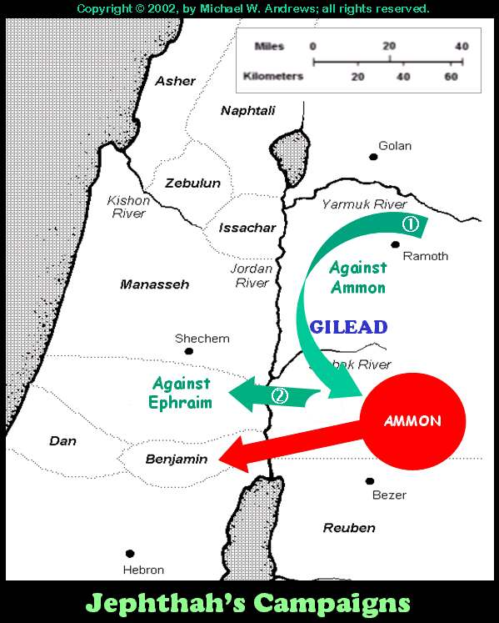

A spiritual revival in Israel let to military action and the mobilization of the opposing parties. Then the sons of Ammon were summoned and they camped in Gilead. And the sons of Israel gathered together and camped in Mizpah. The people, the leaders of Gilead, said to one another, “Who is the man who will begin to fight against the sons of Ammon? He shall become head over all the inhabitants of Gilead” (Judges 10:17-18).

Jephthah, an outcast from his own family in Gilead, was called back from the land of Tob to lead the Israelite forces (Judges 11:1-3). He first attempted to negotiate with the Ammonites on the basis of Israel’s prior claim to the disputed region. In defense of Israel’s claim a lengthy historical review is presented (Judges 11:12-28). While Israel lived in Heshbon and its villages, and in Aroer and its villages, and in all the cities that are on the banks of the Arnon, three hundred years, why did you not recover them within that time? I therefore have not sinned against you, but you are doing me wrong by making war against me; may the Lord, the Judge, judge today between the sons of Israel and the sons of Ammon (Judges 11:27-28). Naturally the Ammonites rejected Jephthah’s reasoning. Negotiations broke down and armed conflict ensued, so Jephthah crossed over to the sons of Ammon to fight against them; and the Lord gave them into his hand (v. 32). This battle and victory brought about Ephraim’s bullied reaction.

Verse 2—Jephthah said to them, “I and my people were at great strife with the sons of Ammon; when I called you, you did not deliver me from their hand”—Jephthah’s answer was anything but diplomatic. He claimed, and rightly so, that Ephraim was a type of ‘big-mouth-but-do-nothing.’ Ephraim had sat back, enjoying the security afforded by the surrounding hill country west of the Jordan, and had neglected her responsibility in Gilead, east of the Jordan. Ephraim had no excuse, and Jephthah had no other choice than to carry out the rescue operation. This interchange between Ephraim and Jephthah led to armed conflict between the tribes.

Verse 4—Then Jephthah gathered all the men of Gilead and fought Ephraim; and the men of Gilead defeated Ephraim, because they said, “You are fugitives of Ephraim, O Gileadites, in the midst of Ephraim and in the midst of Manasseh”—Unfortunately, name calling was the next step in this family feud where damaging one’s honor is as effective as physical blows. These remarks from the Ephraimites led to physical confrontation in which they were the losers. The immediate issue was Jephthah’s unilateral action in Transjordan. However, a much more serious issue is apparent—a developing independence among the tribes east of the Jordan. The conflict between the Ephraimites and the Gileadites is a sad commentary on the lack of Israelite unity in this period.

Verses 5-6—The Gileadites captured the fords of the Jordan opposite Ephraim. And it happened when any of the fugitives of Ephraim said, “Let me cross over,” the men of Gilead would say to him, “Are you an Ephraimite?” If he said, “No,” then they would say to him, “Say now, ‘Shibboleth.’” But he said, “Sibboleth,” for he could not pronounce it correctly. Then they seized him and slew him at the fords of the Jordan. Thus there fell at that time 42,000 of Ephraim. —Following the encounter in Gilead, a slight variation in the usage of two similar Hebrew consonants (Shibboleth and Sibboleth) became a matter of life or death for the escaping Ephramites. This incident illustrates that regional differences (east and west of the Jordan river) had developed on either side of the Jordan. Those differences would eventually produce separate and independent movements on either side of the Jordan.

An Application—Watch out for a spirit of superiority in your life. Threats and insults are not the methods used by a devoted disciple of Jesus Christ. Humility fosters dependence on God. If you are not careful, pride can undermine your perspective and create outcomes you will regret.
- The Lord will return, and when He does, He will put an end to tribal strife, especially the prideful strife between the two double portion tribes of Ephraim and Judah.

A Review of Isaiah 11
WHEN CHRIST RULES, ISRAEL WILL BE HEALED AS A NATION
Verses 11-12—Then it will happen on that day that the Lord will again recover the second time with His hand The remnant of His people, who will remain, From Assyria, Egypt, Pathros, Cush, Elam, Shinar, Hamath, and from the islands of the sea. And He will lift up a standard for the nations and assemble the banished ones of Israel, and will gather the dispersed of Judah from the four corners of the earth—A remnant will return to the Land in the future. The standard the Lord lifts up for the nations is the flag of His kingdom. His will be an earthly kingdom. He will gather and assemble under this banner a remnant of Jews from both the Northern and the Southern Kingdoms, who will be living all over the earth at that time.

Verses 13-14—Then the jealousy of Ephraim will depart, and those who harass Judah will be cut off; Ephraim will not be jealous of Judah, And Judah will not harass Ephraim. They will swoop down on the slopes of the Philistines on the west; Together they will plunder the sons of the east; They will possess Edom and Moab, And the sons of Ammon will be subject to them—Internal strife amongst the tribes will cease and together they will defeat all enemies. That strife will specifically cease between the tribe of Ephraim and the tribe of Judah, the tribes who had received the double blessing from Jacob. Instead of fighting amongst themselves, the Israelites will subdue their common enemies and gain the whole Promised Land. The parameters of the land are in Deuteronomy 1:7 and 11:22-25.

Verses 15-16—And the Lord will utterly destroy the tongue of the Sea of Egypt; And He will wave His hand over the River with His scorching wind; And He will strike it into seven streams and make men walk over dry-shod. And there will be a highway from Assyria for the remnant of His people who will be left, just as there was for Israel in the day that they came up out of the land of Egypt. God’s judgments will allow Jews to return from all over the world. His judgments on Egypt and Babylon will involve the drying up of major barriers, the Red Sea and the Euphrates River. This judgment will allow the Jews to return to the Promised Land from those parts of the world unhindered. They will be able to leave the territory of Assyria, where God had said He would send them captive, as easily as their forefathers left Egypt and crossed the Red Sea in the Exodus. Israel will re-gather in the Promised Land from all over the world trusting in God.

PT—The lesson is that the tribes of Israel will be regathered in Christ’s earthly kingdom in the land of Promise. Prideful conflict between the tribes will vanish as the settle within the territory, this time to stay in peace with each other and the surrounding nations.

Observations from the Tribe of Joseph
- It is striking to consider that almost every time Joseph speaks, he mentions God in some way. His God-filled perspective allowed him to discern God’s hand in the affairs of his life through the trials and troubles he often experienced. now do not be grieved or angry with yourselves, because you sold me here, for God sent me before you to preserve life… God sent me before you to preserve for you a remnant in the earth, and to keep you alive by a great deliverance. Now, therefore, it was not you who sent me here, but God; and He has made me a father to Pharaoh and lord of all his household and ruler over all the land of Egypt. Hurry and go up to my father, and say to him, ‘Thus says your son Joseph, “God has made me lord of all Egypt; come down to me, do not delay”’ (Genesis 45:5, 7-9).
- Joseph waited on God during his trials without seeking revenge of pursuing advancement. In His timing, God exalted His faithful servant to a place of honor where he could become a blessing to others.

PT—Joseph is an example of the truth that as we therefore humble yourselves under the mighty hand of God, that He may exalt you at the proper time (1 Peter 5:6). It was a test for Joseph to wait for God’s timing after having been unjustly sold as a slave, unjustly accused and imprisoned, unjustly forgotten by one whom he had helped.

An Application—Our responsibility is not to be ambitious or self-seeking. God’s job is to hand out promotions. Our job is to be faithful with the calling with which we have been called. To possess our position in life to the glory of God. Joseph faithfully waited in prison before he was lifted to the throne. Elijah faithfully waited at Cherith before he triumphed at Carmel. Moses faithfully labored in Midian before he challenged the power of Egypt. Jesus faithfully carried His cross before He wore the crown.

Jacob Blesses Benjamin
Verse 27—Benjamin is a ravenous wolf; In the morning he devours the prey, and in the evening he divides the spoil.
- Benjamin is a ravenous wolf—Like Judah’s lion, the wolf is no less ferocious an animal than the lion but usually kills far more than it eats. Benjamin would be characterized by a vicious and warlike attitude. He would be ravenous by nature and his would be a mighty warrior tribe.
- In the morning he devours the prey, and in the evening he divides the spoil—The history of this tribe would be filled examples of powerful ferocity. Benjamin’s reputation would be its warlike character and actions.

A Review of the History of the Tribe of Benjamin
Jacob’s prophecy that Benjamin would be a ravenous wolf [who] devours the prey found graphic fulfillment throughout the history of that tribe.

- Benjamin’s strategic location contributed to its fighting spirit. According to Joshua 18, Benjamin became a buffer zone between the two dominant tribes of Ephraim and Judah.

A Review of Joshua 18
Verses 3-5—So Joshua said to the sons of Israel, “How long will you put off entering to take possession of the land which the Lord, the God of your fathers, has given you? Provide for yourselves three men from each tribe that I may send them, and that they may arise and walk through the land and write a description of it according to their inheritance; then they shall return to me. They shall divide it into seven portions; Judah shall stay in its territory on the south, and the house of Joseph shall stay in their territory on the north”—After the tribe of Judah and the House of Joseph received their territory (Joshua 15-17), the leadership of Israel gathered at Shiloh (in Ephraim) in order to decide on the distribution of land among the other tribes. Joshua 9 (of Ephraim) gave the instructions to the tribes. In these remarks there is a hint of potential trouble between the stronger power centers of Judah and the House of Joseph.

Verse 9-10—So the men went and passed through the land, and described it by cities in seven divisions in a book; and they came to Joshua to the camp at Shiloh. And Joshua cast lots for them in Shiloh before the Lord, and there Joshua divided the land to the sons of Israel according to their divisions.
- The important question was which remaining tribe would receive the strategic territory between these two larger units. When a survey was completed, Joshua cast lots to determine the next land allotment for the tribes. The results of that moment were to affect all later history in the region. The die was cast in the very first decision of our record.
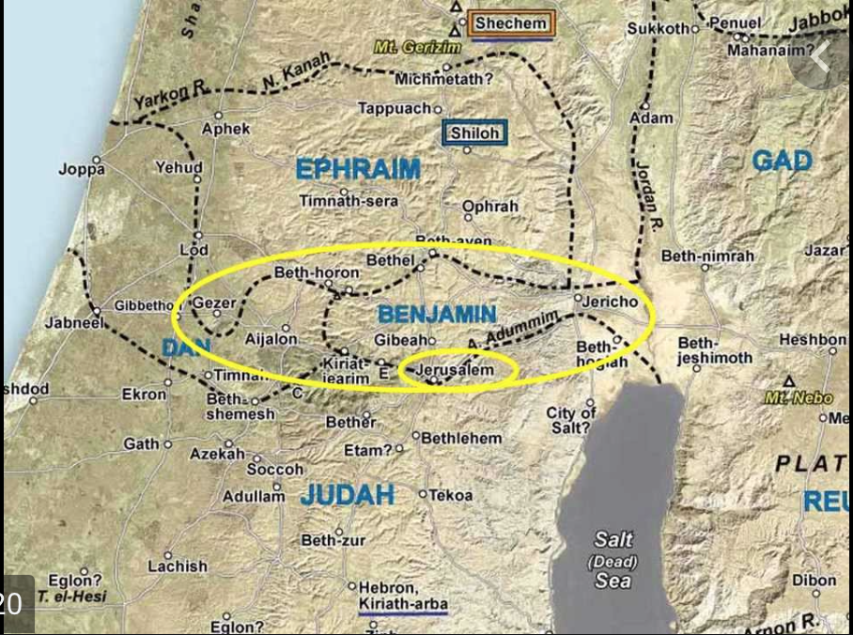

Verse 11—Now the lot of the tribe of the sons of Benjamin came up according to their families, and the territory of their lot lay between the sons of Judah and the sons of Joseph.—Benjamin’s northern line was the same as Ephraim’s southern border. Its southern line was the same as Judah’s northern boundary. This placed the tribe in a precarious position between the two double-blessed tribes, who both had aspirations in the region. Benjamin would be played against these two tribes throughout its history, and thus developed a strong warrior constitution that helped it survive throughout the tribal intrigue that eventually played out between Ephraim and Judah.

Verses 12-18—Their border on the north side was from the Jordan, then the border went up to the side of Jericho on the north, and went up through the hill country westward, and it ended at the wilderness of Beth-aven… Moreover, the Jordan was its border on the east side. This was the inheritance of the sons of Benjamin, according to their families and according to its borders all around—This section is a rather detailed description of the territory of the tribe of Benjamin, including its cities (vv. 21-28). The Ephraim-Benjamin border was most likely never meant to be entirely clear-cut. Ephraim had strong ties to some of Benjamin’s northern border (the city of Bethel, Judges 1:22-26), and Judah had strong ties to some of Benjamin’s southern border (the city of Jerusalem, Judges 1:8, 21). Both of these tribes would chip away at Benjamin’s border lines whenever it was politically or militarily convenient for them. In order for Benjamin to maintain its borders, they had to become a stealth fighting machine, especially as one of the smaller tribes in Israel.
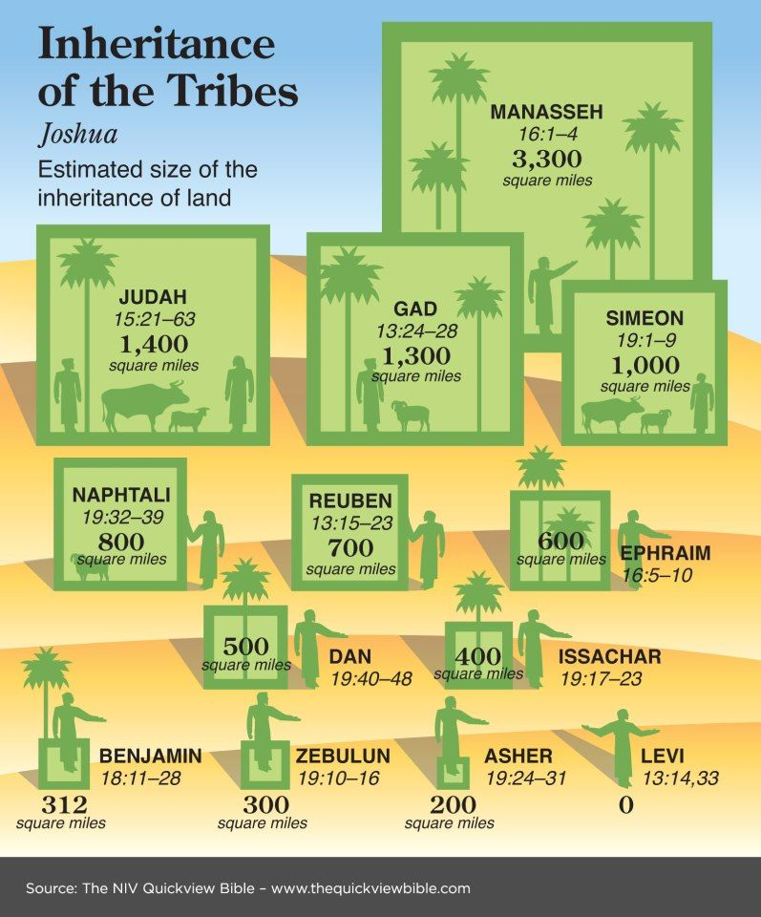

PT—Benjamite territory included many cities important in biblical history (i.e., Jericho, Bethel, Gibeon, Ramah, and Mizpah). Jerusalem was also in Benjamin and Zelah, Haeleph and the Jebusite (that is, Jerusalem), Gibeah, Kiriath; fourteen cities with their villages. This is the inheritance of the sons of Benjamin according to their families (Joshua 18:28).

An Application—God sometimes deliberately places us in tight situations that require tact, strategy, ingenuity, creativity, and forthrightness. In the process, we can learn now to negotiate our way through to a successful conclusion. All of this is designed to not only increase our dependence upon the Lord, but also to test our faith, and shape our character.

- The first evidence of the ferocity of the tribe of Benjamin as predicted in Jacob’s blessing, was the judgeship of Ehud, the second judge of Israel.

A Review of Judges 3
Verses 12-14—Now the sons of Israel again did evil in the sight of the Lord. So the Lord strengthened Eglon the king of Moab against Israel, because they had done evil in the sight of the Lord. And he gathered to himself the sons of Ammon and Amalek; and he went and defeated Israel, and they possessed the city of the palm trees. The sons of Israel served Eglon the king of Moab eighteen years.
- Because of the strategic importance of Benjamin, its territory was often the scene of conflict from internal tribal disputes or from invasions by surrounding nations. One of these attacks came from Moab, a nation in Transjordan which had enlisted the support of the Ammonites and Amalekites. The oasis of Jericho the city of the palm trees served as the back door to Benjamin, to Ephraim/ Manasseh, and to Judah. The question of tribal control of this area faded, however, during the Moabite occupation of the city of palms. This Moabite presence along the routes of the hill country became a difficult hardship for the sons of Israel served Eglon the king of Moab eighteen years (v. 14).
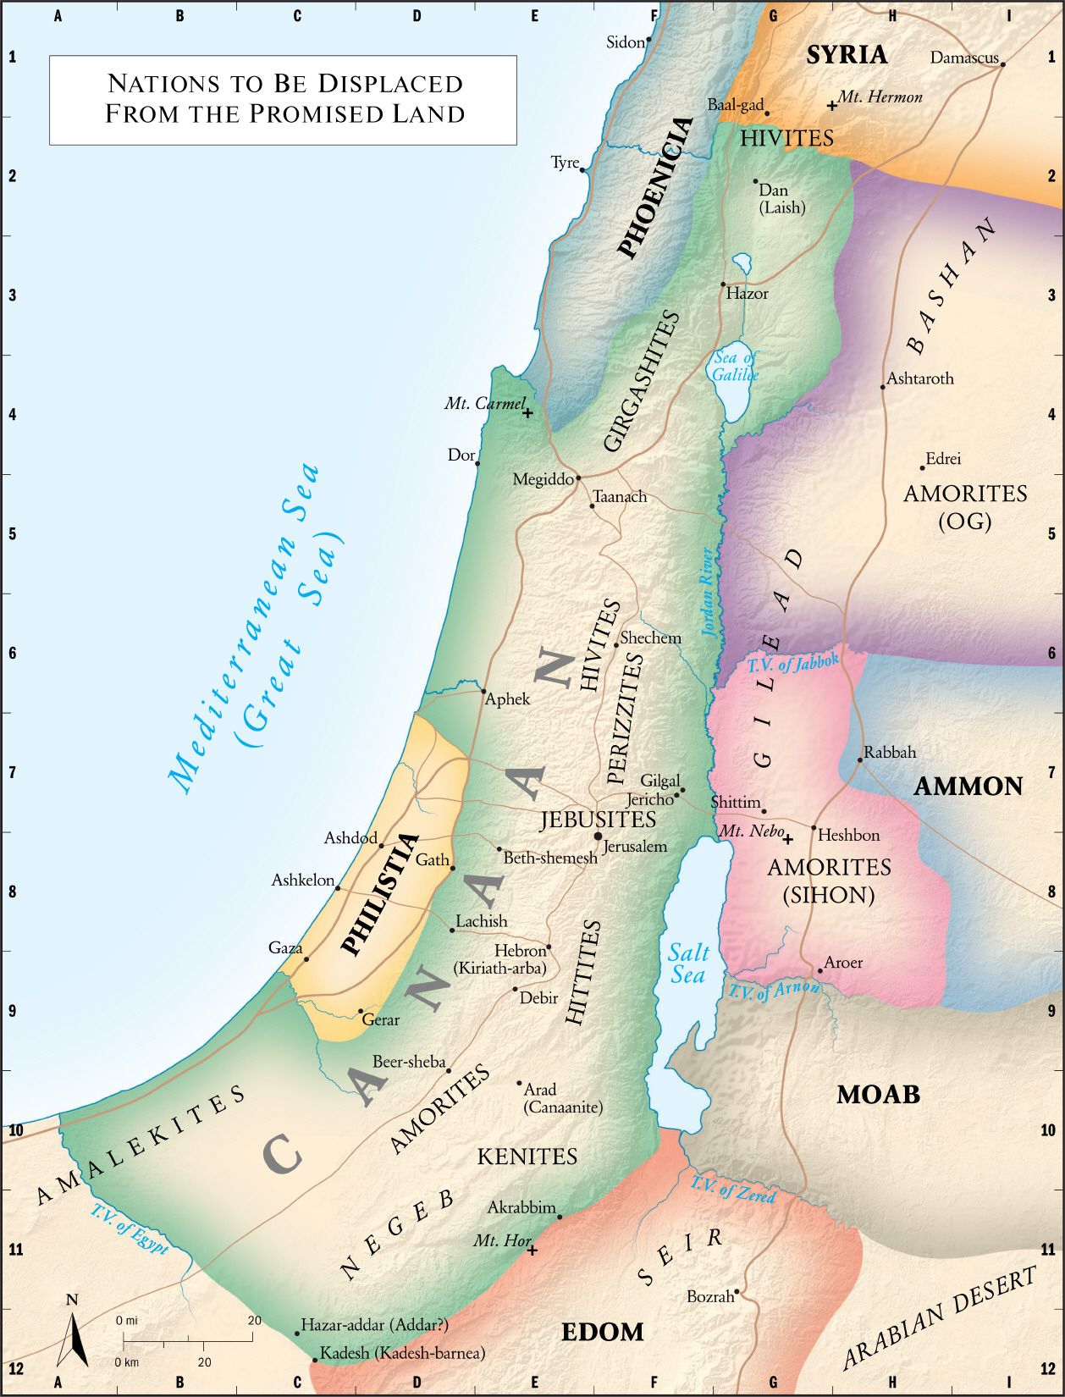

The Moabites knew the strategic value of Jericho, for it served them well as a main base for the exploitation of Israel. Centuries later Israel would gain control of the city and region and would use this same base in her exploitation of Moab (2 Samuel 8; 2 Kings 3). In the meantime, God raised up a champion to fight against the Moabite suppression and free the Israelites from their control.

Verse 15—But when the sons of Israel cried to the Lord, the Lord raised up a deliverer for them, Ehud the son of Gera, the Benjamite, a left-handed man. And the sons of Israel sent tribute by him to Eglon the king of Moab—It was Ehud the son of Gera, the Benjamite, a left-handed man, who finally made a move. This fearless warrior developed a well-thought-out plan of action to address the problem of Moabite oppression of 18 years. The Bible goes out of the way to note that Ehud was a left-handed man. As part of his plan he decided to send tribute to Eglon king of Moab.

Verses 16-22—Ehud made himself a sword which had two edges, a cubit in length, and he bound it on his right thigh under his cloak. He presented the tribute to Eglon king of Moab. Now Eglon was a very fat man… Ehud came to him while he was sitting alone in his cool roof chamber. And Ehud said, “I have a message from God for you.” And he arose from his seat. Ehud stretched out his left hand, took the sword from his right thigh and thrust it into his belly. The handle also went in after the blade, and the fat closed over the blade, for he did not draw the sword out of his belly; and the refuse came out—Ehud single-handedly assassinated Eglon, the king of the Moabites. Concealing his weapon under his garments undetected on his right thigh (Ehud was left-handed) he gained entrance to the king and thrust his dagger in Eglon’s belly. The resulting confusion led to a great Israelite victory over the Moabites and resulted in an 80-year period of peace in the region. they struck down at that time about ten thousand Moabites, all robust and valiant men; and no one escaped. So Moab was subdued that day under the hand of Israel. And the land was undisturbed for eighty years (vv. 29-30).

An Application—What we must sometimes do is take matters into our own hands and take action when it comes to championing righteousness. It is not sufficient to just take a stand about God’s will and Word. Like Ehud, we must also do something about the application of that righteousness. Otherwise, the stand we take is nothing but a bunch of words. It is one thing to take a stand against, say, homosexuality or cohabitation. It’s another thing to do something about addressing it, confronting it, and taking appropriate action to change it.

- One of the most tragic episodes in the history of the region of Benjamin was the tribal civil war which reduced the tribe of Benjamin to a mere six hundred fighting men.

A Review of Judges 19–21
Verse 19:1—Now it came about in those days, when there was no king in Israel, that there was a certain Levite staying in the remote part of the hill country of Ephraim, who took a concubine for himself from Bethlehem in Judah—Unlike most accounts in Judges, the story is entirely an internal problem. There are no Philistines, no Moabites nor any Canaanites mentioned. No famous deliverer like Samson or Deborah emerges. The person who precipitates the drama is known only as a certain Levite. The closing phrase of the entire episode underscores the cavalier spirit that prevailed in Israel at the time due to a lack of central authority in the country, when in those days there was no king in Israel; everyone did what was right in his own eyes (Judges 21:25).

Verses 17-18—And he lifted up his eyes and saw the traveler in the open square of the city; and the old man said, “Where are you going, and where do you come from?” He said to him, “We are passing from Bethlehem in Judah to the remote part of the hill country of Ephraim, for I am from there, and I went to Bethlehem in Judah. But I am now going to my house, and no man will take me into his house”—One of the main causes of moral decadence in Israel at this time was a self-centered attitude resulting in a complete lack of concern for others. The warm hospitality seen in Bethlehem of Judah is contrasted with the indifference of the Benjamites to the needs of a stranger in their midst. The words of the Levite who lived in Ephraim, spoken to another Ephramite in the open square of Gibeah, present a clear testimony against the city of Benjamin and its inhabitants.

Verses 25-26—But the men would not listen to him. So the man seized his concubine and brought her out to them; and they raped her and abused her all night until morning, then let her go at the approach of dawn. As the day began to dawn, the woman came and fell down at the doorway of the man’s house where her master was, until full daylight—Benjamite men brutally, savagely, and sadistically raped the concubine of this certain Levite all night long while he was being entertained for the night. The next morning the Levite took his deceased concubine her back to his home, and he took a knife and laid hold of his concubine and cut her in twelve pieces, limb by limb, and sent her throughout the territory of Israel (v. 29).

Verses 20:1-2—Then all the sons of Israel from Dan to Beersheba, including the land of Gilead, came out, and the congregation assembled as one man to the Lord at Mizpah. The chiefs of all the people, even of all the tribes of Israel, took their stand in the assembly of the people of God, 400,000 foot soldiers who drew the sword—This ‘Gibeah affair’ sparked a confrontation between a number of the tribes of Israel and Benjamin. The Levite’s rather crass report that precipitated such a united tribal front against Benjamin was rarely seen in Israelite history. It appears that no tribe wanted to be missing at this most important moment in Israel’s geopolitical history. It could be said that the ‘Gibeah affair’ was a convenient excuse to get the real issue out on the table—who would ultimately control the strategic territory of Benjamin.

Verses 16-48—Out of all these people 700 choice men were left-handed; each one could sling a stone at a hair and not miss. Then the men of Israel besides Benjamin were numbered, 400,000 men who draw the sword; all these were men of war… So all of Benjamin who fell that day were 25,000 men who draw the sword; all these were valiant warriors. But 600 men turned and fled toward the wilderness to the rock of Rimmon, and they remained at the rock of Rimmon four months. The men of Israel then turned back against the sons of Benjamin and struck them with the edge of the sword, both the entire city with the cattle and all that they found; they also set on fire all the cities which they found—When the tribal leaders of Benjamin refused to relinquish the guilty offenders, a major military confrontation resulted. Benjamin had been seriously weakened as a tribe after this battle over the “Gibeah affair.’ Only 600 Benjamites warriors survived the onslaught and were holed up for months in the wilderness until a peace could be negotiated with the rest of the tribes. Before that could be accomplished, the anger and rage of the remaining tribes was carried out in the destruction of the cities of Benjamin. The wolf had fought valiantly but had been torn in the end.
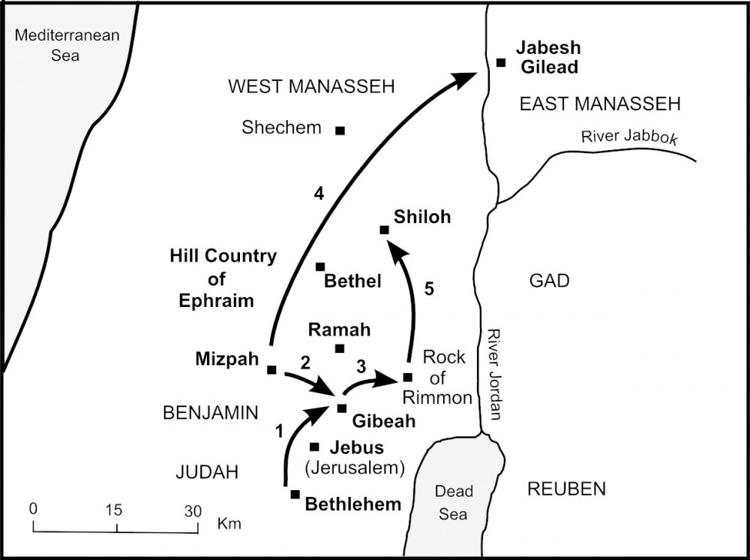

Verses 21:2-3—So the people came to Bethel and sat there before God until evening, and lifted up their voices and wept bitterly. They said, “Why, O Lord, God of Israel, has this come about in Israel, so that one tribe should be missing today in Israel?”—The tribes of Israel appeared to wake up to the fact that the conflict in which they had just participated had been costly. Benjamin had been seriously weakened, and tribal energies had been depleted. Now they were faced with a greater peril. If Benjamin were allowed to disappear altogether, a vacuum would be created in the region. This could trigger a civil war on a much greater scale than anyone wanted to imagine. It would pit Ephraim against Judah for the control of the region and its strategic crossroads. Some sort of an arrangement would have to be worked out to avoid such an eventuality.

Verses 13-23—Then the whole congregation sent word and spoke to the sons of Benjamin who were at the rock of Rimmon, and proclaimed peace to them. Benjamin returned at that time, and they gave them the women whom they had kept alive from the women of Jabesh-gilead; yet they were not enough for them… The sons of Benjamin did so, and took wives according to their number from those who danced, whom they carried away. And they went and returned to their inheritance and rebuilt the cities and lived in them—To replenish the tribe of Benjamin, wives were sought for the six hundred men who survived the conflict. When the first solution did not provide enough wives to go around, a second was devised. It centered around Shiloh in Ephraim. Shiloh was a central and secure place in which the Ark of the Covenant was usually kept. It was in these hills of Ephraim, in the midst of their own family (the House of Joseph), that the remaining Benjamites found wives to repopulate their tribal inheritance.

PT—Paul dealt with one of the main issues of his letter to the Romans—the relationship between the growing Gentile church and its original Jewish stock (Romans 9–11). In the discussion, the apostle, a well-trained and former zealous Pharisee, made the following statement regarding God’s grace. Could he have had in mind the sad events of the ‘Gibeah affair’ as he gave us details of his own personal background? But as for Israel, He says, “All the day long I have stretched out My hands to a disobedient and obstinate people.” I say then, God has not rejected His people, has He? May it never be! For I too am an Israelite, a descendant of Abraham, of the tribe of Benjamin (Romans 10:21—11:1).

Observations from the Tribe of Benjamin
- Moses’ blessing of the tribe of Benjamin noted that of Benjamin he said, “May the beloved of the Lord dwell in security by Him, who shields him all the day, and he dwells between His shoulders” (Deuteronomy 33:12). The point was that Benjamin was to enjoy God’s protection continually, since God would carry this tribe on His back between His shoulders. As the warrior tribe, Benjamin would enjoy God’s protection.
- Saul was a Benjamite and his rule as king over Israel was ferocious. When the Ammonites besieged Jabesh-Gilead, Saul mustered the armies of Israel and attacked them by night so that Those who survived were scattered, so that no two of them were left together (1 Samuel 11:11). This victory helped the Israelites perceive Saul as their king with the result that they committed themselves to him.
- Saul’s son, Jonathan, was also a great warrior. First Samuel 14 records a brilliant maneuver of Jonathan and his armor-bearer in climbing a sheer cliff and slaughtering a Philistine garrison of 20 soldiers. Contrasted with his father’s selfish zeal, Jonathan acted in faith in God’s promise, in spite of the odds. Then Jonathan said to the young man who was carrying his armor, “Come and let us cross over to the garrison of these uncircumcised; perhaps the Lord will work for us, for the Lord is not restrained to save by many or by few” (1 Samuel 14:6).
- Other ferocious Benjamites were—(1) Abner, Saul’s cousin and commander of his army, who mercilessly killed Asahel and was himself murdered by Joab (2 Samuel 2:23; 3:30); (2) Shimei, who cursed David during his flight from Absalom and was himself killed by Solomon in return (16:5-13; 1 Kings 2:44-46), and (3) Sheba, who led a rebellion against David and was himself beheaded by the citizens of Abel Beth-maacah (2 Samuel 20:1-22). They serve as examples of how selfish and misguided zeal received its own punishment.
- Esther and Mordecai were stellar examples of Benjamite zeal for the glory of God. They were cousins in the Persian town of Shushan, and were boldly instrumental in saving their own people by turning the tables on Haman and other Jew haters (Esther 7 and 9). The Jewish festival of Purim commemorates their brave zeal.
- The Apostle Paul graphically portrayed the wolf-like viciousness of his ancestors. Summarizing his zeal, he described his former manner of life in Judaism, how I used to persecute the church of God beyond measure and tried to destroy it (Galatians 1:13). Furthermore, he stated, “I persecuted this Way to the death, binding and putting both men and women into prisons (Acts 22:4). He testified so then, I thought to myself that I had to do many things hostile to the name of Jesus of Nazareth. And this is just what I did in Jerusalem; not only did I lock up many of the saints in prisons, having received authority from the chief priests, but also when they were being put to death I cast my vote against them” (Acts 26:9-10). Luke, the early church historian, described this son of Benjamin thus: but Saul began ravaging the church, entering house after house, and dragging off men and women, he would put them in prison (Acts 8:3).

Just before his conversion, Luke indicated, Saul, still breathing threats and murder against the disciples of the Lord, went to the high priest, and asked for letters from him to the synagogues at Damascus, so that if he found any belonging to the Way, both men and women, he might bring them bound to Jerusalem (Acts 9:1-2). Paul, the ‘wolf’ tore in pieces the followers of Jesus until he was finally converted. His zeal did not abate, however; it was just channeled in a different direction. For am I now seeking the favor of men, or of God? Or am I striving to please men? If I were still trying to please men, I would not be a bond-servant of Christ. For I would have you know, brethren, that the gospel which was preached by me is not according to man. For I neither received it from man, nor was I taught it, but I received it through a revelation of Jesus Christ (Galatians 1:10-12).

An Application—Fully resolve to live your life in such a way that God is pleased. Paul said it this way: therefore we also have as our ambition, whether at home or absent, to be pleasing to Him (2 Corinthians 5:9). Ambition is a good thing when it is directed toward eternal outcomes.

Verse 28—All these are the twelve tribes of Israel, and this is what their father said to them when he blessed them. He blessed them, every one with the blessing appropriate to him—In his twelve sons, Jacob blessed all the future tribes of Israel. This is only the second mention of the 12 tribes in the Bible, the previous reference being in verse 16, where we read the tribes of Israel. This editorial note concludes this section being about the 12 tribes of Israel and Jacob’s blessing of each of them. They shared in the richest blessings in accordance with their faithfulness and their characteristics.

PT—All of the sons of Jacob were blessed to carry the Abrahamic Covenant forward, as they all became founder members of the tribes who went up out of Egypt and on into the Promised Land. The various promises made to Abraham were then channeled to the tribes through the 12 sons of Jacob. On the basis of the lives of these men, God through Jacob endowed rewarding positions in the future land for their descendants. Their families would be there in the land of promise, but each in differing capacities.

An Application—Our actions as believers will also determine our future portion in eternity. Our lives are preparation for our eternal life where, based on our faithfulness and the eternal rewards from Christ,
we, too, will live and serve with differing capacities in the eternal realm. We should live in such a way that we are preparing ourselves for our eternal life promised to all who believe Christ for that gift.

The Ephod and the Breastplate
The garments of the Israelite high priest are described in detail in Exodus 28. You shall make holy garments for Aaron your brother, for glory and for beauty. You shall speak to all the skillful persons whom I have endowed with the spirit of wisdom, that they make Aaron's garments to consecrate him, that he may minister as priest to Me (vv. 2-3). The ephod was a cloth garment that hung over the shoulders and covered the front and back. Fastened to the shoulder pieces of the ephod and placed in gold settings were two onyx stones. On each was engraved the names of the sons of Israel, six of their names on the one stone and the names of the remaining six on the other stone, according to their birth (vv. 9-10). The inscriptions of their names coordinated with the order of their births, whereas the blessing of Jacob was in sequence with their birth by their respective mothers.

The purpose of the location of the onyx stones was that the stones of memorial for the sons of Israel, and Aaron shall bear their names before the Lord on his two shoulders for a memorial (v. 12). Thus, the high priest represented all of Israel when he ministered in the Tabernacle, particularly upon entering the Holy of Holies on the day of Atonement (Leviticus 16). There was also a breastplate of judgment (v. 15), a seven-inch-square pouch attached to the ephod by 4 gold rings. Inside this pouch were placed two precious stones called Urim and Thummin used in seeking God’s will for decisions (Deuteronomy 33:8). On the outside of the breastplate ad placed in gold settings were 12 precious stones in four rows of three stones each—each one inscribed with a tribal name.
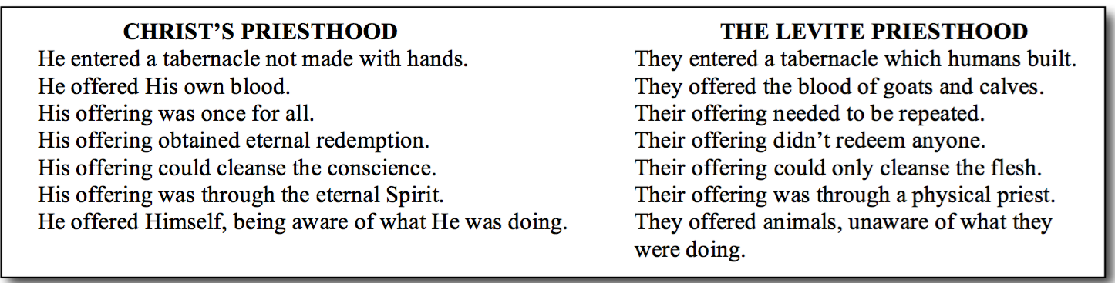

PT—The nation as a whole rested on the shoulders of the high-priestly person and work. On the other hand, he carried the tribes individually into God’s presence on his heart. In comparison to the Old Testament high priest, the great accomplishment of Christ is that He entered into a greater and more perfect tabernacle. but when Christ appeared as a high priest of the good things to come, He entered through the greater and more perfect tabernacle, not made with hands, that is to say, not of this creation; and not through the blood of goats and calves, but through His own blood, He entered the holy place once for all, having obtained eternal redemption (Hebrews 9:11-12).

The Prophetic Future of the Twelve Tribes
Jacob’s deathbed blessings upon his 12 sons touched upon prophecies with future characteristics for each of them. Many of those prophetic blessings were fulfilled throughout the history of Old Testament Israel. Other Scriptures, however, indicate that there is still future prophecy yet to be fulfilled in relation to the 12 tribes.

The 12 Tribes in the Tribulation
The major section of the book of Revelation (chapters 6 through 19) describes events during the seven-year Tribulation period. Chapter 7 is between the sixth and seventh seal judgments. In that chapter two large groups of people appear who represent those saved during this period of time.

Verse 4—and I heard the number of those who were sealed, one hundred and forty-four thousand sealed from every tribe of the sons of Israel—This group of 144,000 is clearly described as every tribe of the sons of Israel. 144,000 are sealed (12,000 from each of the 12 tribes of Israel). It means these tribes exist today and are identified as such in the Tribulation.
Verses 5-8—From the tribe of Judah, twelve thousand were sealed, from the tribe of Reuben twelve thousand, from the tribe of Gad twelve thousand, from the tribe of Asher twelve thousand, from the tribe of Naphtali twelve thousand, from the tribe of Manasseh twelve thousand, from the tribe of Simeon twelve thousand, from the tribe of Levi twelve thousand, from the tribe of Issachar twelve thousand, from the tribe of Zebulun twelve thousand, from the tribe of Joseph twelve thousand, from the tribe of Benjamin, twelve thousand were sealed—The Apostle John identified this entire group as Jewish by mentioning that 12,000 came from each tribe of the 12 tribes and even giving their specific tribal names. This group is contrasted with a great multitude which no one could count, from every nation and all tribes and peoples and tongues, standing before the throne and before the Lamb, clothed in white robes, and palm branches were in their hands (v. 9). Most likely these are believers martyred during the Tribulation.

PT—These sealed Jews are those who came to faith in Jesus as Messiah during the Tribulation period. They are further described as the ones who have not been defiled with women, for they have kept themselves chaste. These are the ones who follow the Lamb wherever He goes. These have been purchased from among men as first fruits to God and to the Lamb. And no lie was found in their mouth; they are blameless (Revelation 14:4-5). Instead of being evangelists or preachers, this group will be known for their moral purity and the fact that they were protected from martyrdom during the Tribulation. They are further described as the first fruits to God and to the Lamb, indicating that they compose the first stage of a final harvest of Jewish souls to be gathered later at the Lord’s coming in glory.
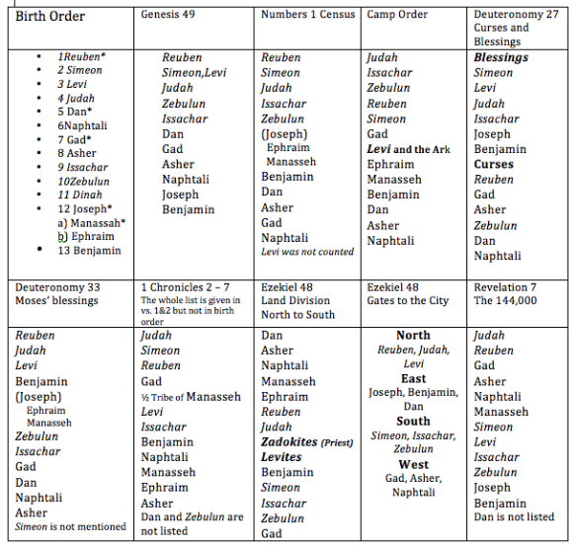

There is no standard way to list the 12 tribes. There are at least 19 different ways of listing them in the Old Testament, and none of them agree with the list here. In this listing Ephraim and Dan are both absent. We know that Dan was overrun by idolatry from the days of the judges. That may have been a contributing factor here. Interestingly, Jeroboam’s idols were placed in the tribes of Dan and Ephraim (Bethel, 1 Kings 12:29). So, in the Revelation 7 listing of the tribes, Dan was replaced by Levi (v. 7) and Ephraim was replaced by his father Joseph (v. 8). Joseph’s brother Manasseh, was included to complete the list of 12 (v. 6).

An Application—God has a future for all the tribes of Israel (apparently, except Dan). He is still honoring His promise to Abraham way back in Genesis 12. God keeps His promises and He keeps them specifically, not generally nor approximately. The prophecies of Jacob in relation to his sons will be as literally and specifically fulfilled as the prophecies of the past were literally and specifically fulfilled.

The 12 Tribes at the Second Coming
The Jewish tribes will eventually come to the realization that they did actually crucify the Son of God and that recognition will bring mourning and repentance when Jesus returns to earth.

Revelation 1:7—Behold, He is coming with the clouds, and every eye will see Him, even those who pierced Him; and all the tribes of the earth will mourn over Him. So it is to be. Amen—This is a description of the Second Coming of Christ, not the Rapture, because every eye will see Him, even the unbelievers, which is not the case with the Rapture (1 Thessalonians 4:13-17). The Rapture is never mentioned in the book of Revelation. Believers will ascend with clouds at the Rapture (1 Thessalonians 4:17); and Christ will return with the clouds, ...they were looking on, and a cloud received Him out of their sight...This Jesus...will come in just the same way as you have watched Him go into heaven (Acts 1:9-11).

Zechariah 12:10—Even those who pierced Him refers to the Jews when God said, “...the house of David and... the inhabitants of Jerusalem...will look on Me whom they have pierced...”. But we know that this moment will result in much repentance (such as the 144,000, for example). The fulfillment of this announcement does not actually occur until Revelation 19:11-16, which takes place at the end of the Tribulation.

PT—In the context of Zechariah’s prophecy, those who look upon him whom they have pierced (12:10) are the inhabitants of Jerusalem—Jews. The great mourning in Jerusalem (v. 11ff.) are Jewish inhabitants of the land of Israel. This mourning is an indication of the penitential remorse to be experienced by Israel at its national conversion prophesied in the Old and New Testaments. afterward the sons of Israel will return and seek the Lord their God and David their king; and they will come trembling to the Lord and to His goodness in the last days (Hosea 3:5) and so all Israel will be saved; just as it is written, “The Deliverer will come from Zion, He will remove ungodliness from Jacob” (Romans 11:26).

Unfortunately, it will take a Tribulation judgment to prepare the nation Israel for her Messiah, and to bring about the conversion of a multitude of Jews who will enter into the blessings of the Kingdom and experience the fulfillment of all Israel’s covenants. “It will come about in all the land,” declares the Lord, “That two parts in it will be cut off and perish; But the third will be left in it. And I will bring the third part through the fire, refine them as silver is refined, and test them as gold is tested. They will call on My name, And I will answer them; I will say, ‘They are My people,’ And they will say, ‘The Lord is my God’” (Zechariah 13:8-9 [i.e. cf. Deuteronomy 4:30; Jeremiah 30:7; Ezekiel 20:37; Daniel 12:1; Matthew 24:9-26; Revelation 7:4-8; 12:1-2; 17]).

PT—Interestingly, this is the same message preached by Peter at Pentecost in Acts 2:36. There he concluded, let all the house of Israel know for certain that God has made him both Lord and Christ—whom you crucified. The result ‘now when they heard this they were pierced to the heart’ saying ‘to Peter and the apostles “what must we do?” (v. 37). Peter said, “Repent…” Unfortunately for Israel, the repentance of Pentecost never took place on a larger scale. But in this day to come, yet future, the entire nation will be pierced to the heart about their piercing of this One, the Messiah. Unlike Pentecost, at the Second Coming of Christ, the tribes of Israel will change their mind about who Jesus is and accept and fully embrace Him as their Messiah.

The 12 Tribes in the Millennial Reign
Following the Second Coming to Earth, Jesus Christ, the Messiah will reign over a restored Israel and a renewed earth for a thousand years. During this period the tribes of Israel play a prominent role.

Matthew 19:28—And Jesus said to them, “Truly I say to you, that you who have followed Me, in the regeneration when the Son of Man will sit on His glorious throne, you also shall sit upon twelve thrones, judging the twelve tribes of Israel”—Peter wondered what reward he and his fellow disciples would receive because they had forsaken all in this life to follow Jesus. He told them the physical reward would not come in this life but in the life to come, when the apostles would participate in the millennial government. Here, their assignment would be making disciples in the midst of rejection and persecution, but in the kingdom, they would be judging the twelve tribes of Israel as vice-regents to the King of Kings in His millennial administration.
The concept of believers judging or ruling in the sense of governing also appears in 2 Timothy 2:12. If we endure, we will also reign with Him and also those who had not worshiped the beast or his image, and had not received the mark on their forehead and on their hand; and they came to life and reigned with Christ for a thousand years (Revelation 20:4).
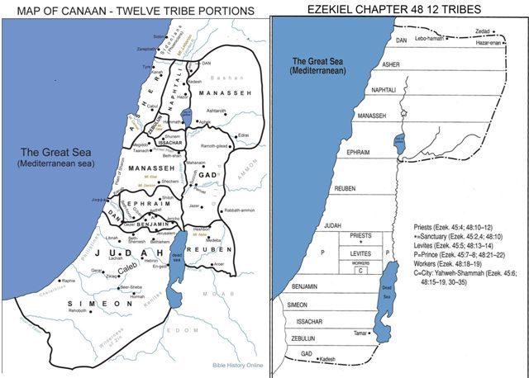

Ezekiel 48—“Now these are the names of the tribes… the workers of the city, out of all the tribes of Israel, shall cultivate it… As for the rest of the tribes… This is the land which you shall divide by lot to the tribes of Israel for an inheritance, and these are their several portions,” declares the Lord God… shall be the gates of the city, named for the tribes of Israel—These verses describe the Millennial Temple with its regulations and priestly duties and the appointment of the land to the various tribes. Here is the description of the boundaries of the Millennial tribal divisions, which differ considerably from the original boundaries in Joshua 13–19 allotments. The entire territory west of the Jordan River is to be divided into 12 parallel portions running east and west. The northern boundary is in the modern country of Lebanon. The southern boundary is roughly the same as Israel’s present boundary line with Egypt. Each tribe will receive an equal share from north to south in this order—Dan, Asher, Naphtali, Manasseh, Ephraim, Reuben, Judah, Benjamin, Simeon, Issachar, Zebulun, and Gad. Between the territories of Judah and Benjamin will be situated the sanctuary of the Lord shall be in its midst (v. 10).

PT—It is noteworthy that the tribes descended from the handmaids, Bilhah and Zilpah, are placed at the extreme ends, farthest from the sanctuary. It should also be noted that the tribe of Dan, although not included in the 144,000 Jews sealed during the Tribulation, will have its own portion in the Millennial Kingdom. Jerusalem will even have a name change “and the name of the city from that day shall be, ‘The Lord is there’” (v. 35). The tribes of Israel, long scattered in the lands of exile, will be regathered, restored, regenerated, and rued over by their Messiah King, The Lord Jesus Christ.

An Application—Eternal rewards are based on leaving everything of worldly value behind. That will be true for the apostles and for all believers. Life lived here on earth is God’s laboratory by which His people prepare themselves for the eternal life to come. for we must all appear before the judgment seat of Christ, so that each one may be recompensed for his deeds in the body, according to what he has done, whether good or bad (2 Corinthians 5:10).

The 12 Tribes in the New Heavens and the New Earth
In the eternal realm, in the new heavens and earth, the 12 tribes of Israel will have a presence and role in the eternal affairs of God’s kingdom administration.

Revelation 21:1-2—Then I saw a new heaven and a new earth; for the first heaven and the first earth passed away, and there is no longer any sea. And I saw the holy city, new Jerusalem, coming down out of heaven from God, made ready as a bride adorned for her husband—With the passing of the first earth, a new eternal one will emerge. The first one will be destroyed by fire but the day of the Lord will come like a thief, in which the heavens will pass away with a roar and the elements will be destroyed with intense heat, and the earth and its works will be burned up (2 Peter 3:10). God will replace the old city of Jerusalem with one coming down out of heaven. The city itself is beautiful, as a bride is beautiful on her wedding day.

Verse 12—It had a great and high wall, with twelve gates, and at the gates twelve angels; and names were written on them, which are the names of the twelve tribes of the sons of Israel—This new Jerusalem will have specific dimensions and will be entered and exited through 12 gates. For all eternity, these gates will represent the tribes of Israel, the people of the promises, the covenants, the Scripture, and the Messiah—each gate will have a tribal name. This city will have angel guards at its gates.

Verse 14—And the wall of the city had twelve foundation stones, and on them were the twelve names of the twelve apostles of the Lamb—The 12 gates are balanced by the 12 foundations of the wall which bear the names of the 12 apostles. Although this reference does not describe a separate role for the 12 tribes in that day, it does speak of the fact that throughout eternity the Old Testament people of God, the tribes, and the New Testament people of God, the apostles, will be together in the light of the glory of God and of His Lamb, where the Lord God the Almighty and the Lamb are its temple. And the city has no need of the sun or of the moon to shine on it, for the glory of God has illumined it, and its lamp is the Lamb (vv. 22-23). The 12 sons who originally gathered around their aged father’s bedside scarcely could have realized that their descendants would play such a crucial role in the plan of God for the ages.

Conclusion
The twelve tribes teach us about sanctification. We are to take possession of our position in life. That position involves everything God has provided: our talents, desires, opportunities, spiritual gifts, convictions, personalities, and physical situations, so that we walk in a manner worthy of our salvation. Like the Tribes, we have been given a position in life. Like the Tribes, we have accountability for taking possession of the position for the glory of God. Like the Tribes, we have a prophetic future to live and prepare for as we apply the position in life God has given to us. As the Tribes were to live out their lives taking possession of their position, so we, too, having been given the gift of eternal life, have an obligation to live now preparing for that everlasting life. Taking possession of our position in life is laying up treasure in heaven. It’s getting ready for the judgment seat. It’s enduring, so we can reign with Him. It’s being an overcomer, so we have the fullest blessing available in eternity. It is receiving a full reward. Watch yourselves, that you do not lose what we have accomplished, but that you may receive a full reward (2 John 1:8).

