e-concepts __________________________________________________
A Weekly Publication of Relational Concepts Inc.
The Essence of Fellowship
David DeWitt
In the Bible, a relationship has three basic elements: fellowship, friendship, and love.
Fellowship is mutual sharing. It’s all about reciprocation. Either it is giving, expecting a response, or responding to something given. The opposite of fellowship is stinginess, the unwillingness to share mutually.
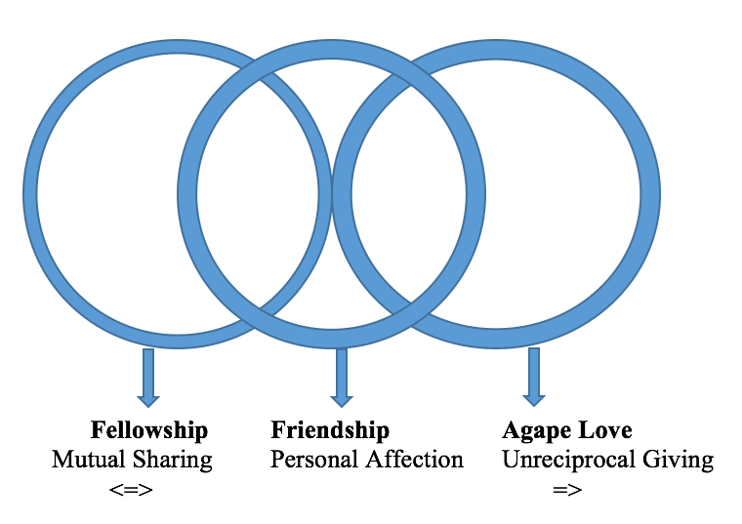

Love (agape love) is very different. In one sense, it’s the opposite of, without being contradictory to, fellowship. Love is giving without an expectation of reciprocation. It has no expectation of a return for a gift. Although it may hope for good things to happen later, it is giving without any thought of return for the giving itself. Fellowship is two-way. Love is one-way. Both may or may not exist at the same time, but they are not the same thing. Fellowship and love are mutually exclusive (non-overlapping) aspects of a biblical relationship.

Friendship, on the other hand, can go two-way, one-way, or no-way at all. Friendship is an affection which may either expect a return, or not expect a return, or have a subjective return. In other words, a person can have an affection others aren’t even aware of. And that’s the major difference between biblical friendship and secular friendship. The secular definition of friendship is always two-way, “a relationship of mutual affection between two or more people” (Wikipedia). That “mutual” concept of friendship is also in the Bible. But the Bible recognizes a friendship that the world does not, or at least the world would use a different word for it. Biblical friendship can be with those who do not, or things that cannot, reciprocate, such as the world itself (James 4:4).

As depicted in the circles diagram:
There is considerable overlap between fellowship and friendship, since either of them may reciprocate. Friendship might be reciprocated and fellowship always is.
And friendship overlaps with love because both of them might give without expectation of return.
Friendship might give without expecting reciprocity, love always does.
But there is no overlap whatsoever between fellowship and love. Fellowship always expects a return, love never does.

Defining Fellowship
The Christian life has many values, even here on earth, this side of heaven (Mark 10:29-30). We have the eternal Word of God recorded in the Bible to give us truth in the midst of a world of lies. We have the indwelling Holy Spirit to convict us of sin and guide us to an application of God’s Word. We have a peace that passes understanding, an assurance of eternal hope, and a promise of salvation. As believers, we also find one another and establish a network of Christian fellowship, which allows us to support each other, encourage each other, give to each other, laugh together, and weep together.

From the very start of the church, they were continually devoting themselves to the apostles’ teaching and to fellowship, to the breaking of bread and to prayer (Acts 2:42). Fellowship is essential for a healthy spiritual life. Everyone needs others. That’s the way God made us. The noun form of koinonia combined with the prefix sug meaning together, is the Greek word sugkoinonos. This word occurs 4 times in the New Testament, translated fellowship together or participate. I suggest that, biblically speaking, Fellowship Is an Entanglement of Human Lives, resulting in a Decision to Share Something Beneficial. Or simply, Fellowship Is Beneficial Sharing.

