e-concepts ______________________________________________________________
A Weekly Publication of Relational Concepts Inc.

The Need for Hope
Dr. David DeWitt
But now abide faith, hope, love, these three and the greatest of these is love (1 Corinthians 13:13).
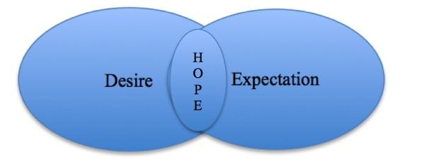
Since it is not possible for us humans to live without desires and expectations about the future, it is not wise to attempt to do so. When those ever-present desires and inevitable expectations overlap, we have hope. And…we cannot live without hope.
That’s’ why we wrote this material. Since we can’t live without hope, we should try to understand it.

Defining Hope
The word hope occurs 140 times in the Bible.
Hope is desired expectation

Hope is: a feeling of expectation and desire for a certain thing to happen.
Desire is: a strong feeling of wanting to have something or wishing for something to happen.
Expectation is: a strong belief that something will happen or be the case in the future
[These definitions are from the Mac Pro dictionary. All the emphases in all quotations in this paper are ours.]
A.W.Tozer wrote: “Hope is the music of the whole Bible… Hope means a desirable expectation, a pleasurable anticipation (The Tozer Pulpit, p 40).”

Applications
- We cannot live without hope. [Every living being has desires, but that is not sufficient. I cannot live without also having some future desires which I expect will happen.]
- Someone without hope, or someone who denies that they need hope, is dysfunctional. [Without expected future desires we will be despondent, grumpy, ornery, mean spirited, depressed, discouraged, or suicidal.]
- Hope governs our investments. [Since we invest in our hope, our investments reveal our hope.]
- Hope and love do not contradict one another, they complement one another. [Hope without love leads to futility, love without hope leads to depression.]
- Hope is what supplies life’s motivation. [It’s the fizz in life’s soda pop. Without it life is boring, uninteresting, or intolerable. It’s hope that gets us out of bed in the morning.]
- Temporal hope is valuable when it is connected to eternal hope. [Temporal hope is essential and valuable, unless it is tied only to this world and not to eternal hope.]
- Hope prioritizes our decision-making. [When I hope for something (a car, a spouse, a house, an education, maturity, or eternal life) that prioritizes all of my daily decisions.]
- The further my hope is projected into the future, the more it clarifies my present thinking. [The further I look down the road, the straighter I will drive.]
P.O. Box 141456 • Grand Rapids, MI 49514 • relationalconcepts.org • @RelationalConc1

